# **ADVANCED JAVASCRIPT**

## JavaScript Behind the Scene

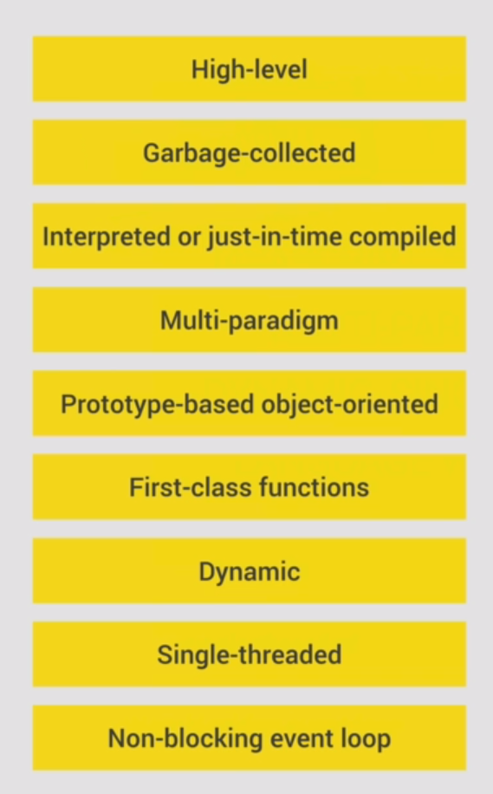JavaScripts is a Hig-level, Garbage-collected, interpreted or just-in-time compiled Multi-paradigm prorotype-based boject-oriented first-class functioned Dynamic, Single-threaded Non-blocking event loop language. (Don’t remember the above, tis just a joke from the course) Yet javascript is all these things, so the further we dive deeper into this topic the more we will understand exactly how javaScript works, **behind the sceene**.

### **High-level**

Javascript is a high level language, which meants, that it does not have to manage memory-resources manually, but has all it’s memory sources allocated/disposed and re-allocated automatically, making it much easier to work with, than for example the **low level C language**, where the programmer has to manually manage the computer resources.

The upside of high-level languages is their ease of use, accessibiliy, while the downside is the fact that they will simply never achieve the same level of optimization that is possible when you manually assign recources, which can only be done on a low-level programming language.

**Garbage-collection**

The automated method that automatically cleans up and manages unused resources(memory) and cleans up(deletes) the resources no longer used.

### **Mulit-paradigm**

An approach and mindset of structuring code which will direct your coding style and technique.

1. Procedural Programing
2. Object-oriented programming
3. Functional programming

The interesting thing about Javascript is that it supports all three Paradigms, while other languages generally support only one specific paradigm (C-supports Procedural) while C# supports OOP

### **Prototype-based object-oriented**

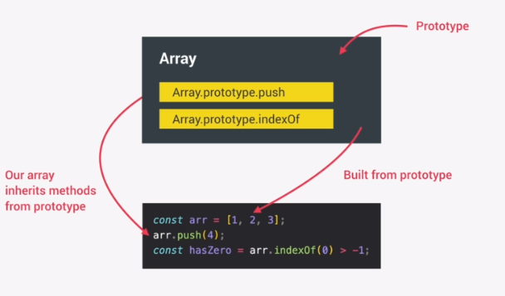

Everything in JavaSript is is an object, and all the elements that we create have their blue-prints pre-prepared in Javascript interface-like-classes. So in the case of creating an Array, we are basically only defining the pre-set attributes of the Array-object-prototype and creating an object based on said prototype/blueprint, or as it would be in C#, we are creating an object from a class that implements an “interface”.

### **First-class functions**

In a language with **first-class functions**, functions are simply treated as variables. We can pass them into other functions, like we would pass any other variable, and we can also set a function to be a return value of another function

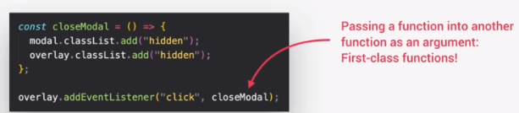

### **Dynamic**

Javascirpt is a Dynamically-typed (data-typed) languages. This means that there are no definitions that set a datatype of a function or variable, javascript automatically and dinamically aissgns datatype-type to the variables/functions depending on the data that is being stored/returned, as well as having automatic imlpicit data-conversion, which the user has to be well familiar with, since there is no explicit control over the datatype of the variables/funcitons as you work with them. This makes it easier to write code, yet, the fact that you have to Know exactly how Javascript thinks, many believe that it is much easier to make a strict-typed programming lanugage like C, C#, Java, Rubi, etc…. NOTE: **TP(TypeScript**) does exist as a strict-typed JavaScript language.

### **Single-threaded**

**Concurency-model:** How javascript handles mulitple events at the same time.

Javascript runs in one **single thread**, so it can only be doing one thing at a time.

**Thread(**A set of instructions that can be executed by your cpu in one CPU measure of time)

This means that if we, for example have a lon-running task, which would be fetching-data from a server in real time. We would not want our program to be permanently assigned to just that one single task, as that task would usually block our **single thread.** To manage this behavior we want a **non-blocking behavior.** We achieve that by using:

### **Non-blocking event loop**

Using an event-loop, takes long runing tasks, executes them in the “background: and puts them back in the main thread once they are finished.

## **The Javascript engine and Runtime**

### **What is a JavaScript engine**

That is a program that executs a Javascript code. Note that every browser has it’s own javascript engine, that executes javaScript code. Note that Google uses **V8-Engline** to read javascript code

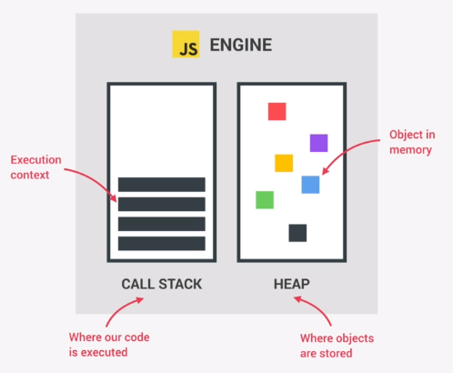

Every javascript engine has a **stack** and a heap memory. Stack-memory is used to temporarily store, execute and after execution pop(dispose) our written code. It uses the First-In-Last-Out datastructure, meaning that the first code that enters the stack will be the last to get disposed from it.

On the other side, the unstructured **HEAP**-memory actually stores objects in memory. The addresses for said objects are contained inside the Stack(as they are the relative datatypes we use to reference objects from our code). The objects in HEAP memory are garbage collected, (ie.deleted)when there are no references(addresses) on the stack, pointing to said objects. If that is the case, the garbage collector picks them up and deletes them automatically.

### **Code Compilation vs Code Interpretation**

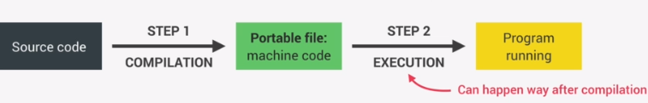**Compilation:** The entire code is converted into machine-code(1:0) at once, and written to a portable binary file that can be executed by the computer. Note that this means that the entire code at first translated to machine code, and then, later, executed when the program starts to work.

**Intepretation:** In this case the code is translated and immediately executed line by line. Meaning that the code exists in its current non-translated state, and upon the execution of the program the interpreter starts translating then executing the code line by line. This is of course much much slower than runing a pre-compiled code…

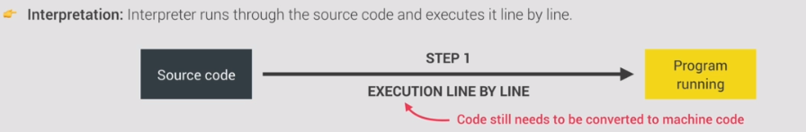

#### **Just-in-time compilation (JIT)**

Javascript was originally an exclusively **interpretive** language, but has, later, due to the demands of modern browser applications become a mix of **compilation and interpretation** when processing code. This combination of the two approaches is known as **Just in time Compilation.**

**JIT:** The entire code is converted into machine code at once, then executed immediately. (note: it is not first written in a portable binary file, then executed like in the regular compilation process, but intead skips the part of creating and storing binary data in the portable binary file, and moves to execute the converted (now binary) code immediately after conversion)

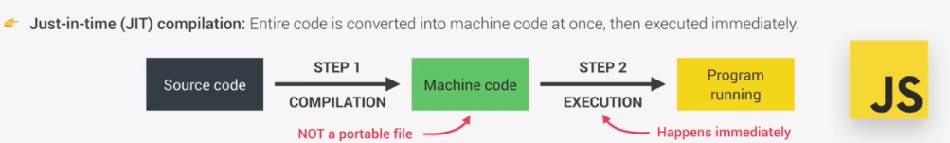

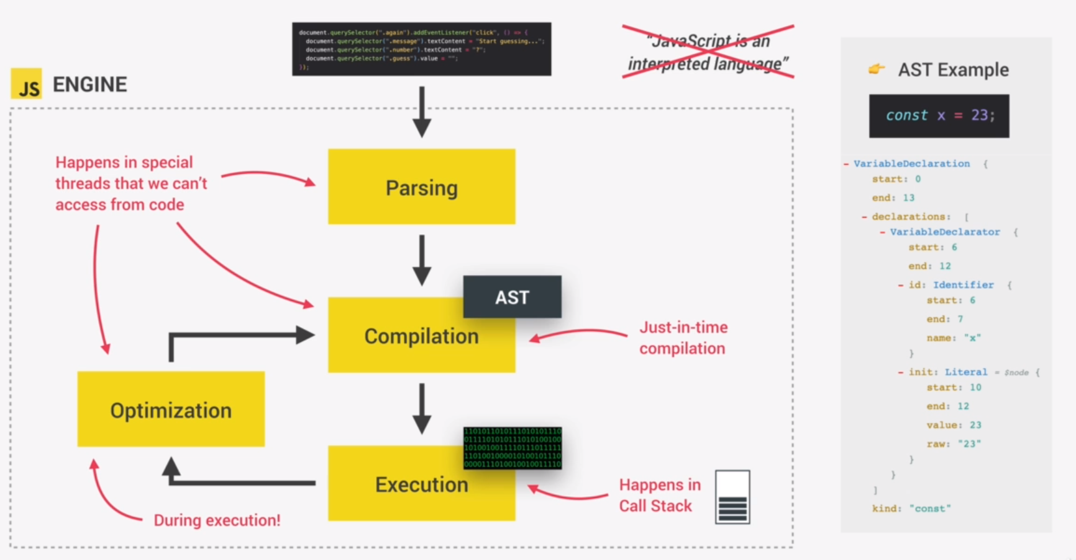

**Just in Time compilation process:**

1. **Parcing the code:** Meaning, to read our code gets parsed and compartimentalised inside the **AbstractSynthaxTree(AST).** In other words all programming keywords like **const, let, var, function(), etc…** get compartimentalized in the **AST** data structure, where the various programming keywords from our code, get separated and structured inside the AST tree, as well as checked for any synthax errors, where the resulting data-tree will later be used to generate machine code. In the program above we see the **AST EXAMPLE** of what exactly happens to our code (how it gets interpreted) inside the data-tree, and we can notice how the structure of the tree has a class for **VariableDeclaration()** that upon reading **const x =23;** creates an instance of the variableDeclaration class with the necessary parameters to do so. (This gives you a real sense at the level of abstraction high-level programing languages work on).
2. **Compilation:** as the code gets read and structured in our **AST** data-structure, it gets turned (compiled) into a machine code
3. **Execution:** This machine code gets immediately executed when the compilation finishes to compile the entire program. Note that initially the machine code generated is un-optimized, in order to make the code initially start as quick as possible, with the only goal of making it runable the first time.
4. **Optimization:** As the code begins to run, on each iteration of the code, ie during the process of code execution the machine-code passes through an awesome algorythm that optimizes it, so after a whilebetter it becomes optimized and actually run faster and more efficiently (memory-wise) than it did on the initial startup.

**NOTE THAT NONE OF THESE PROCESSES ARE ACCESIBLE TO THE DEVELOPER THEY ALL WORK, ESSENTIALLY, UNDER THE HOOD.**

### **JAVASCRIPT RUNTIME**

#### Access to a browser

#### A javascript Engine

#### Access to web APIs

#### A callback queue

-For javascript runtime to happen, it needs access to a browser.

At the heart of each javascript runtime, lies a javascript engine that actually runs the javascript code.

But to run certain codes and enable various functionalities , javascript engine needs WEB API’s which borrow the javascript engine, for executing various functionalities stored within said API. An example of API is DOM (which is not contained in the javascript code, or the javascript engine that runs the code, but is instead stored inside a Browser API, and from there accesible to the javascript engine, as it complies and runs the code. All of these API functionalities are stored and accessed on the **Window** global object. And are not a part of the Javascript language itself.

A typical javascript runtime also includes a **callback queue.**

**Callback queue:** This is a datastructure that contains all the callback functions that are ready to be executed. Callback functions for various events (click) or methods: forEach(callbackFunction()).

Example:The process of the callback function getting activated on an event-Listener:

On click the callback function will be called. The first thing that happens after the click-event is that the callback function will be placed inside the **callback-queue**, then, when the call stack is empty and more orders can be passed to it, the callbackFunction will be placed inside the call-stack so that it can get executed.

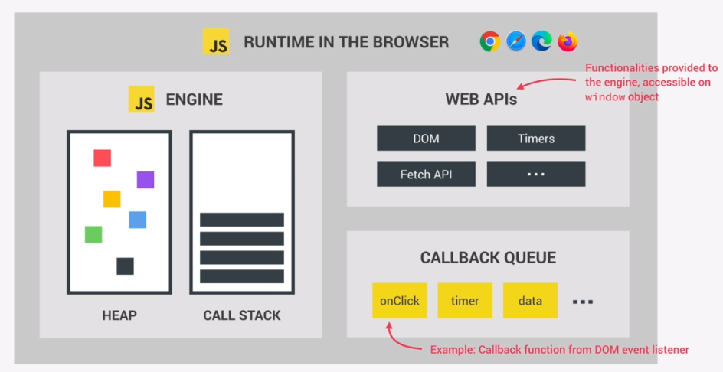

## Execution context and the call-stack

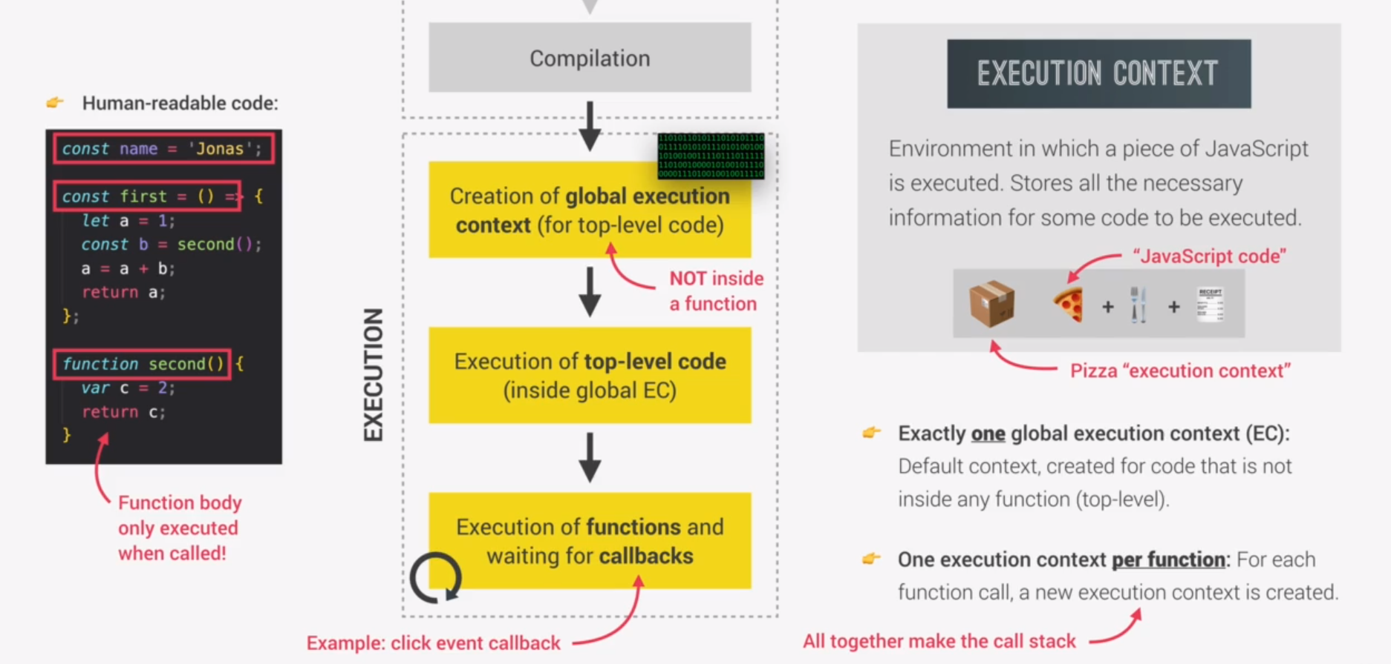

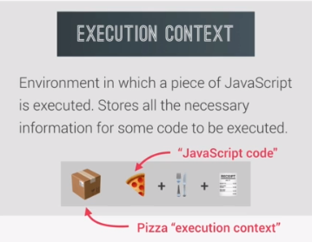**Definition of an EXECUTION-CONTEXT:** an abstract environment that **Stores all the content necessary for the information to be executed** (think of a semantic order in which we do things, ie, first we eat then we wash the dishes, or in the mornings we usually go to the toalet first, where the toalet is the abstract environment where all the various higiene related operations happen, then we go to the closet, which is where all the dress-related operations happen)

Global Execution context:In the beginning, only the code outside of functions will be executed, Ie the compiler reads and executes the code in the (“Main”) class, or if it is a procedural code, it executes the part of the code that is not within the functions, and only enters functions as they are called within the main part of the code.

For any javascript code, there can only ever be one **global-execution-context**

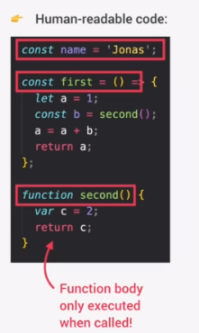In the example to the left, the global execution context sees and executes the declaration of the variable “name” and executes/stores just the reference-type-variables (the locations)of the function “first()” /writen as a function expression, as well as “second()” written as a function declaration. But what the **top-level code** does not execute or see are the lines of code within those function bodies. (it only remembered their addresses stored inside their reference-type function names) The function code is visible to the compiler and executed only when and where those functions are called.

### Function execution context

For each and every function call a new execution-context will be created containing all the necessary information to run that very function (the same goes for methods)

All the **execution contexts** together make up the **call stack**.

**After all the functions are done executing, the engine will wait for the callbackFunctions to arrive to execute those, from the callback-Queue of the Event-Loop.**

**1.First the functions and methods get executed**

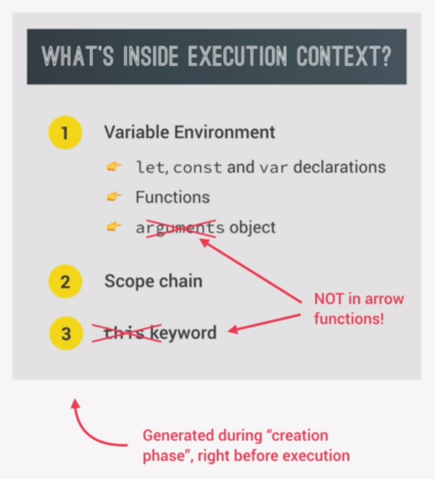**2.The callback functions get executed**

### What is inside the execution context

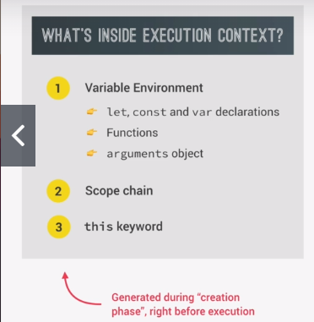Execution context of arrow functions**:**  how execution context for arrow functions does not contain the **arguments** object or the **this** keyword. And an arrow function can only use the **arguments and this** from it’s direct parent function element.

## **Execution context in detai**

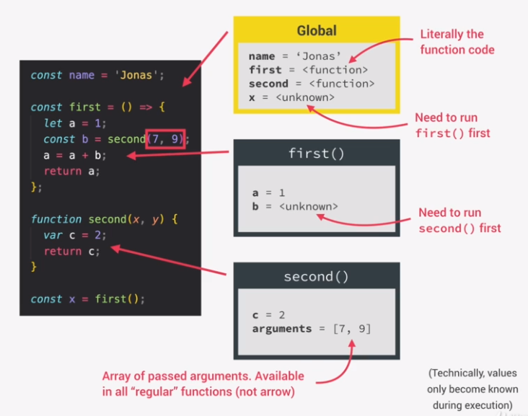

Above we can see the code on the left being compiled and ran, The codes on the left are being executed in various ecxecution contexts. For the codes outside of any function or method body(variable names, function names,/references, etc…), we have the **Global execution context**, while for every function/method body the compiler creates a separate **function-execution context,** as we can see done for the **first** and **second** function.

Now, the piece of code on the left is very very simple, so it may not be too difficult to dettermine the order in which the code will be run. But let’s for a second imagine a program with thousands upon thousands of lines of code. How will the interpreter know in what order is he supposed to execute function and methods? That is where the **call-stack** finally comes in.

## **The call stack**

The call stack together with the memory-heap makes up the javascript engine itself.

Javascript code runs inside th **execution contexts** which run/execute in the **call stack**. Below we will see how the call stack works in dettermening which functions(execution context) run in what order.

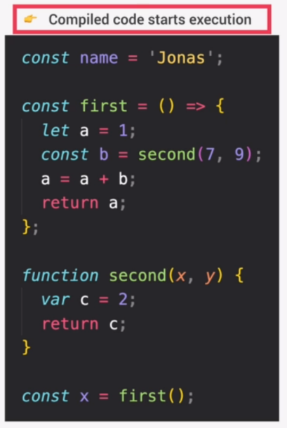

**(1)Sequence** At first, the global execution context is created and in set as the current running execution context inside the stack. In the global context the variable “name” is declared and intialized, and the two functions “first(){}” and “second(){};” are declared. Note that declaring a function essentially means that the compiler noted the address at which it can access the function code.

**Note on function declarations:** When the global execution context passes a function declaration (or any execution context for that matter) it simply remembers the function name and location(address), it does not care or go through any of the code inside the function-body.

-The global context also declares the variable **x** and assigns it the value of a function call(); **first();**

### Stack push

-**(2)Sequence:** The global execution context reaches the **first();** function call. When this happens a new **function-execution context** is created and placed at the top of the stack as the new **active-context**. The **global-context** is paused (remember javascript is **single-threaded** and can only run one execution thread at a time) and the **execution context** for **first();** is run.

Inside the **first()-ExecutionContext**, the the compiler declares and initializes **let = 1;** then declares a constant **const b = second(7,9);** 🡪 Now this is another function call so the compiler creates another **execution context** for the **second();** function, and places it on top of the stack as the new **active-context.**

-**(3)Sequence:** Inside the **second()-ExecutionContext** the compiler declares and intializes **var c = 2;** and then returns the value **c.**

### Stack pop

-**(4)Sequence:** When the execution-context reaches the end of a function body, or gets to a **return** function word, the **current function-ExecutionContext** is popped off the stack and the compiler enters the next execution-context that was below it. (the current execution-context on top of the stack)

This means that the **second-executionContext** got popped off from the **call-Stack and the** compiler returned to the **first()-Execution context** carrying with it the value **C(value:2)** storing it inside **const b** , then proceeding to calculatee **a = a + b;** (1+2, = 3)and arriving at the line of code **return a;**

-**(5)Sequence:** From there the **first-executionContext** got popped off from the **call-stack,** leaving our **globalExecutionContext** on the top of the stack. This means that our compiler returned to the **Global-executionContext** carrying with it the value of the variable **a**(3) to the location where the previous execution-context-function was intitially called, storing the output value of said function inside **const x.**

The **globalExecutionContext** will remain in the stack indefinitely, or until the program itself is shut down.

This does, in a brief example explain exactly how the **call-stack** helps the compiler map and arange the order in which functions and methods are executed. Hope it makes sense and is not to vague or hastily written.

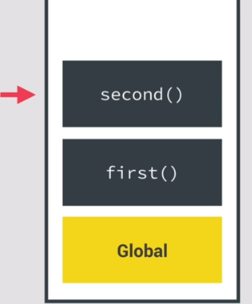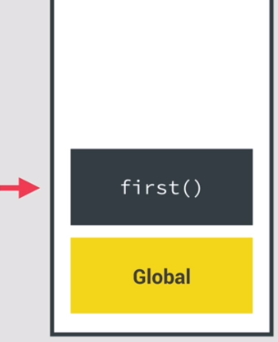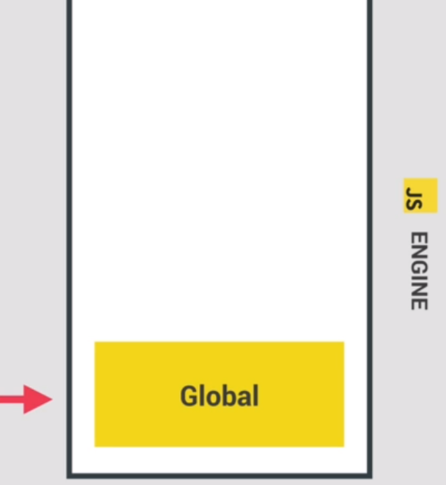

Figure Sequences **(1) -> (2) -> (3)**

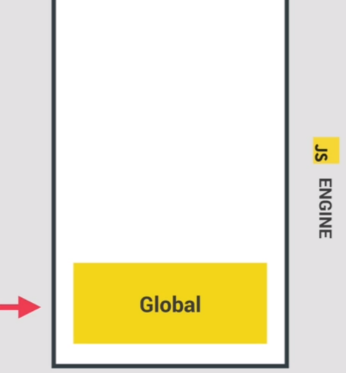

Figure : Sequences **(4) -> (5)**

Figure Sequences **(4) -> (5)**

## **Scoping and Scope Chain**

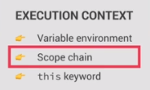**Scoping:** Defines how our program’s variables are organized and accessed. In other words it: “Defines where our variables and function live” or “Defines where we can access a certain variable, and where we cannot”.

Javascript uses **Lexical scoping:** Scoping is controled by placement of functions and blocks. For instance, a function within another function has acess to the variables inside the parent function.

**Scope:** Is the environment in which a certain variable is declared and accessible.

**Javascript scopes:**

1. **Global-Scope**
2. **Function-Scope**
3. **Block-Scope**

**Scope of a variable:** Region of code where a certain variable can be accessed.

When talking about scope in Javascript **Variable-scope 🡸🡺 Function-scope,** behave in completely the same manner, because, to javascript, functions in the context of scope are just values stored inside variables, and so are both treated in the same way.

**Global-scope:** Top level code. These variables are accessible everywhere in our program

**Function-scope:** Also called Local-scope: The variables are accessible only inside the function.

**Block-scope:** A newer scope addition to javascript. Just like in functions, variables declared inside the block are only accessible within the block curly-braces. **However: Block-scope only applies to LET and CONST variables**  and not (var)/old javascript version. If we declared a **var** within a block-scope, that variable would still be accessible to the program immediately outside the block-scope and the block-scope itself.(it essentially ignores the block), “so we say **var** is a function scope.”

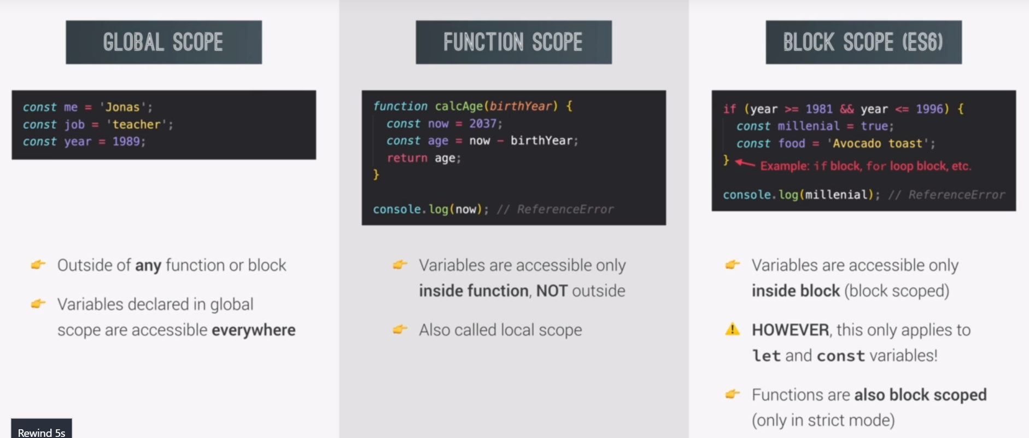

## **The Scope Chain**

**EVERY SCOPE HAS ACCESS TO EVERY VARIABLE FROM ALL(I MEAN ALL) ITS OUTER SCOPES**

If one scope needs to use a variable that it does not have in its current scope, a process called **variable-lookup** will travel up it’s scope chain to look for and fetch that variable from any of its parent elements.

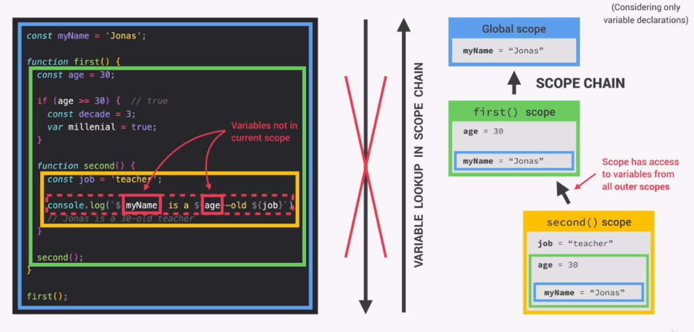

The chain works like this because essentially every scope has access to the variables inside their direct parent’s scope. And because the direct-parent-scope is the scope of the parent and the parent’s parent, this local direct inheritance aggregates to the principle where a child scope inherits THE SUM OF ALL OF THE PARENT variables and functions.

So here we can see that the **First()scope** has access to the const “myName”, from the global scope, since that is its parent element.

The **second() scope** has access to the **“const decade**” and “**var millenial**” variables, of its parent element “**first()scope**”, but ALSO to the “**const myName**”, since the parent element “**first()**”’s parent is the global scope. And if the parent element of the **second()** scope can get elements from the global scope, that means that the **second()scope** can aslo have access to the “**myName**” variable inside the global scope.

This is why scopes in practice chain together so that every child-scope has access to all the elements of every parent element(all the outer scopes) it is nested inside.

**This works exactly like:**

**SERBIAN:**

**(Izvedene klase)** gde svaka izvedena klasa ima pristup svim atributima roditelj/nadRoditelj etc… klasa. Dok roditelj nema pristup dete-klasama(lokalnim elementima svojih izvedenih klasa)

**Back to English:**

This principle applies for functions the same way it applies to variables, and **it also applies to function arguments!**

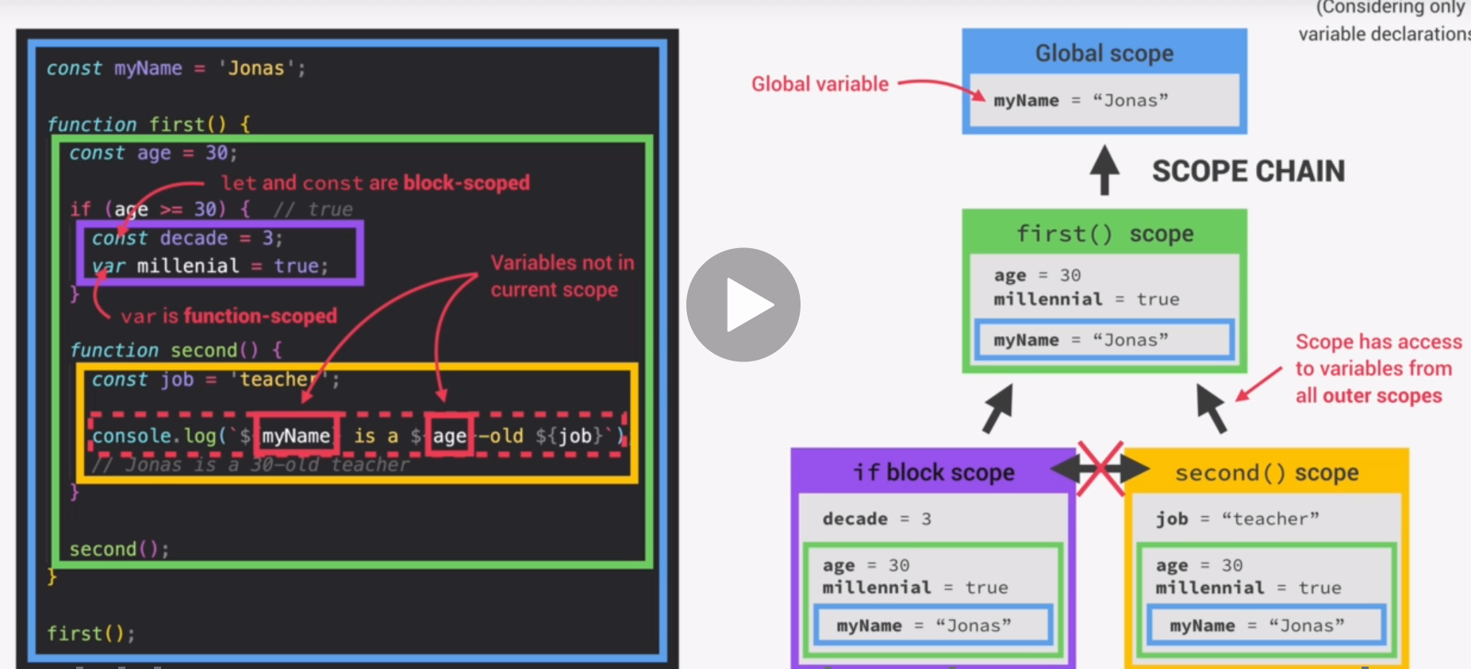

Above we can also notice block scopes with the **“const decade”** and **“var millenial”** variables assigned to it. Now since block-scopes only work for **ES-6(variables**) this means that **“var-millenial”** actually exists within the **first(); scope** and is not contained within its block,while the **“const decade**” is block-scoped and has its access limited within its block. **Block-scopes** follow the exact same **scope-chain** as **function-scopes,** so the same rules apply: **meaning that block-scopes have access to the variables of ALL of their parent elements.**

### **Rules of lexical scoping:**

One interesting thing to note here is that **sibling scopes. IE**: two separate scopes nested within a single parent-scope, do not share or have access to each-other’s local-scope variables.They **do, however, share** access to the elements of **ALL of their parents,** but they **do not share** or have access to each others **local-scope** elements.

To emphasize:

* The scope-chain grants access **from bottom up**
* **It does not gran access sideways (sibling scopes)**
* **It does not grant access from the top down. (give parents access to children variables)**

## Is the Scope Chain related to Call Stack?

The scope chain is in no way related to the call stack, and it does not IN ANY WAY affect the order in which **ExecutionContexts** are placed executed and run through the **call stack**.

That said, let’s take a look at an example with of **scope chaining** with functions and not just the variables.

-The **local scope** of a function is equivalent to the **variable environment** of its **execution-contex**t.

-Look at the **variable environment(local scope)** of the third function. Within it we can see that the only local variable, in the variable environment of the call-stack is : d =”Hey:. But the **third()scope** also inherits the **first()** function **const a = ‘jonas’** constant **;** and very important: itself: **third();** function. Why? Because the function itself is placed inside the global-scope, and ***the child scope inherits everything from its parents, including itself, if it is a function.*** (which is why we are allowed to reccursively call, within the local-function-scope, the very function whose variable environment we are executing)

-The scope of each function is it’s variable environment (that it gets from the call-stack) but also, the variables and functions it inherits through the scope-chain, so while we may look to see a scope of a function inside the **variable-environment** contained within the functions **ExecutionContext** within the call-stack, we would miss all the other functions and variable it inherits from its parent elements (parent function-scope, parent block-scope, or ultimately the global-scope) that are not definied in the **variable-environment** but **ARE ACCESSIBLE** because of the **scope-chain mechanism.**

**-*We can say that SCOPE-CHAIN of a certain scope is equal to adding together all of the variable environments of all the parent scopes.***

*SUMMARY*

* *Scoping asks the question “Where can we access a certain variable, and where we can not?”*
* *There are 3 types of scope in Javascript, the global-scope, the functionc-scope, the block-scope*
* *Only let and const variables are block-scoped. Variables declared with var belong to the scope of their nearest function scope.*
* *Javascript uses lexical-scoping, which means that the rules that define how our scopes function are based on exactly where in the conde functions and blocks are written.*
* *Every scope has access to all of the variables and functions from all of its outer scopes.This is called the scope-chain*
* *When a variable is not in the current scope, the engine looks up in the scope chain until it finds the referenced variable. (if it cannot be found inside the scope chain, a reference error is thrown) This search for a non-local variable within a scope-chain is called* ***Variable Lookup***
* *The scope chain is a one-way street: a scope will ever, ever have access to variables of an inner scope (of a child element).*
* *The scope chain in a certain scope is equal to adding together all the variable environments of all the parent scopes.*
* *The scope chain has nothing to do with the order in which functions were called. It does not affect the scope-chain at all*

## Scoping in practice

'use strict';

function calcAge(*birthYear*) { //NOTE THAT FUNCTION DECLARATIONS AND FUNCTION

  const age = 2037 - birthYear; //EXPRESSIONS FUNCTION-EXACTLY THE SAME

  console.log(firstName);

  //"firstName" does not exist within the local scope of

  //this function, but it does exist in the parent

  //Global-Scope, and so is available within this function

  return age;

}

const firstName = 'Jonas';

calcAge(1991);

//Now you may ask yourself, how can we enter "firstName"

//inside the calcAge()function if the constant "firstName"

// is declared after the calcAge()function?

//The answer is: First the global-execution context is compiled

//So the compiler first moves through all of the function

//and variable declarations, and only ever enters a function

//code when a function is called (This is important)

// The "firstName" is DECLARED after calcAge(){declaration};

//But, "firstName" is declared before calcAge(call);

//And it is only when we are calling a function that it's code

//is actually executed.

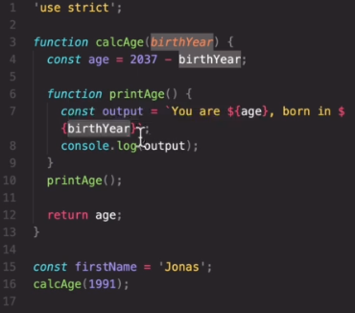Notice how the argument **birthYear** is accessible to the function printAge(), just like any other variable. This is what we mean when we say that function arguments behave just like normal variables and functions inside the scope-chain, and as such can be accessed/referenced the very same way.

### Variable-Lookup in practice

*Here we can again track the* ***variable-lookup*** *process for the “firstName” reference inside the printAge() function scope. The engine first tries to find “firstName” in the local scope (the variable environment), as it fails to find it in the local scope, it travels one level up to the parent scope of the* ***calcAge()*** *function. But because calAge() does not contain a “firstName” variable in its own local scope, the variable-lookup travels another level up to the global-scope. And in the global scope, we can see that there does indeed exist* ***const firstName = ‘jonas’;***

*Since it was indeed declared and initialized before the* ***calcAge()*** *function was* ***envoked.*** *(and remember, it’s the function call that is important, not the function declaration) The* ***variable-lookup*** *can indeed pickup the value from the firstName const in the global-scope, return it one level down to the local scope of the* ***calcAge()*** *function, and then one level down once more, to the local-scope of the* ***printAge()*** *function, to the location where our* ***variable-lookup*** *actually started.*

### Older Function-scoped Var (in context)

Notice the block scope of the if-clause. We have learned that block-scopes contain and separate from their parents any variable declared within them with the **let** or **const** keywords.

This means that **const str** is completely inaccessible to the parent function, as it is normally the case (the scope-chain not allowing acces to child elements to the parent).

But the variable **var millenial** declared in the block-scope of the if-clause is **function-scoped**, that is, it belongs to pre-modern javascript, so it does not recognize block-scopes. This means that **var millenial** is accessible throughout the entire printAge(){} **function-scope**. As can be seen highlighted in the screenshot to the left. Note that this is useful to know when working with older code where **var** declarations are still used. You yourself should only use **let** and **const** declaration.

### Function block-scoping when using ‘strict mode’ in javascript

What this means, as it is a pretty elaborate sub-title, is that, as we’ve seen with the way declared(var/const) variables are scoped inside blocks, the same rules apply for functions declared within a block-scope.

This means that were we to declare a function inside an **if(){block}** that function would not be accessible outside of that if(){block}. **Bear in mind that this is only the case in javascript ‘strict-mode’**

On the left we can see an example of this, where inside the if(){block-scope} a function “add(a,b){}” was declared.

If it would be called outside the block-scope in ‘strict-mode’, a reference error would be thrown. But in non-strict mode functions are not block-scoped, and as such, no error would occur.

### **How variable-lookup when there are identically-named variables within the scope chain**

When there are identically named variables or functions inside a scope, were we to reference a variable or a function for an operation(for example) ***the engine always checks the local-scope first.***  Before engagin **variable-lookup** to search for the reference one level up, to the parent scope, and so on until it finds the referenced variable (or alternatively, not finding it, returns an error).

This of course has a result of the closes identically-named variable or function being the first and only one to get fetched by the variable lookup(if the variable is not declared locally). And that is why in situations where we have two identically named elements, the closest one to the local-scope of the element reference is going to be returned by the **variable-lookup.**

function calcAge(*birthYear*) {

  const age = 2037 - birthYear;

**let firstName = "John";**

  console.log(firstName);

  function printAge() {

**let firstName = 'Shawn';**

**console.log(firstName);** //Prints 'Shawn'

    const output = `You are ${age}, born in ${birthYear}`;

  }

  printAge();

  return age;}

### **Redefining (overwriting) a parent-variable inside a child function/block-scope**

function printAge(*birthYear*) {

  let **output** = 'initial output';

  let passCondition = true;

  console.log(**output**);

  if (passCondition) {

**output** = 'New Output';

    //We are redefining the value of a variabl that exists outside of the block-scope

  }

  console.log(**output**);

}

const firstName = 'Jonas';

calcAge(1991);

Even though the scope of the **output** element belongs to the **printAge()** function, it was redefined in the block-scope of the if clause and so the redefined value remains.In other words when redefining a variable in any scope you are accessing the original memory-location of that element and overwriting the original value with a new one regardless of the scope it was accessed from, any proceeding reference to that same element(same memory location) will now hold the now information.

## **Hoisting and the TDZ**

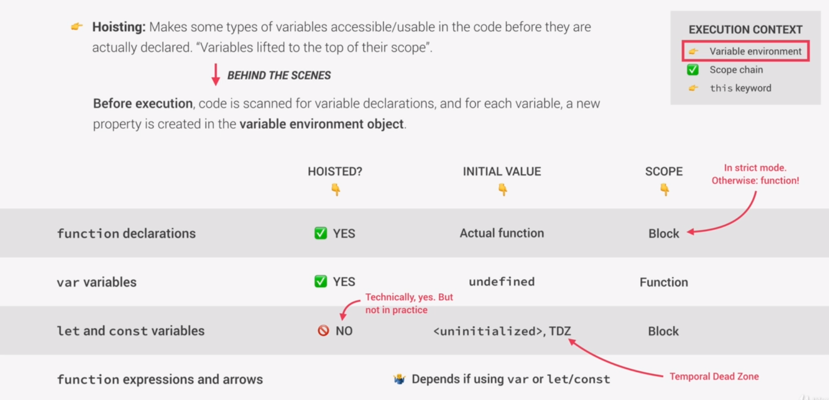

### Hoisting function-declarations

When the compiler reads and sorts our code inside the AST data structure, all function declarations have priorty, meaning that, since the code is compiled before it gets executed, all function declarations are actually already defined, irregardless of their position in the code as it gets executed in the run-time.

Their value after compilation is set to the value of the actual-function/(address of the code stored in the function, otherwise known as the function-name-reference-type). And their accessability scope is set to **block-scope**(if javascript is run in strict mode/otherwise it is function-scope)

### Hoisting **let** and **const** variable-declarations

We mentioned that all of the code gets compiled first, then ran. This must mean that naturally as the code is sorted in the AST data structure all variable declarations are hoisted and made recognizable by the program as well? Well..yes and no.

**Yes**… in the way that they are indeed hoisted.

**No**… in a way that making them hoisted would require them to be able to return a value, were they ever referenced before they are declared inside the actual run-time (as the program runs through the code) , so to combat that, they are hoisted with an “undefined value, but their “undefined” value is actually placed inside a temporal Dead Zone, which, if accessed just returns a reference error, making the variable **act** like it was not actually hoisted. ***This maintains the usual programming logic where we cannot reference an element value if it was not declared beforehand.***

### Hoisting function-expressions

Function expressions(function declarations assigned to variables) and arrow functions behave in exactly the same way as variables do, and the way they are **hoisted** depends on whether they were declared using **var, let, const** declaration statements, behaving according to the **hoisting behavior** of ther respective declaration statement.

This is why we cannot use arrow functions or function expressions in the code, before they are actually declared.

### **The Temporal Dead Zone(TDZ)**

Each and every **let** and **const** variable get their own **temporal-dead-zone,** that starts at the beginning of the scope and extends all the way until the line when the variable is first initialized. After that line (after the end of the **temporal-dead-zone**) the variable is safe to use, as it has been initialized.

Note that The javascript engine has already compiled the entire code before runing it, that means that it contains in its AST tree, declarations for all variables and functions that exist within the scope of the program. This means that were we to attempt to use a variable before it was initialized, the program will **KNOW** that the variable first of all (EXISTS), second, that it WILL BE INITIALIZED EVENTUALLY. Because it already compiled the code, and it has it’s initialization data stored in it’s AST variable-property. But it does not allow the value to be set, before the program passes through the code itself, and in the case that the variable and it’s value is used before it is initialized, it is set to throw an error, stoping this illegal move.

This is how the engine stops the user from accessing files and values before they are initialized in the program, even though all of the declared variables have been hoisted and assigned an “undefined” value within the AST, when the javascript engine compiled the entire program before running it.

In other words, this is how Javascript simulates the behavior of an interpreter (compiling and running code line by line), while actually being a **just-in-time-compiled**  language that compiles everything first then runs the code.

It artificially block off access to variables that are used before being defined, even though it does technically allready know exist and store “undefined” value a, seeing how all function and variable declarations are automatically hoisted upon compilation.

#### Why does the TDZ exist?

**The main reason:** Accessing variables before declaration (accessing their “undefined” values) is bad practice and should be avoided. (apparently it is the cause of many bugs and developer heartache), and the best way to avoid it is by simply throwing an error whenever we attempt to do so.

**The less imporant reason:**Makes const variables impossible to use or assign a new value to before and after declaration

***To completely remove a temporal dead zone from a scope, you would simply declare and initialize a variable in the same line, using zero or an empty string, and this would eliminate the posibilty of creating an error, and at worst result in simply a bad output/calculation.***

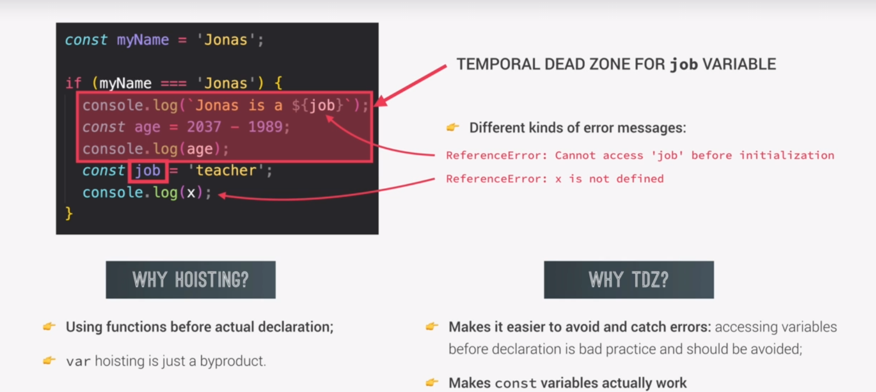

***If hoisting was so troublesome and had to have ways to ameliorate the issues it causes why was it done in the first place?***

Hoisting was first introduced in order to allow for recursive function calls, and to allow the program to call other functions within it,before having to arrive to the line of code where they were declared. This essentially allows any one function to use multitude, or literally all other functions in the program, without having to place it as the last function declaration, as well as allowing the first function to be able to envoke, within its body, the last declared function. This simply allows much more easier programming.

The reason why var-variables are hoisted, is because the only way functions were able to be hoisted was to use the built in behavior that controls the way var-variables work. If you wanted to hoist a funciton, you had to hoist all the **var** declared variables as well. It was simply impossible to divide the two functionalities at the time hoisting was being engineered. Since this was now a feature, the developers set a default value assignment to hoisted var variables to “undefined”, and this solved some problems, but introduced a myriad of other bugs and javascript jank for a lack of a better word.

Since Javascipt follows the rule of never deleting any features of its code (so that literally millions of websites and data doesn’t crash) this var behavior that came up as a byproduct of hositing functions, remains and cannot be changed. And unfortunaltely javascript was never expected to become this ubiquoutus, some of it’s features were intially janky and not at all future-proof. This is indeed one of the reasons **let** and **const**  have been introduced, in order to circumvent the problem, since it cannot be fixed.

# Hoisting and TDZ in practice

'use strict';

//variables

//trying to use the variables before they are defined

console.log(me); //Output: undefined

console.log(job); //reference error

console.log(year); //reference error

var me = 'Jonas';

let job = 'teacher';

let year = 1991;

//functions

//tryin to access functions before they are defined

console.log(addDeclaration(2, 3)); //returns 5. It works!

//calling a function declaration before it was defined is allowed

//THE ONLY FUNCTION THAT CAN BE USED BEFORE BEIGN DECLARED IS A DECLARED-FUNCTION

console.log(addExpression(2, 3)); //error

console.log(addArrow(2, 3)); // error

//const/let arrow-functions and function-expressions

//throw a "tried to use a variable before initialization" error whenever they

//are envoked before their declaration, just like any other let or const would.

console.log(addVarArrow(2, 3)); //undefined is not a function error

//Calling a var arrow or expression before its declaration,

//being a VAR it is hoisted and its value is set as to an

// "undefined" value. This means that it works in the same way as if we were

// writing the following: "undefined(2,3);""

function addDeclaration(*a*, *b*) {

  return a + b;

}

const addExpression = function (*a*, *b*) {

  return a + b;

};

const addArrow = (*a*, *b*) => a + b;

var addVarArrow = (*a*, *b*) => a + b;

'use strict';

if (!numProducts) {

  deleteShopingCart();

}

var numProducts = 10;

function deleteShoppingCart() {

  console.log('Deleted all products');

}

### //HOISTING CAUSING A PROBLEM WITHOUT GENERATING A VISIBLE ERROR

//In the code above we can see that the if clause is using

// the 'numProducts' variable before it has been declared

//but seeing how it is a 'var'declared variable this means

//that using it before its declaration will not generate an error

//but will simply reference the hoisted variable with the value

// of "undefined"

//"undefined" being a falsy value

if (!numProducts) {

  deleteShopingCart();

}

//will make this line of code always true because

// undefined === false

//if(!undefined) <--> if(!false) <--> if(true)

//this in turn means that this if clause condition will always

//result "true", and whatever the numProducts actual intialized

//value was supposed to be, the deleteShopingCart() will, always run

//and funilly enough, always delete the shopping cart until this problem is

//fixed by moving the declaration and intialization of the

// "numProduct" variable above the if clause

//The code below will work as intended.

var numProducts = 10;

//variable reference

if (!numProducts) {

  //function reference(call)

  deleteShopingCart();

}

//function declaration

function deleteShoppingCart() {

  console.log('Deleted all products');

}

The problem from the previous example is really important because an error is not being generated. This will make the bug it creates very difficult to find. To combat this, programmers and developers need to stick to using **javascript coding best practices** as a preventative measure when writing their program.

### Javascript coding best practices

1. **Don’t use Var (when declaring variables)**
2. **Use “const” most of the time, when declaring variables**
3. **And use “let” if you really need to change the variable later**
4. **Declare your variables at the top of each scope (to write a clean and easy to read code, as well as circumvent the problem of using variables before they are defined)**
5. 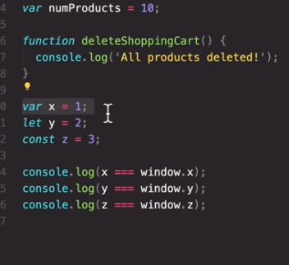**Always declare all your functions first, and use them only after their declarations**

Final note of the topic:

Variables declared with the **var** keyword are stored inside the global-window object property, or differently said: they exist inside the window global object.

While **let, const** declared variables do not exist in the window-global object.

## The “this” keyword.

**The “this” keyord/variable:** is a special variable that is created for every execution context. It takes the value of(points towards) the “owner” of the function in which “this” keyword is used

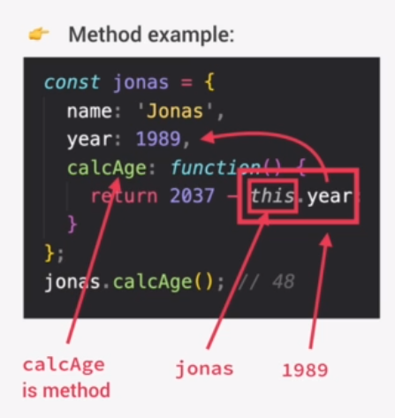“**this” variable is NOT static:** Its value depends on the execution context it is called in, and changes from context to context respectivelly;

**Simple function call(functions** unassigned to objects): In “strict” mode, “this” is undefined (does not get a reference to an object or method) when calling regular declared functions in an execution context, so using ***this.functioncall();*** would be like writing *undefined.functioncall();*. Outside of “strict-mode” **this.functionCall();** would reference the window global object, an in turn be the same as if writing **window.functionCall();**

**Method call:**  As for calling methods(functions inside an object), inside the object definition(scope) “this” keyword references the object itself. Like in the image to the left **this.year== jonas.year**

**Arrow functions do not get a “this” variable**

If we were to use an arrow function inside an object or another method, the “this” would simply reference the owner object of said arrow function, and not actually belong to the execution context of the arrow function itself.

**Event listener**s: The “this” keyword inside the execution context of an event listener takes up the the reference value of (points to) the <html> element that the event listener handle is attached to. And in that sense:

**header_handle.AddEventListener(‘click’, function()**

**{this.textContent === header_handle.textContent} );**

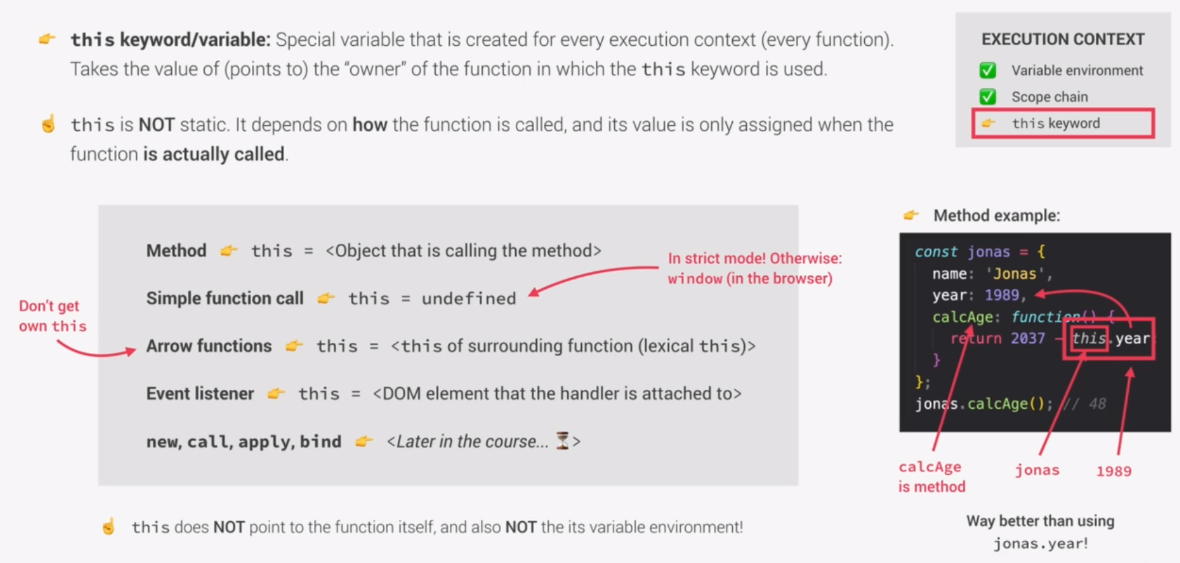

**What the THIS keyword does not do:**

It does not and cannot point to a function itself (only parent objects) **htmlHandles, objects** when calling their methods within an object/class body**, global-window-object** when envoking a normally declared function in the main/global execution context in (non-strict-mode)

const jonas = {

  year: 1991,

  calcAge: function () {

    console.log(this); //this ===jonas (the object)

    console.log(2037 - this.year); //2037 – parentObject.year //2037 – 1991

//2037 – 1991 if johas calls the method

//2037 – 2017 if matilda calls the method

  },

};

jonas.calcAge(); //prints (jonas) object reference

const matilda = {

  year: 2017,

};

matilda.calcAge = jonas.calcAge; **//Method Borrowing**

jonas.calcAge(); // prints **46** (2037 – 1991)

matilda.calcAge(); // prints **20** (2037 – 2017)

## THIS as a CLASS REFERENCE not an OBJECT reference

//Note that "THIS" **does not reference just the one object it exists inside**

// it references any **object** that calls it, belonging to the class, it is created in

//But the object that envokes the "Object class", which means that it points to //whichever object of the class that uses the “THIS” keyword in a class-method, for //example. **So THIS keyword always points to the object that is calling the method.**

jonas.calcAge(); //prints (jonas) object reference

const matilda = {

  year: 2017,

};

## Method Borrowing

matilda.calcAge = jonas.calcAge;

matilda.calcAge(); //

//since functions are just values, we can actually assign a function

// to be a method, to another object, as long as the object attributes/methods

//list ends with a colon(,).

//Here we see that matilda was created without a method, and after assigning

// the object a method/function value, using a dot(.)notation to set

//the new method value for the object, allows us to create declare and initialize

// a new method inside an object, from the outside.

Above we can see that **matilda.calcAge** is in a sence the method definition, while **=johnas.calcAge;**  is the initialization of said method. (the body of the calcAge method from johnas, was copied to the body of calcAge of the object matilda.

Note that we could have called the new method for matilda anything, like **matilda.newMethod = johnas.calcAge**; and this would have created a new method inside the object of matilda called, new method. That would have the body of the calcAge method from johnas.

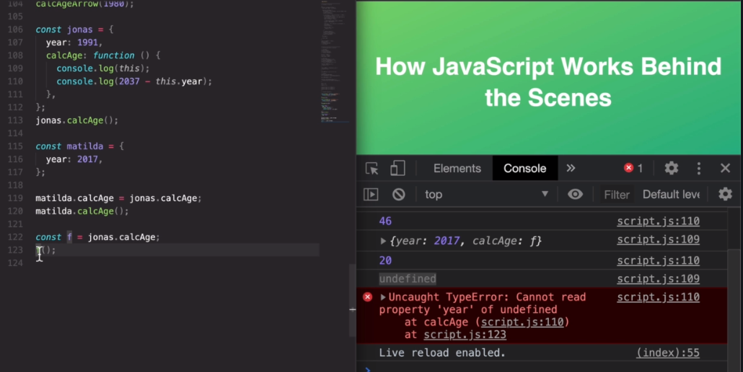

Above, we’ve assigned the calcAge method of object **jonas** to a function **f** using a function expression to declare **f.** Now since the THIS keyword of the calcAge() method defined in **jonas** references the parent element that envokes the method. If we are to envoke the function **f** (now containing the same body of the method **jonas.calcAge()** including the THIS keyword as used in it) To what object will the THIS keyword point inside the function if it is envoked using a normal function **F** defined in a function expression?

Well, since THIS points to the parent object that is envoking it, envoking **f();**  meants that this keyword looks for the first parent object. Since **f();** is a normal function and not a metod it does not have a parent attached to it. So this is in fact the same function **jonas.calcAge(),** just used without an object.

So, in the case of envoking **f()** in the globalExecutionContext, the THIS inside the function looks for an implicit object that called it. But not being able to find one, THIS gets hoisted with the value of **undefined.** So what happens in the function is the following

() {

return (2037 - this.year); //this not having a reference object becomes ‘undefined’

  },

//So return (2037 - undefined.year);

//and this returns the error Cannot read property year of undefined at calcAge.

# A function is just a value (WHAT DOES IT MEAN?)

When this is said, it does not mean that the function represents its return value, it literaly means that the function body is just a value, the function {body} definition is what is contained in the function as a value. S

If we had a function return age

const jonas = {

  year: 1991,

  calcAge: function () {

    return (2037 - this.year); //17

  },

};

And we wanted to create another function with this body (essentially we want to copy a function)

We would do the following

const myFunctionCopy = jonas.calcAge;

This would not store the function returnn value of 17 inside the **const**. Because to do that we would need to envoke/call the function when assigning it to the const

myFunctionCopy = jonas.calcAge();

Writing just the method/function name, actualy assigns the body of one function/method to another.

So writing const myFunctionCopy = jonas.calcAge;//without envoking() calcAge

would actually take the body of the function(in this case, the body of the method) :

{

  year: 1991,

  calcAge: function () {

    return (2037 - this.year); //17

  }

And place that body (entirely) inside the const myFunctionCopy.

And this is what const myFunctionCopy = jonas.calcAge; looks like to the compiler:

const myFunctionCopy =  function() {

  year: 1991,

  calcAge: function () {

    return (2037 - this.year); //17

  }

## Regular functions vs Arrow function

-NEVER EVER USE AN ARROW FUNCTION AS A METHOD

#### Common (THIS)keyword error when nesting functions inside of methods

**Error caused by envoking a function that uses (this.) within an object method expecting that THIS will reference the object, and it instead references the value of “UNDEFINED”**

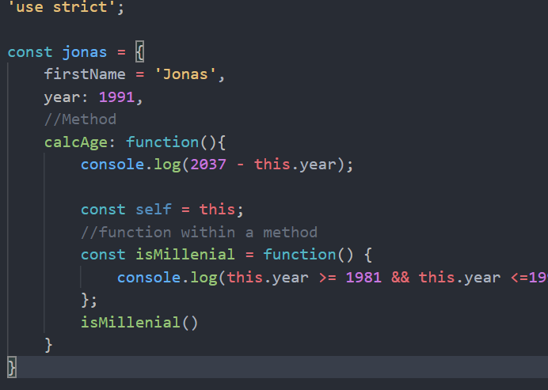Below we can see a function call **isMillenial()**

Unfortunately when we try to execute the function, an error is created at the line where our function 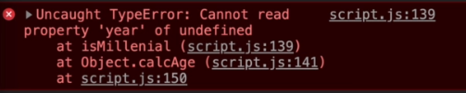**isMillenial()** references the THIS keyword.

Why did this error happen? Well, basically we already learned that a normal declared function, has an undefined THIS variable, this means that if we access THIS inside our normal **calcAge() {function body}** it will actually fetch THIS variable locally (inside itself), and not fetch the THIS variable from the object-literal’s method.

But the error happened when a function that is declared inside

**calcAge(){/*function body*/… isMillenial(){… this.year} }**

Normally all functions declared inside objects are METHODS, and method THIS keyword always references the Method object. But sometimes our methods need functions of their own, and those functions that are declared as normal functions (function expression or function declaration) have their own THIS keyword values, and they are set to “UNDEFINED”. This means that using THIS inside a function that exists inside of an object METHOD, will result in it not referencing the object, but the undefined value of the local function. IN this case, the THIS of isMillenial() function, is a new THIS variable, created by the very same isMillenial() function, and for this reason, it does not have acces to (since the variable lookup does not have to be engaged) the THIS variable of the parent element scope, that would normally fetch the reference to said parent element.

All of this means that our THIS reference inside isMillenial function will return a local value of this, that is for normal function declarations or expressions, as a rule set to: ‘undefined’

const isMillenial = function(){

//on declaration it implicitly creates and initializes local THIS = undefined;

console.log(undefined.year >= 1981 && undefined.year <=…

};

This is a Bug, or at least a problem with the way THIS rules work in JAVASCRIPT, and there are two solutions in which we can give access to the THIS variable of the OBJECT_METHOD, inside the METHOD_NESTED_FUNCTION.

For the solutions and problem to make sense, we have to remember the rules for the THIS keyword, as it applies to simpleFunctions, and arrow functions

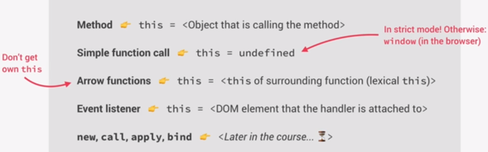

**Problem/solution 1;**

As we can see Simple functions (declarations or expressions) have their onw THIS with the value of ‘undefined’. That is why THOSE THIS values are used whenever we call these simple functions inside a method. To combat this, we will have to store the value of THIS variable in a constant, usually called (self/that), that we can use to pass to the function the value of the METHOD-this, without having to use the keyword, which would result the method-this, being overwritten by the local-function-this (“undefined”)

**Problem/Solution 2:**

Alternatively, inside the method we can just nest an arrow function that does not even generate it’s own THIS variable value, and instead borrows the THIS value of the parent element (method in this case). If this doesn’t seem like a simple and clean solution I don’t know what is… It almost seems to be a built in solution to solve this very problem, no? =3

## **Passing a function as a CallbackFunction argument in Javascript**

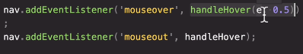Note how callbackFunctions for methods (eListeners, forEach, etc..) expect a function definition to be passed as an argument, not a function value. If we pass them a function call, what we are really giving as the argument is the **return value of the envoked function**. And that is not what the argument is for. It expects a function definition, which, as we know, is stored inside the function name/without the envoking braces()

Always keep this in mind. A function call returns the returned value of a function, and not the function body itself. While the function-name, returns the actual body of the function definition, and in that essence, the only way to pass a function as an argument is to pass the function-name

#### SOLUTION 1 Passing the value of THIS through another variable (Old solution)

What we need to do in order to create access to the THIS variable value of the object within the function that existsi insde the object method, is to declare a separate constant inside the object-method, that will take the value of THIS as it exists in the function method(to remember, THIS inside the method, references the object that envokes said method)

const jonas = {

    firstName = 'Jonas',

    year: 1991,

    //Method

    calcAge: function(){

        console.log(2037 - this.year);

        const self = this; //called: (self/that)

        //function within a method

        const isMillenial = function() {

            console.log(self.year >= 1981 && self.year <=1996);

        };

        isMillenial()

    }

}

As can be seen here, **self** contains the value of THIS, as it grabs the value of THIS within the scope of the method calcAge(), (Remember THIS inside a method scope always references the method’s object itself)

-Then we pass **self**  to the function **isMillenial()** declared inside the method, and now **self** will work in the way, we intially expected **This** to work our function nested inside a method.

-Note. The **isMillenial** function has access to **self** because of scope-chaining, as it has access to all of the variable environments of all of its parent elements.

### Solution2: Using an Arrow function whenever we need to nest a function inside an object method.

**-Arrow functions inherit the THIS keyword from their parent element**

'use strict';

const jonas = {

    firstName = 'Jonas',

    year: 1991,

    //Method

    calcAge: function(){

        console.log(2037 - this.year);

        const self = this;

        //function within a method

        const isMillenial = () => {

            console.log(this.year >= 1981 && this.year <=1996);

        };

        isMillenial()

    }

}

Since the arrow function does not overwrite the value of the THIS variable with within its scope, but rather take the THIS value from its parent element, we can safely reference the THIS inside the isMillenial()=> arrow function, confident that it will indeed be the same value from the parent method();

## The ARGUMENTS keyword

-Arguments keyword is only available to normal functions(declarations or expressions)

-THE ARGUMENTS keyword IS NOT AVAILABLE IN ARROW FUNCTIONS

//arguments keyword

const addExpr = function (*a*, *b*) {

  if (arguments.length > 2) {

    let sum = 0;

    for (let i = 0; i < arguments.length; i++) sum += arguments[i];

    return sum;

  } else {

    return a + b;

  }

};

console.log(addExpr1(2, 5));

//notice that it is completely legal to add more

//arguments in the function call, than there were

//specified function parameters during declaration

console.log(addExpr1(2, 5, 10, 12));

//Note that only arguments 2 and 5 will be named (a, b)

//The other passed arguments will be stored as values

// in inside the normal-function built-in arguments-array

## Primitives VS Objects(reference types)

-primitives(numbers, strings, booleans, etc…)

-referenceTypes(adresses that point towards a value or structure inside memory) 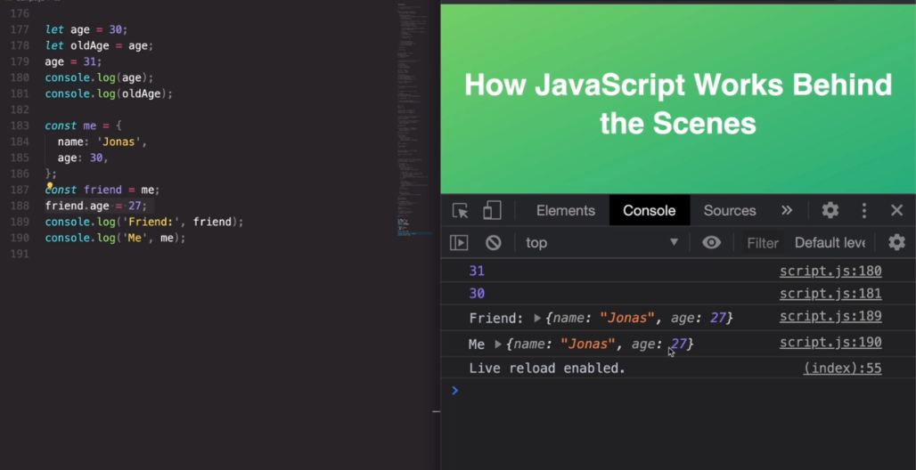

Lets try to answer the question of why when changing the friend’s age, is the age of the me object also changed to 27…

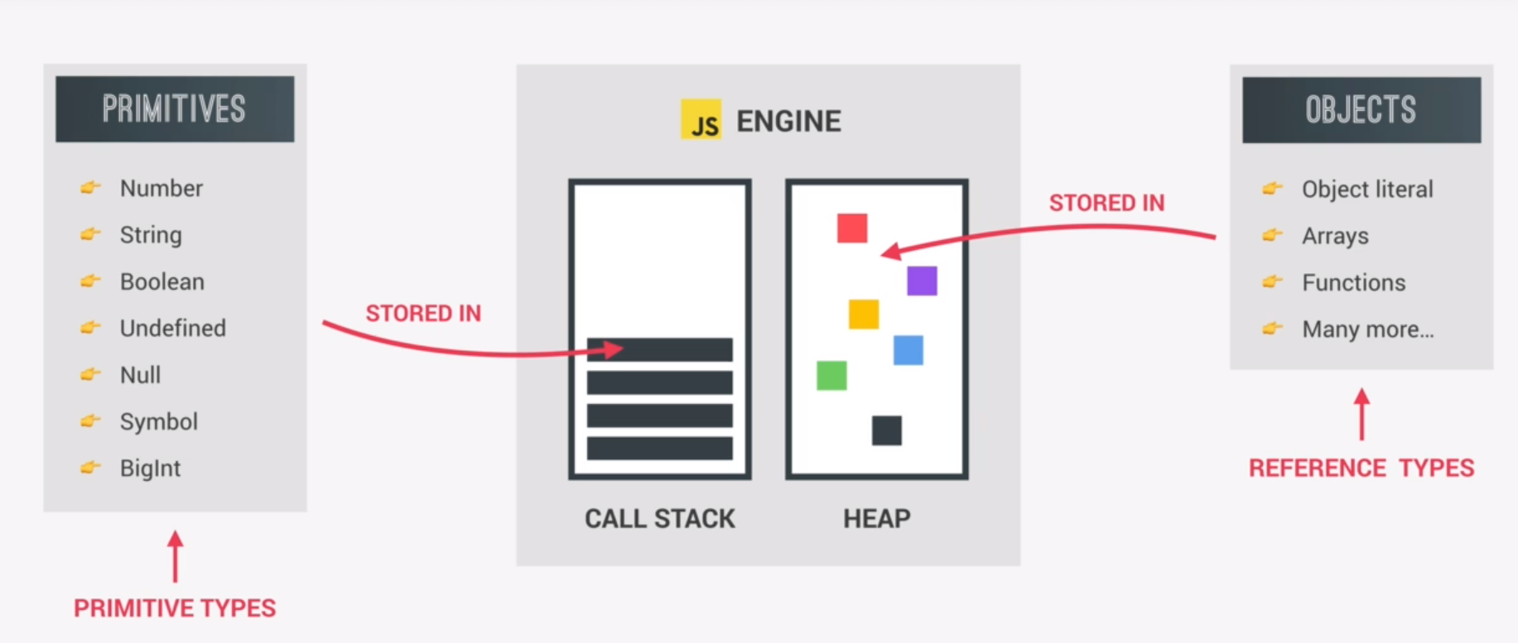

### How primitive variables work

What variable names actually store

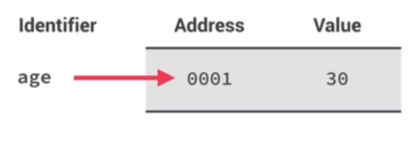The variable name, does not in fact contain the data of the variable, but the name contains the address(references the address) of the memory location where the value is stored. So in the example we have here **age** that has a value of 30. But in literal termes the variable age, containst not the value, but the address where the value 30 is stored.

let age = 30;

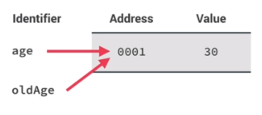let oldAge = age;

**Assigning one variable to another**

What happens here, is that it wasn’t the value of one variable copied and overwritten on the memory location of the other variable

What actually happens in cases like this is that, actually the adresses are shared. And so in this line of code

**let oldAge = age;**

Both variable names point to the same memory adress.

**What happens when out of the two variables that share an adress one gets redefined with a new value?**

let age = 30;

let oldAge = age;

age = 31;

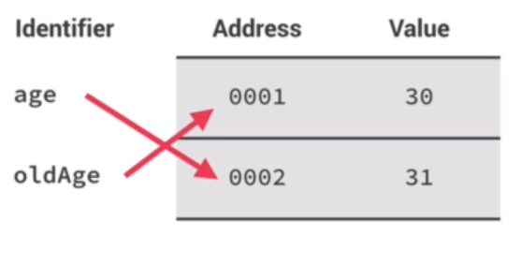Since allocated memory locations cannot be overwritten by new data, unless they are deallocated, then prepared to be used again by a new variable by the engine.

This means that the assignment of a new value age = 31;

Does not simply change the value of age in the address 0001, but in fact the variable switches to a new adress (points to a new available address) and places in it the newly assigned value.This in practice means that as far as memory is concerned, overwriting data inside an already allocated memory location within the call-stack is not possible. Any new value assignment will instead require for a new location to be set and used for storing the value, making the variable itself now point to a completely different address, than it did for the previous value it contained.

## How object(reference) types work

Why are objects stored on the heap and not on the stack?

Objects can be to large to be stored on the stack, hence stop our program from getting executed, but having it stored passively inside the almost unlimited HEAP memory, allows the value to be used only as necessary, and not take up too much space on the stack.

What really happens when we declare an object is the following:

1. **A variable with the object name is created on the call-stack**, it’s name pointing to an address in the stack memory of the variable itself, while the value stored on that address is not an object but instead, it is another address, this for a memory location inside the HEAP memory
2. 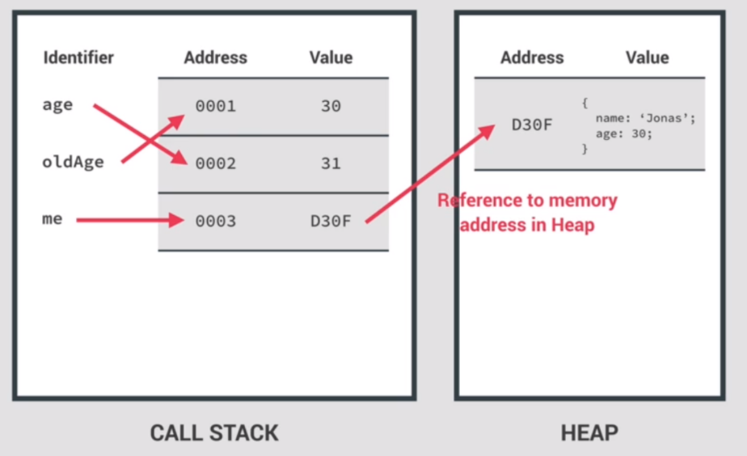**Inside that address on the heap memory, the actual object gets created** and it’s properties and values stored in various places of the heap, whereby each property is connected not as an array, one next to each other (in the heap) but in random locations, where each property of the object remembers the address of the next property. (you learned this in ITS).

The fact that the value of the HEAP address is stored inside the call-stack object name is particularly interesting. Because these variables/constants contain addresses in their value to a HEAP mem-location(Reference) of an object, and not a primitive type of value, is what makes these elements called **reference types.**

**Assigning one reference-type variable to another**

What happens when we do this is that both variables, now point to the same stack address where the object-address is stored just like it is the case when assigning one variable to another with primitive types.

**Changing the value of an object that has two call-stack reference variables assigned to it:**

If we have two reference-type variables assigned one to the other, that meanst that we have two variables pointing to the same address on the call stack, that address on the callstack contains the value of the HEAP address of the single **object** created on the heap.

This essentially means, that we have **two call-stack variables** **with which we can change a single object on the HEAP.**

Which one we use, to change a property value of an object is not important, because they both essentially reference and manipulate a single persistent object on the heap.

**How is it that we can change objects if their reference variable is always CONST.**

As a rule, when creating objects we tend to use the declarative CONST keyword. We would do this for all persistent data, and objects are just that, persistent data. But unlike primitive variable types, to objects we normally assign new values (new property values) no problem, how does this work if they are a constant?

Well the answer is pretty obvious. The address of the object, ie: the reference-type variable that points to the object and is created on the call-stack does not change its value/heapAddress when we assign new values to it. The address to the object on the heap is the CONSTANT. But the heap-object itself, is not, and it is the object that is being changed or redefined, and not the constant variable that stores the address to said object.

So, it makes sense that we can redefine object-property values through a reference-type **constant .**

**ONLY CONSTANTS WITH PRIMITIVE VALUES STORED ARE IMMUTABLE**

**WHEN REFERENCE TYPES ARE STORED IN A CONSTANT, ITS “REAL” VALUE AS IT STANDS ON THE HEAP CAN BE REDEFINED (arrays,objects…)**

The big takeaway:

Whenever we think we are copying a variable of an object, we are actually just pointing the new variable , where we want to copy our reference variable to, to the same object.

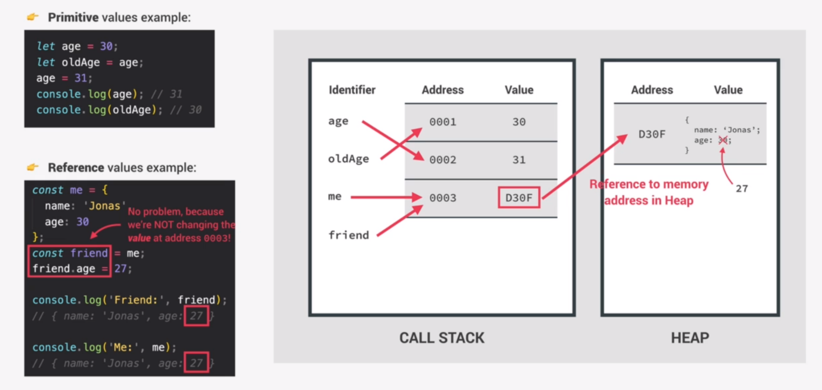

### Primitives vs Objects in practice

//Changing the reference-type constant

marriedJessica.lastName = 'Davis'; //changing the object is allowed

marriedJessica = {/*new object address*/};//NOT ALLOWED

### Copying the actual object from one object to another

//The way of actually copying the object itself

//and not just the object-address(reference)

const jessicaCopy = Object.assign(),

  jessica2;

//This will now be a completely different object from jessica2 on the HEAP

//And the newly created object  will copy  the exact

// parameters and their values of jessica2

//The main difference here is that, redefining a parameter

//in 'jessica2' will not affect in any way, the object

//  'jessicaCopy'. (it will remain unchanged), they are now

//copies, but completely separate objects unattached to each other

The problem with this approach is that Object.assign(); method only works on one-level. Meaning that, if an object we are trying to copy has another object for a property (an object inside the object), a new copy of that nested-object will not, in fact. Be created. That object, will in the object-copy remain as a reference-copy, to the same heap-object , for both the original and the copied object.

**Object1{nestedObject}.**

**Const Object2 = Object.assign(), Object1; //This is a shallow copy, and not deep-clone**

Object2 and Object1 are now different objects on the heap, but they both hold the address to the same **single-object** {**nestedObject**} on the heap. So any changes made to the nested object by Object1 or Object2 will in fact be made to the very same ‘nestedObject’ on the heap. Even though Object1 and Object2 are different objects on the heap. They share the same reference for the nested object as one of their properties. (hope this makes sense)

*Note that the same rules apply to Arrays, because arrays are actually Objects behind the scenes*

# **ADVANCED DOM AND EVENTS**

## How the Dom works behind the scenes:

-The DOM is a very complex API(AplicationProgrammingInterface), meaning it contains a ton of methods and properties we use to access the webpage from javascript

-Dom contains many various NODES. Some NODES are html elements, and others are just text

.

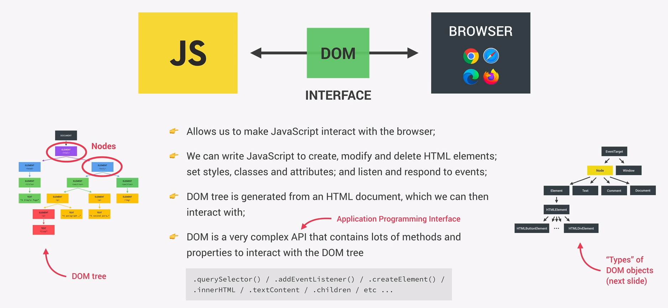

-Every single NODE in the DOM tree is a NODE-datatype

-A Node(parent)type, has different subtypes(children) types (ELEMENT,TEXT,COMMENT,DOCUMENT).

There is a rule that a NODE structure follows: **Everything that goes into html has to go into the DOM as well.** Which is why we have all of these various subtypes

### Document (class-object)

The DOCUMENT object is in fact just another node type, and it is a child in the NODE tree, of the NODE parent-class. It contains the querySelector() method, and other methods that we are used to using in the DOM. But notice how querySelector(); is also avaliable to the ELEMENT child class of the NODE parent-class. This means that the **querySelector()** method is in fact inherited from their common general-class parent, **NODE,** and ELEMENT as well as DOCUMENT specializations, contain all of their parent attributes and methods as per the usualy (Object Oriented Programming hierarchy paradigm)

### EventTarget

**EventTarget** Is the highest ranking abstract-class in the NODE TREE, a parent Both to the Abstract-**Node**-Type and to the Global-**Window**. Meaning that its methods, addEventListener(); for example, can be placed ony any element in the dom,tree or any element belonging to the global-window-object.

### Representations of different NODES, behind the scenes, in the DOM API

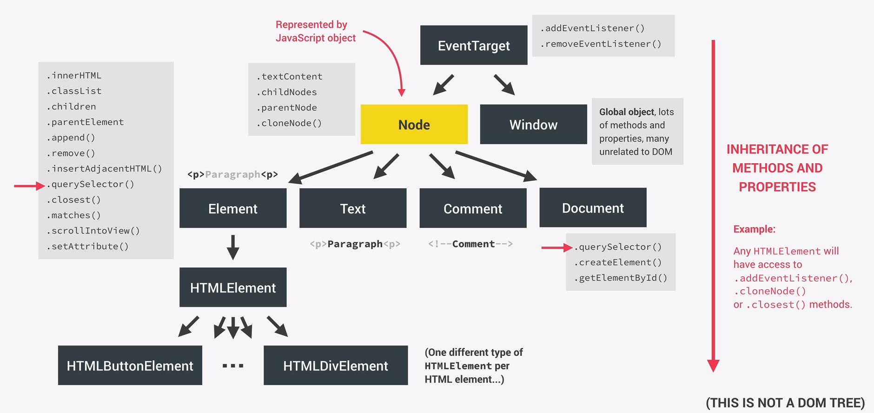

## HTMLElement NODE

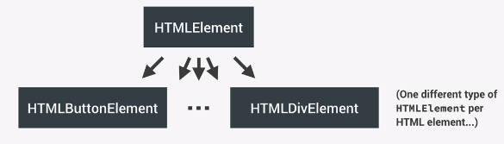

Each HTMLElement type has One subtipe for every single different html element that exists. What this means is, that HTMLElement can be treated as global-abstract-classrepresenting all html types, while its subtipes represent specializations for the actuall html objects that can be created, and their various attributes, and values need to represent their corresponding <html tag> element.

**To visualize:** HTMLElement is (Vehicle-class ) HTMLElement-Child is (Car, Boat, Plane, motorcycle… - subclass)

## **QUICK DOM METHOD REFERENCES**

(Very difficult to find and understand from MDN documentation)

## **///////////SELECT METHODS ////////////////**

#### //The method for selecting the ACTUAL Document-object/the :ROOT:ELEMENT

console.log(document.documentElement);//returns :**root**{}

#### //The HEAD and BODY elements don't require a query selector

//Selecting the 'head' object

console.log(document.head);

//Selecting the 'body' object

console.log(document.body);

#### //querySelector(method-argument)

//Returns the first element within the method-object's scope

//in this case the method object is (document.)//so within the document

document.querySelector("h1"); //Returns the first h1 element

document.querySelector(".header"); //Returns the first element with a "header"class"

#### //querySelectorAll(method-argument);

//Returns a node-list of all elements

//that correspond to the passed method argument

const allSections = document.querySelectorAll(".section");

console.log(allSections); //logs **Node-list**

### //NodeList//

Is a static collection of elements that only represents the values(elements) from the html at the time the collection was accessed and stored in a variable.

If we were to, for example const h2NodeList = querySelectorAll(‘h2”); elements, and after storing the nodeList in the constant, delete all h2 elements inside our html, the nodeList would still have those stored elements in it, even though they no longer exist in our html-file.

The same Is absolutely not the case with HTMLCollection, which automatically updates to keep track of the elements that are currently placed inside our html-file.

#### //getElement- methods (In case you need a live HTMLCollectiion)

document.getElementById("section1");

const allButtons = document.getElementsByTagName("button");

console.log(allButtons); //logs **HTMLCollection**

document.getElementsByClassName("btn"); //returns a live HTMLCollection

### //HTMLCollection//

//It is a live collection of elements that

//**updates automatically** every time the DOM changes

//That means that it is actually a live representation

//of the elements belonging to a certain tag, as they

//are currently present in the DOM.(it updates persitently)

//That is why we have to first pass it to Array.from(); method

//to create a static Array, out of the HTMLCollection

// in order to be able to use the Array methods and process

// the values within it in certain ways that are not normally

//accessably to the HTMLCollection, because of its live-update

//property.

///////////CREATING AND INSERTING A DOM ELEMENT/////////////////

//Creating and initializing a full DOM object locally

//Then inserting it into the HTML

const message = document.createElement("div"); //Creates a <div> Dom-object

//locally creates a (div element) and stores it in the constant

//That (div element) now behaves just like any other DOM element

//that we would normaly use querySelector(); to create. (USE IT LIKE A HANDLE)

message.classList.add("cookie-message");

message.textContent = "We use cookies for improved functionality";

message.innerHTML = "<button class='btn btn--close-cookie'>Got it!</button>";

const header_handle = document.querySelector(".header");

//Next we insert our (message)DOM-object into our html header-class element

header_handle.prepend(message); //Prepend sets 'message'to be the first child

header_handle.append(message); //makes our dom-object the last child of the html element

//IMPORTANT NOTE: This DOM-object "message" when it gets inserted

//into the html becomes a live HTMLElement.That means that when we

//refer to it multiple times, it always references just the one 'message'-object

//within the html

//That means that, first we would have our element placed inside the html

// as the first child element (prepend)

header_handle.prepend(message);

header_handle.append(message);

//then the same element would not get copied, but would instead be moved

//to the bottom as the last child element, once we reference it again

//using the (append) method

//To remember, if a local DOM-object is inserted into an html

//it becomes a persistent object, and .append .preppend, methods

//will not make duplicates, but instead just move the object around

//the html document

//CLONING existing DOM-Objects inside the html

//If we were to want to have two message (dom objects)

//one as the first and the other as the last child

//within the <header class="header"> html element

//We would have to copy the original (message-object):

header_handle.append(message.cloneNode(true));

//.cloneNode(CopyAllObjectChildElements?)

//if you create an object using .cloneNode(true)

//it will also copy all of the child elements

//within the element you are copying.

//////////////**Deleting Elements**/////////////

////**the new .remove(); method**

document

  .querySelector(".btn--close-cookie")

  .addEventListener("click", function () {

    message.remove();

    //we can either remove the object from the javascript

    //And it will automatically (being a live HTML object)

    //be removed from the html document

    document.querySelector(".cookie-message").remove();

    //or we can search the DOM for

    // the class initialized the object with, and delete it

    //not in the javascript file, but only in the DOM

  });

////**THE OLD .removeChild('childName'); ,method**

//This remove(); method is actually a very new addition to the

//Javascript.  Before, you could only use the .removeChild(); method

//And this is how it would work:

//with the DOM-Object

message.parentElement.removeChild(message);

//with the html element handle

const cookieMessage = document.querySelector(".cookie-message");

cookieMessage.parentElement.removeChild(cookieMessage);

//Funny, right? We first target the node, then we get their parent

//so we would have access to the node itself as a child-element

// and then insert the name of the node handle that accessed it's parent

//into the parent's removeChild() method.

//It works like this basically

// extraChild.parentElement.removeChild(extraChild), or

// removeMe.parentElement.removeChild(removeMe);

### **Alternative way of selecting the first element from an array**

const [entry] = entries; //same as writing entries[0];

//////////////////**Applying Styles**/////////////////////////

const message_handle = document.querySelector(".cookie-message");

message_handle.style.backgroundColor = "#37383d";

message.style.backgroundColor = "#37383d";

//Notice how the (message) object acts just like an html handle

//It is cause they are both recognized as DOM elements

//Getting/reading the html style properties

//Notice that we can only read the inline styles

//that we have already set inside the HTML element

message.style.color;

message.style.width;

//the above will return a value only if the properties

//already have an inline value for color and width

//The way to get the default(user agent) set css properties

//for the message html element (DOM object)

getComputedStyle(message_handle).height; //returns a string

//example output '42.555px'

//If we were to want to use the returned value as a number

//we would have to convert the string into a Number

//and find a way to delete the last two non-number characters 'px'

//The Number.parseFloat(); method//

//converts string numbers into numbers and ignores

//any character codes for non-number characters

//(forgets/deletes strings)but keeps the numbers

console.log(getComputedStyle(message_handle).height);

let message_height = Number.parseFloat(getComputedStyle(message_handle).height);

message_height = message_height + 100; //to prove it is now a number type

console.log(

  "Converted to number and added by 100: " + message_height + "pixels"

);

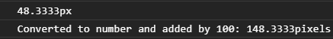

//above is the output of getComputedStyle, and bellow is after the nuumber output after conversion to a number and the operation of addition having been successfully done with it.

### Working with css custom properties/css-variables

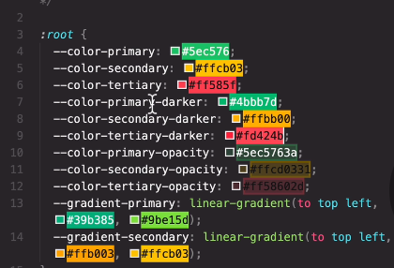

//.style.setProperty('cssVarName', 'desiredNewValue');

document.documentElement.style.setProperty("--color-primary", "orange");

//Assessing html attributes (alt, href, src, placehodler, etc...)

const logo_handle = document.querySelector(".nav__logo"); //<img class="nav__logo">

console.log(logo.alt);

console.log(logo.any);

console.log(logo.designer);

console.log(logo_handle.className); //returns the value of <img class = "class_name">

//so it is logo_handle.className not logo_handle.class that returns the class name

//for non default/user created attributes

console.log(logo_handle.getAttribute("attributeName"));

console.log(logo_handle.setAttribute("MyCustomAttribute", "attribute_value"));

#### //getting absolute or relative addresses from your href/src attributes

console.log(logo.src); //returns the absolute address

console.log(logo_handle.getAttribute("src")); // relative addres

//While the .getAttribute(); method, returns the relative address

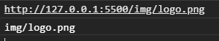We can see the first one returning the absolute address, while the second one returns the adress relative to the index.html folder location.

Same story goes for the href attribute:

const link = document.querySelector(".twitter-link"); //<a class="twitter-link">

console.log(link.href);

console.log(link.getAttribute("href"));

#### //Data Attributes

console.log(logo.dataset.versionNumber);

#### //Classes

logo_handle.classList.add("ClassName, optionalSecondClass");

logo_handle.classList.remove("className");

logo_handle.classList.toggle("className");

logo_handle.classList.contains("className");

//different name than array.includes(); //.classList.contains();

## Implementing Smooth Scrolling

### Bounding client rectangle

**ElementHandle.getBoundingClientRect();**

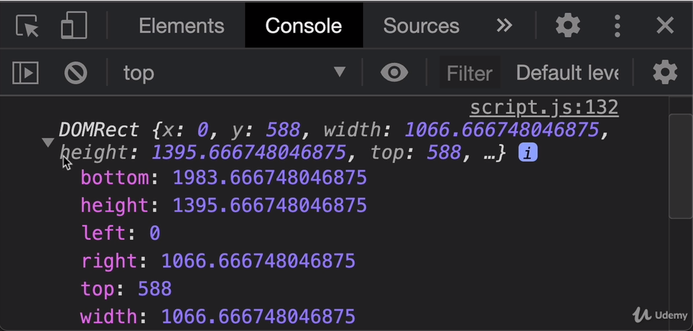It basically represents the position of the element geometry. Top, left, right, bottom represent the px distance from those sides of the browser, while the height and width represent the hight/width of the actual element rectangle (element space, if you were to put a border on it, too see how much space it takes up) So…a rectangle ^^

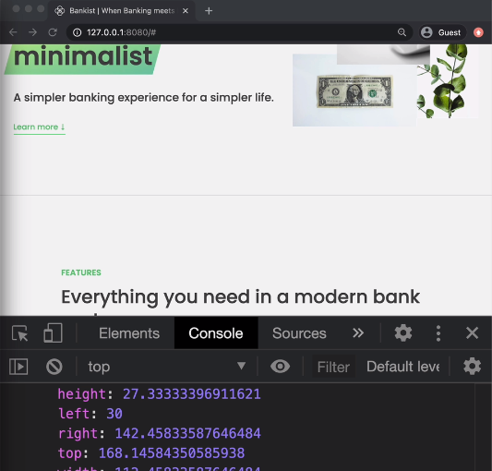The data represented in the rectangle is always relative to the position of the viewable part of the website. So scrolling up and down and changing the size of the browser, will indeed change the rectangle propery values

### //getting the current scroll position

console.log("current scroll away from the top: ", window.pageYOffset);

console.log("current scroll away from the top: ", window.pageXOffset);

window.pageYOffset;

window.pageXOffset;

// for Yoffset they show how many px you are away from the top of viewport

// XOffset tells you how many px you are from the left of viewport

### //Getting the height and width of the viewport

console.log(

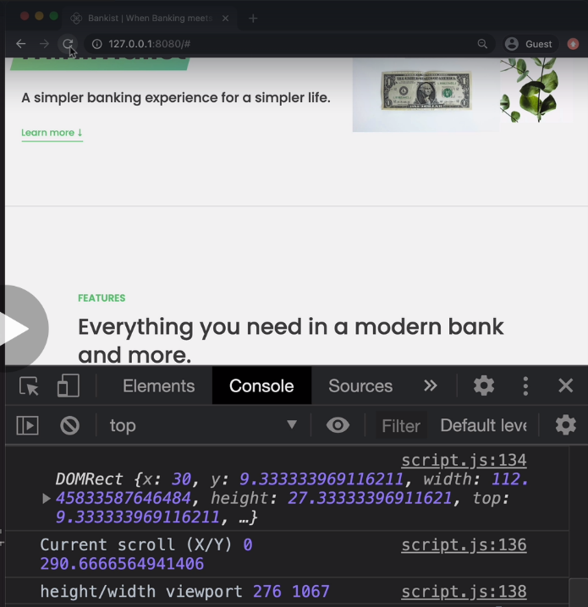  "height/width viewport",

  document.documentElement.clientHeight,

  document.documentElement.clientWidth

);

So basically, as the client switches devices, or just changes/resizes the browser window, these properties automatically update to the values of the current viewport width.

### Formula to generate a random integer

const randomInt = function (*min*, *max*) {

  Math.floor(Math.random() * (max - min + 1) + min);

};

///////////////////////////////////////////////

//////**Implementing SMOOTH SCROLL**///

///////////////////////////////////////////////

const btnScrollTo = document.querySelector(".btn--scroll-to");

const section1 = document.querySelector("#section--1");

//Creating the click functionality that initiates smooth scroll

btnScrollTo.addEventListener("click", function (*e*) {

  const s1coords = section1.getBoundingClientRect();

  //gets the coordinates of the #section--1 rectangle (s1coords)

#### //Scrolling (Old-school way)

  //Manually setting up the position of the scroll

  window.scrollTo(

    s1coords.left + window.pageXOffset,

    s1coords.top + window.pageYOffset

    //s1coords.left -> current viewport distance of the element, from the left of the page

    //window.pageX0ffset //the current distance of the viewport from the left of the page

  );

  //The second option adds an object as an argument instead

  //of the two arguments as was done previously

  window.scrollTo({

    left: s1coords.left + window.pageXOffset,

    top: s1coords.top + window.pageYOffset,

    behavior: "smooth", //this makes the scroll smooth ^___^ Ya, baby!

  });

#### //Scrolling (ModernJavascript)

  section1.scrollIntoView({ behavior: "smooth" }); //accepts an object argument

  //it tells it to scroll the element "section1" into view

});

## **Types of Events and Event Handlers**

An event is a signal generated by a certain DOM node. This signal transmits when something (an action) has happened.

-Events always happen when the user does something. Click for instance will happen and will generate an event object (e) whether or not we have actually placed an event listener or not.

Event listeners Handle events, they do not generate them.

Events act like state-variables, they track the state of what the user is doing and where he is doing it, on the webpage

### The advantage of using eventListeners as handlers instead of on-event properties/inlineHTML-attributes

The first advantage is the fact that we can attach more than one event listener to a single event. While the onEvent property can only hold one value or be overwritten.

Another, and this time, more key reason modern Javascript uses eventListeners, is because of the option to remove any (user-named) event listeners from an html element using the **handle.removeEventListener(‘eventName’, namedCallbackFname);**

//Modern Javascript (event-handling)//

//Creating a custom event-handler callback function

const alertH1 = function (*e*) {

  alert("addEventListener: Great!");

  h1_handle.removeEventListener("mouseenter", alertH1);

  //The event listener removes itself after getting

  //passed-on to an event

};

//Passing the event-handler to the event listener

h1_handle.addEventListener("mouseenter", alertH1);

//Old-school (Javascript event-handling)

//Using On-event event handlers (inline event attributes)

h1.onmouseenter = function (*e*) {

  alert("On-mouseenter handled the hover event");

};

//Removing eventListeners with a setTimeout(); function

//setTimeout(callback(), miliseconds);

setTimeout(function () {

  h1.removeEventListener("mouseenter", alertH1);

}, 3000);

# Bubbling and Capturing

Events as they happen are not actually generated at the target-element. Events are actually generated at the **root** of the document.

-Event phases

1. **Capturing phase** happens as the event travels down the tree to the target-element, and as the event travels down the DOM tree, to its target, it ill pass through every single parent element, of the target element.
2. **Target phase:**  happens as soons as the event has reached its target, and the event itself gets handled (or not) by the target. Using eventListeners in modern javascript, or onEvent properties in older javascript.
3. **Bubbling phase:** as the event reaches the target-element, after being handled by an event handler if one was set up waiting for the event at the target, the element starts bubbling up through all of the target-element’s parent elements, to return back to its root element. Note that as the event bubbles up, it only passes through parent-elements, an not through sibling elements. The consequence of event bubbling is that as the element passes through each and every parent element, as far as event listeners are concerned, it is as though the event actually happened in that element, and so, all the event listeners of the parent elements it passes on its way up to the root would run their event handlers**, if they are waiting for the same event**. This is not a bug, it is a feature, that allows for some very powerful event Bubble-chaining(I just made that up :3 )

**By default: events can be handled only at the target element and at the bubbling phase. This can be overwridden so that event-handling happens on the capturing phase.**

**Not all events, get created in the :root, some actually get created at the target element itself, so you can only handle them there.**

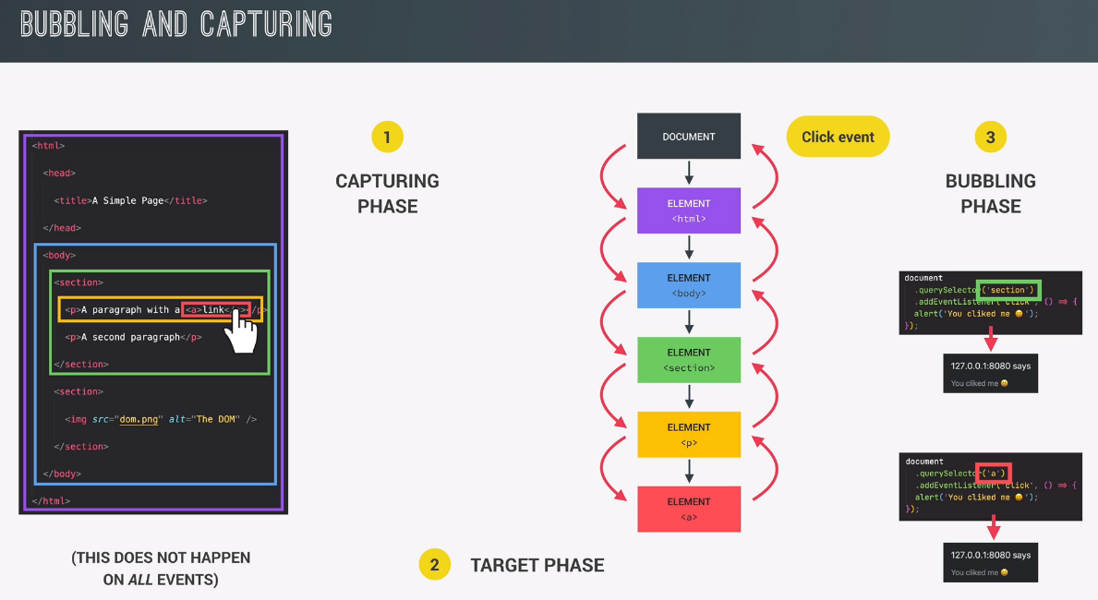It is correct to say that events Propagate (spread) from the target element to the root. So every event has an echo that spreads the event over all of the parent elements of the element-target

## **Event Propagation and Bubbling in Practice**

### The difference between e.target and “this” inside the event-handler

//Selecting our handles from the NavBar

const navigationLink = document.querySelector(".nav__link");

const linksContainer = document.querySelector(".nav__links");

const navigationBar = document.querySelector(".nav");

//Adding event listeners

navigationLink.addEventListener("click", function (*e*) {

  this.style.backgroundColor = randomColor();

  console.log("Link", e.target);

  //"this" always points to the element the eventHandler(listener) is attached to

  // e.target -> always points to the element where the event "click" happened

  //"e.target" (is not always) "this." except in the target element event handler//

});

linksContainer.addEventListener("click", function (*e*) {

  console.log("Container", e.target);

  this.style.backgroundColor = randomColor();

});

navigationBar.addEventListener("click", function (*e*) {

  console.log("container", e.target);

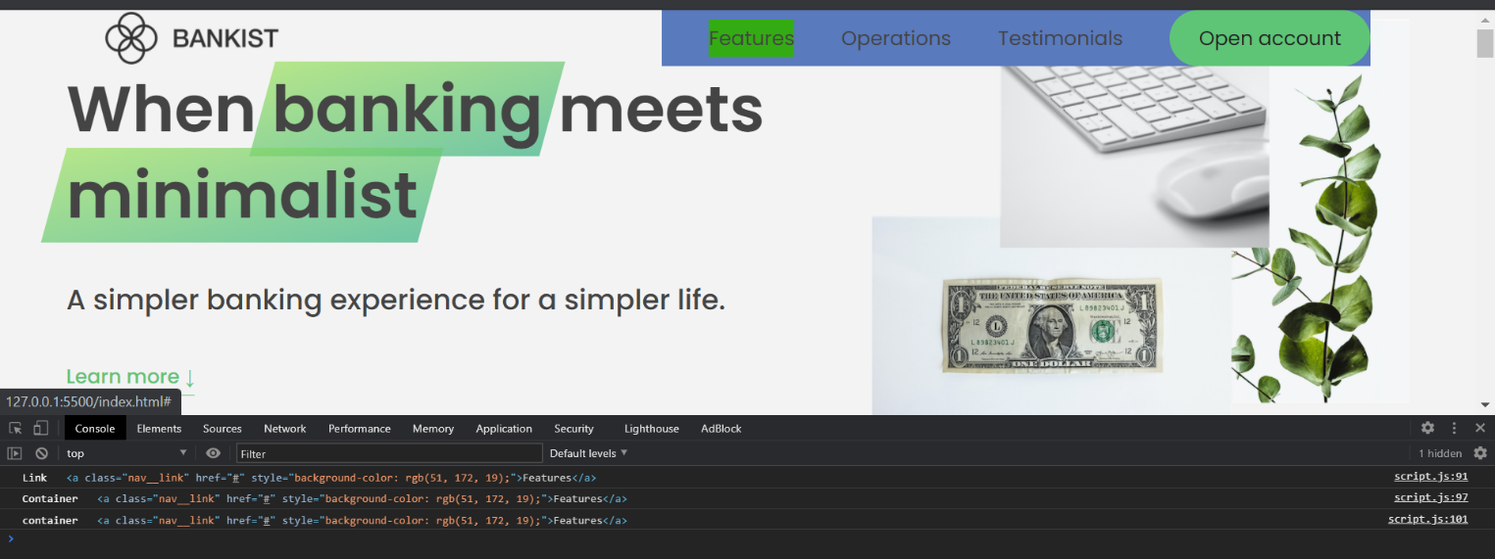});

We can see that as we’ve clicked on the “features” .nav__link, the click event propagated through all three of it’s parent elements, as it bubbled up to the root, but the e.target remained the same throughout. Namely the target is not the element the event handler is attached to, but the element where the click event happened. Because of this, were we to use **e.target.style.background = randomColor;** on all of the elements, the e.target would only affect the target element, in the case of us clicking the link again, it would simply and only change the background of the target link.

**THE e.target Element is NOT the element our event listener is attached to. It is, as it says the address to the element where the event happened.**

### **e.currentTarget property**

This e.currentTarget **is in fact the element our event handler is attached to,** and this essentially meanst the following:

navigationLink.addEventListener("click", function (*e*) {

  this.style.backgroundColor = randomColor();

**is the same as:**

navigationLink.addEventListener("click", function (*e*) {

  e.currentTarget.style.backgroundColor = randomColor();

  console.log("Link", e.target);

**So:** e.currentTarget.style. backgroundColor === this.style.backgroundColor

**e.currentTarget === this**

#### Handling events in the capture phase

(handling an event in the parent during the capture phase, before it even reaches the target element) 🡪 **addEventListener(‘eventName’,eventHandlerCallbackFunc, true/false);**

navigationLink.addEventListener("click", function (*e*) {

  this.style.backgroundColor = randomColor();

  console.log("Link", e.target, e.currentTarget);

  //"this" always points to the element the eventHandler(listener) is attached to

  // e.target -> always points to the element where the event "click" happened

  //"e.target" (is not always) "this." except in the target element event handler//

});

linksContainer.addEventListener("click", function (*e*) {

  console.log("Container", e.target, e.currentTarget);

  this.style.backgroundColor = randomColor();

});

navigationBar.addEventListener(

  "click",

  function (*e*) {

    console.log("container", e.target, currentTarget);

    this.style.backgroundColor = randomColor();

  },

  true //This will make the event listener of the Parent trigger before the  child

);

//the last argument inserted is a boolan (true/false)

//So if we want the eventListener to get triggered to an event in the capture phase

//we would simply add the third argument with the value of "true"

## **Event Delegation**

-In our bankist website we want to implement a smooth scrolling action to sections of our website that correspond to the links on our navBar. So when a user clicks on one of the nav elements, he should be smooth scrolled to the element that corresponds to the name of the navBar link. In other words, if he presses on a link that says something like, “Our Social Media” it should take him to the social-media section, usually on the bottom of a webpage.

**We will implement this feature using “Event delegation!” (Holy music playing in the background).**

### **Common technique of implementing smooth scrolling with <a href-attribute>**

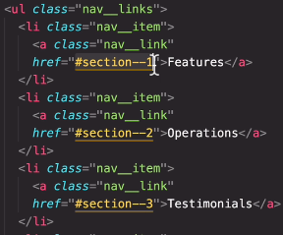In our anchor tags we set up links for the elements we want to scroll to, by entering those element’s ID’s.

So in this example, our href =”#section—1” actually has an element with a corresponding

**< tagName id = “section-1”>** By adding the (**#**) in our <anchor **href**> we allow the href value to be read in javascript, with the (**#**) **(always as a relative address, using getAttribute()**),and then store the returned value inside a variable.

**Const id = this.getAttribute(“href”);//”#section-1”**

Before passing it over as an argument to a query selector. The (**#**) that we added will tell the query selector that it should look for an element with the id=”section-1”

Finally passing the argument:

**document.querySelector(id).scrollIntoView({behavior: ‘smooth’});**

this is the same as writing: document.querySelector(‘#section-1’). To get the desired element.

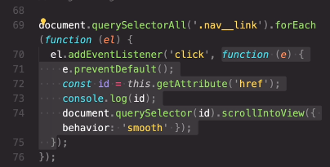**The not so Ideal way of implementing the Smooth scrool:** This is the example of implementing our smooth-scroll system to each of our link-elements, by adding a separate event listener, to each of them. Of course since all our event listeners listen for the same event and do the same thing, this would seem to be, in fact a three times over, redundant code.**This** would mean that For each unique line of code for a child element, we have (n) more sibling duplicates, seing how we cycle through elements in a parent container in this case

**The Inefficient smooth-scroll code, from above, with commentary:**

document.querySelectorAll(".nav__link").forEach(function (*element*) {

  element.addEventListener("click", function (*e*) {

    //preventing the default html action of the target element

    e.preventDefault();

    //prevents default anchors from linking us automatically

    //<a class="nav__link" href="#section--2"></a> to the href section of the page.

    //IMPLEMENTING SMOOTH SCROLLING

    //the link we want to scroll to is inside the href of our element

    //just grabbing the value with "this.href" of "e.currentTarget"

  //would return the absolute address,and all we actually want is the relative address

    //so we use getAttribute('href'); method

    const id = this.getAttribute("href"); // returns: #section--1

    //Notice how #section--1 still has a hash# this means we must use querySelector()

    //to find it's corresponding element, well, to keep it simple at least

    document.querySelector(id).scrollIntoView({ behavior: "smooth" });

  });

});

### **Event delegation technique**

**Event delegation steps:**

1. **FIRST:  we add an event listenerto the common parent of all the elements that we are interested in.**
2. **SECOND: In the parent event listener, dettermine what element triggered the event**

**The optimal way of implementing using event delegation:**

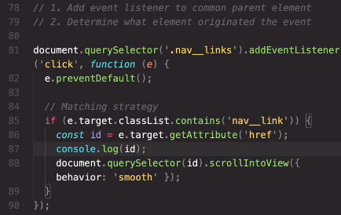

**The event delegation code, explained with commentary:**

//1. Add event listener to common parent element

//2. Determine what element originated the event

document.querySelector(".nav__links").addEventListener("click", function (*e*) {

  e.preventDefault(); //Note it needs to be envoked on the event object, not the html element!

  const id = e.target.getAttribute("href");

  //MATCHING STRATEGY//

  //We want to prevent the click from doing anything if the user

  //clicks somwhere else on the parent element "nav__links" -> plural

  // we want only to allwo clicks on the parent's children: 'nav__link' ->singular

  if (e.target.classList.contains("nav__link"))

    //Only if the target element is of a "nav__link" class, let it pass fam!

    document.querySelector(id).scrollIntoView({ behavior: "smooth" });

});

### **Using event delegation for event handling of dynamically created html elements**

Another really important way we use event-delegation, is when we are trying to handle events on elements that do not yet exist on the html page on run-time. In other words, for handling elements that will be dynamically added, as the user does something.

Because adding event handlers on elements that do not exist already in the html page is not possible, we must rememer that we can always delegate the child-events, from the parent container, where those elements will be dynamically created and placed.

## **DOM Traversing**

//////////////////////////////////

////Traversing the DOM////////////

/////////////////////////////////

const h1 = document.querySelector("h1");

//going downwards: child//

h1.querySelectorAll(".highlight");

//selects all the children of the h1 element,

// with a class of class="highlight"

//No matter how deep they are inside the (h1)parent element

h1.children; //returns a live HTML collection (remember that it gets refreshed)

//returns only the direct children of an element, not grandchildren or lower.

h1.firstElementChild;

//This returns a handle to the first html-element from h1

//we can use it just like a handle/reference

h1.firstElementChild.style.color = "orangered";

//////////////////////////

//Going upwards: parents//

//////////////////////////

h1.parentNode;

h1.parentNode.style.background = "powderblue";

//returns the parent element handle, basically

h1.parentElement; //use this one instead of parentNode

h1.parentNode.style.background = "powderblue";

//finding a parent element, that is not a direct parent

h1.closest(".header").style.background = "var(--gradient-secondary";

//works just like a querySelector, but instead   ////used css-variable/custom property

//of returning the first element we pass as an argument

//it actually returns the first closest parent-element to the (h1)/handle

//we envoked the method on.

//Important NOTE: if the element we are calling the .closest('.header');

//method on, is actually the element we passed as an argument

//then, that element will basically return itself with this method.

h1.closest("h1"); //will return itself

//is the same as writing just (h1)

//COMPARING .closest() vs .querySelector() METHODS//

//Note that .closest(''); works in the exact opposite way of

// .querySelector(''); method//

//where .querySelector('queriedElement'); searches for

//the first queried child element

//no matter how deep inside the element is.

//closest(); method//

//The .closest('queriedElement'); searches for the first-parent element

//no matter how far away// how high it is, relative to the element

//that envoked the method.

////////////////////////////////////

/////Going sideways: siblings //////

////////////////////////////////////

//Getting the first next and first previous sibling//

h1.previousElementSibling; //gets the first sibling on top

h1.nextElementSibling; //gets the first sibling below.

//the methods for returning nodes

h1.previousSibling; //returns sibling above NODE

h1.nextSibling; //returns sibling below NODE

////Getting all of the siblings around the element/////

//since there is no direct way to do this in javascript

//we basically have to travel up to the parent, then

//get the children elements of the parent...

h1.parentElement.children; //returns all h1 siblings including the h1 itself

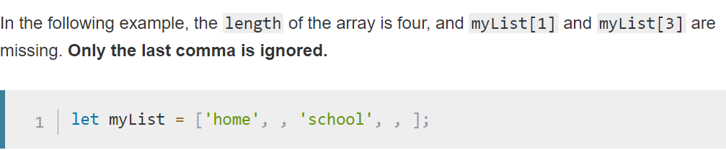//Remember, it returns a live HTMLcollection!!

Figure Random important info on the function of extra commas in arrays

## The tabbed-component feature:

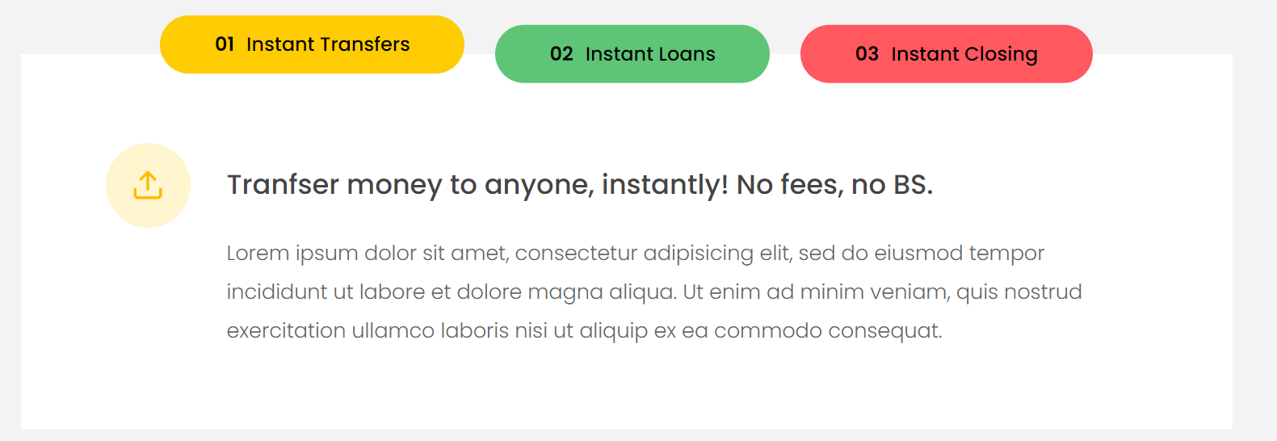

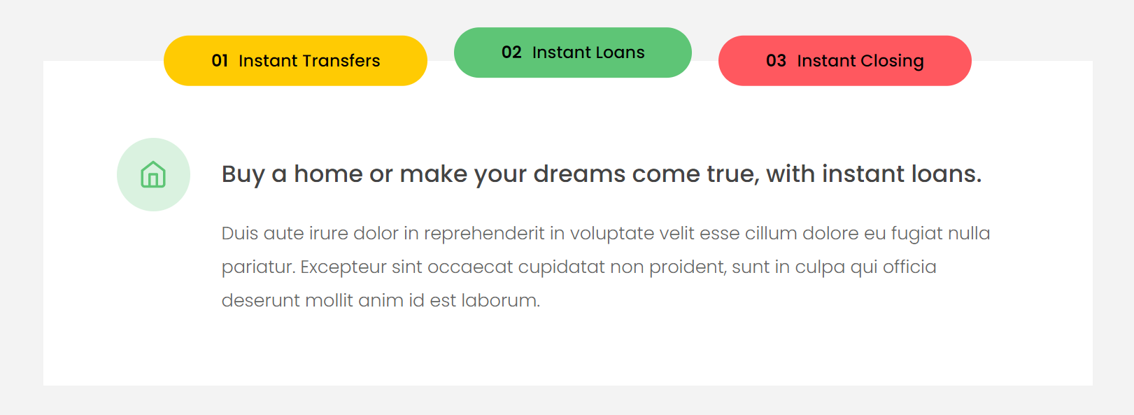

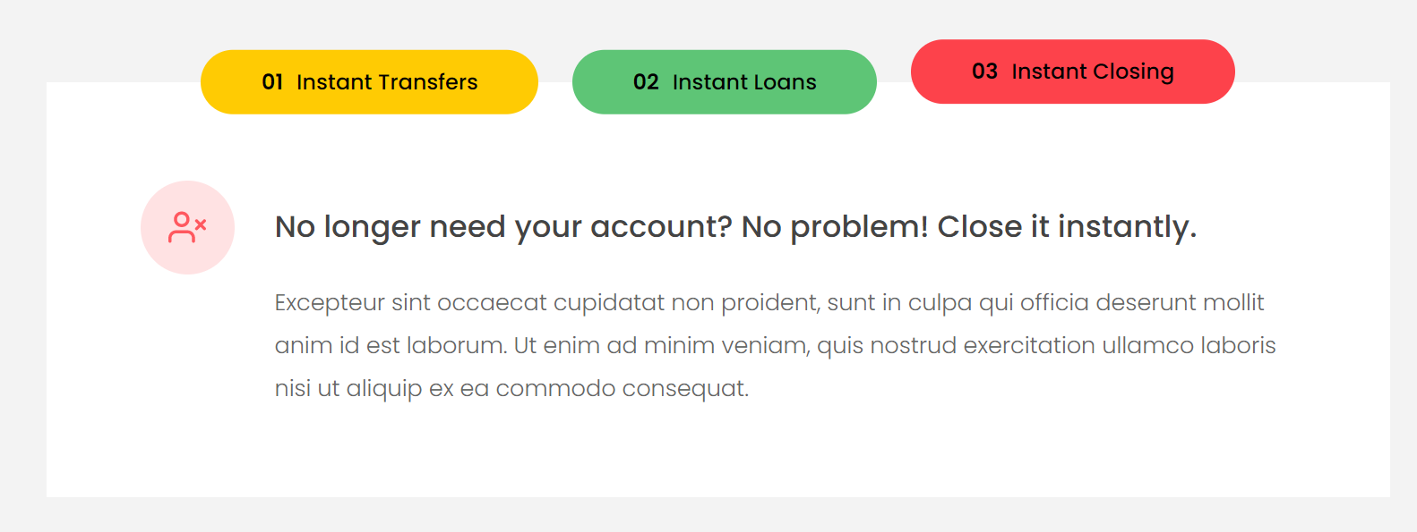

Write javascript code that will change the entire component-content when theuser clicks on one of the tabs, as can be seen on the three different components and their corresponding clicked tabs on the images above.

//Explicit conversion from HTMLcollection to an array

Array.from(h1.parentElement.children).forEach(function (*element*) {

  if (element !== h1) {

    element.style.transform = "scale(0.5)";

  }

});

//Implicit(ish) conversion from HTMLcollection to an array

[...h1.parentElement.children].forEach(function (*element*) {

  //so we don't include the (h1) itself

  if (element !== h1) {

    element.style.transform = "scale(0.1)";

  }

});

Data-tab html attribute

<button

class="btn operations__tab operations__tab--1 operations__tab--active"data-tab="1" >

<button class="btn operations__tab operations__tab--2" data-tab="2">

<button class="btn operations__tab operations__tab--3" data-tab="3">

What it does is connect the class number with the data-tab attribute in javascript. How his is done, is by referencing a class and placing a handle property inside the class name in order to change the “operations__tab—3” last number.

**currentTab = document.querySelector(‘.tab’);**

**correspondingButton = document.querySelector(`operations__tab--${handle.getAttribute(‘data-tab’}`).classList.Add(‘active’);**

We can see how in this example we can use the getAttribute(); method to dynamically change the button element that we are getting by placing the attribute value of our element inside the query string, so that whichever **data-tab** value is placed(1,2,3), get’s us the corresponding button class(operations__tab—1/2/3)

To get the ‘data-tab’ attribute value, we may use: **handle.getAttribute(‘data-tab’)** or **handle.dataset.tab;**

**Code examples:**

 //CODE USING .getAttribute(); to retrieve the data-tab attribute value:

const clicked = e.target.closest(".operations__tab");

////Activate content area

  console.log(clicked.dataset.tab);

  document

    .querySelector(`.operations__content--${clicked.getAttribute("data-tab")}`)

    .classList.add("operations__content--active"); //active is a style that removes display:none; for the element

});

 //CODE USING .dataset.tab to retrieve the “data-tab” attribute value:

const clicked = e.target.closest(".operations__tab");

////Activate content area

  console.log(clicked.dataset.tab);

  document

    .querySelector(`.operations__content--${clicked.dataset.tab)}`)

    .classList.add("operations__content--active"); //active is a style that removes display:none; for the element

});

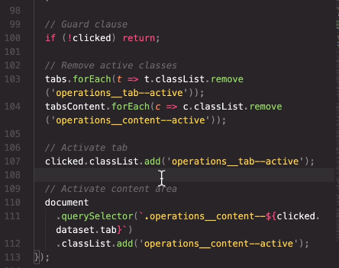

Figure Tabbed component class solution

### MY CODE FOR THE TABBED COMPONENT

////////////////////////////////

//////TABBED COMPONENT/////////

//////////////////////////////

const tabs = document.querySelectorAll(".operations__tab");

const tabsContainer = document.querySelector(".operations__tab-container");

const tabsContent = document.querySelectorAll("operations__content");

///event delegation for tab-button clicks///

tabsContainer.addEventListener("click", function (*e*) {

  //matching strategy, to know whitch button is clicked

  const clicked = e.target.closest(".operations__tab"); //searches for the closest operation tab

  //we want to to get the button element even if the user

  //presses the <span> text element inside the button.

  //Guard clause

  if (!clicked) return; //if clicked == null/undefined it returns false and !false == true -> return;

  //whenever there is no clicked element

  //that corresponds to our e.target.closest() handle,

  //don't do anything and leave the function

  //clearing "clicked" style from all tabs

  tabs.forEach(function (*element*) {

    element.classList.remove("operations__tab--active");

  });

  //Setting a "clicked/active" style for the current clicked tab

  clicked.classList.add("operations__tab--active"); //css active button styling for the pressed button

  ////Activate content area

  //First remove 'operations__content--active' classes from all 'operations__content' class elements

  document.querySelectorAll(".operations__content").forEach(function (*content*) {

    content.classList.remove("operations__content--active");

  }); //could have used the 'tabsContent' handle.

  //Then we add the 'operations__content--active' class to the current clicked element.

  document

    .querySelector(`.operations__content--${clicked.getAttribute("data-tab")}`)

    .classList.add("operations__content--active"); //active is a style that removes display:none; for the element

});

//Elaboration on the code: const clicked = e.target.closest(".operations__tab");

//To insure our desired element is 'click' element is handled even if there are other

//elements around it that can cause the click event to happen, becoming e.target themselves

//we would use the .closest(); metod, which will return our desired element itself if pressed

//or go to the closest desired element, if the user accidentaly presses

//one of the html elements around our element,

//This problem happens because when designing our thml, we use various elements

//to make up, a button for example. So what we may have is a <span> and <p> tags

//within or around the visual space of our <button> tag. And so if the user tries to press

//the button, it might happen that the <span> or <p> become 'click' event targets

//And if we want to handle a click event for the <button> element they make up

// we, knowing that the button is close to those <p> and <span> elements

//just assign the event-handling-operation to the handle

//<button><p>Button <span>No2</span> text!</p></button>

// e.target.closest('button').backgroundColor = 'red';

//This will do the following:

//1.If the user presses the

//button background. the closest 'button' element will be the button itself

//2.If the user presses the "No2" <span> text, the e.target element becomes <span>

// <span>.closest('button'); will select our button element

//3.If the user pressese the "text!" the e.terget will be set to <p>Button text!</p>

//  <p>Button text!</p>.closest('button'); is going to return the button element.

## Passing Arguments to Event Handlers

Create a menu fade animation where all other meny items fade out on-hover, but the item that our cursor is directly pointed at.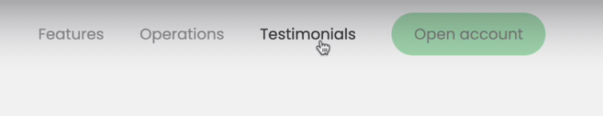

### Mouseover vs mouseenter event

Mouseover event functions in the same way as mouseenter does (mouse-hover-action) with the biggest difference being that:

* **mouseover allows bubbling of events.**
* **Mouseenter prevents bubbling from occuring.**

### **Mouseenter/Mouseleave mouseover/mouseout**

The events that undo the actions that happen for their respective mouseover/mouseenter events. These actions happen when the mouse leaves/exists the space if previously hovered over.

//////Menu fade animations/////////

const nav_handle = document.querySelector(".nav");

const links = nav_handle.querySelectorAll(".nav__link");

nav_handle.addEventListener("mouseover", function (*e*) {

  //(1)CHECK IF TARGET IS DESIRED NAV LINK///////////////

  if (e.target.classList.contains("nav__link")) {

    const target_link = e.target;

    //(2)SELECTING THE SIBLINGS VIA PARENT ELEMENT/////////

    const sibling_links = target_link

      .closest(".nav")

      .querySelectorAll(".nav__link");

    //(3)SELECTING THE LOGO/////////////////////////////

    const logo = target_link.closest(".nav").querySelector("img");

    //(4)APPLYING THE STYLES(change the opacity)///////////

    logo.style.opacity = "0.5";  //Changing the image opacity

    sibling_links.forEach(function (*link*) {

      //Check to change only the opacity of sibling links(not the target)

      if (link !== target_link) {

        link.style.opacity = "0.5";

      }

    });

  }

});//(5) RETURNING NORMAL OPACITY WHEN MOUSE LEAVES THE LINK

///////////Copy paste the "mouseover" code and change opacity to 1 instead of 0.5

nav_handle.addEventListener("mouseout", function (*e*) {

  //-CHECK IF TARGET IS DESIRED NAV LINK///////////////

  if (e.target.classList.contains("nav__link")) {

    const target_link = e.target;

    //-SELECTING THE SIBLINGS VIA PARENT ELEMENT/////////

    const sibling_links = target_link

      .closest(".nav")

      .querySelectorAll(".nav__link");

    //-SELECTING THE LOGO/////////////////////////////

    const logo = target_link.closest(".nav").querySelector("img");

    //-APPLYING THE STYLES(change the opacity)///////////

    logo.style.opacity = "1";     //Changing the image opacity

    sibling_links.forEach(function (*link*) {

      //Check to change only the opacity of sibling links(not the target)

      if (link !== target_link) {

        link.style.opacity = "1";

      }

    });

  }

});

//(1)CHECKING IF THE MOUSEOVER ELEMENT IS OUR DESIRED ELEMENT

//To make sure the effects don't trigger between elements, or somwhere

//random on the "nav_handle", the edge of the navBar for example, we must first

//do a CHECK

//(2)SELECTING THE SIBLINGS VIA PARENT ELEMENT

//To make the solution really robust and general, rather than especific

//we opted to use the closest() method when finding the parent container

//to the (nav__link) elements.

//Presupposing that there are move (.nav) elements on the page

//we are looking for the closest('.nav') as the obvious parent

//then in order to select the children (and get a node list) we would use

//link.closest('.nav').querySelectorAll('.nav__link');

//on the parent, giving us all the "nav__link" children, our link-siblings.

//-We would not use (parentQuery).children; because a) it returns a live HTML coll

// b) it would return ALL child elements, not just the ('.nav__link') elements.

//(3)SELECTING THE LOGO. The best way to select the logo within a container

//of our target_link element(sibling element, but image), is to first select the parent of our target link

//and then querySelect the parent for an image (if it is the only image inside container)

//this method will then work on all navBars with a single image(making the code more adaptible/robust)

//(4)APPLYING THE STYLES. Here we want to first apply the opacity to our the logo

//then using the forEach loop pass through all the link elements

// each time a new element is selected in the forEach, we check if it is NOT the target element

// if it isn't we apply the opacity. If it is, we do nothing (we don't want our target link to fade )

//(5)RETURNING NORMAL OPACITY. When the mouse leaves the link, we want our opacity to return

// to default. Basically we simply use the opposite event from the mouseover --> mouseout

//and copy the same mouseover event body to mouseout, with the only change being that we are no longer

//applying 0.5 opacity, but reverting it back to 1(full visibility)

//Of course copy-pasting code is not DRY so obviously this will become a function when refactored

//////////////////////////////////////

//////**Menu fade animations refactored**

//////////////////////////////////////

const nav_handle = document.querySelector(".nav");

const links = nav_handle.querySelectorAll(".nav__link");

//SETTING THE OPACITY FOR ELEMENTS ON HOVER

nav_handle.addEventListener("mouseover", function (*e*) {

  hoverHandler(e, 0.5);

});

//RETURNING NORMAL OPACITY WHEN MOUSE LEAVES THE LINKS

nav_handle.addEventListener("mouseout", function (*e*) {

  hoverHandler(e, 1);

});

//REFACTORING MENU FADE ANIMATIONS//

//Here we are creating a function that will be passed on

//as an event-handler(callback-function) to an eventListener

//(1)CHECK WHAT IS DIFFERENT

//(opacity is different) add it as a function parameter.

const hoverHandler = function (*e*, *opacity*) {

  if (e.target.classList.contains("nav__link")) {

    const target_link = e.target;

    //(3)SELECTING THE SIBLINGS VIA PARENT ELEMENT/////////

    const sibling_links = target_link

      .closest(".nav")

      .querySelectorAll(".nav__link");

    //(4)SELECTING THE LOGO/////////////////////////////

    const logo = target_link.closest(".nav").querySelector("img");

    //(5)APPLYING THE STYLES(change the opacity)///////////

    //Changing the image opacity

    logo.style.opacity = opacity;

    sibling_links.forEach(function (*link*) {

      //Check to change only the opacity of sibling links(not the target)

      if (link !== target_link) {

        link.style.opacity = opacity;

      }

    });

  }

};

//(1)CHECK WHAT IS DIFFERENT. Add a parameter so that the difference

//can be passed within the code as an argument. Here the code is the same

//in both event listeners, but THE OPACITY IS DIFFERENT

//and so, we will create an (opacity) parameter for our refactored function

/////Passing a function with multiple arguments to the event handler/////

//Our custom eventHandler function declaration with parameters for two arguments

const hoverHandler = function (*e*, *opacity*) {};

//Normally, when we need to pass an event handler as a separate function

// we would simply place a function name in place of the event handler

//anonymous function.

//SETTING THE OPACITY FOR ELEMENTS ON HOVER

nav_handle.addEventListener("mouseover", hoverHandler);

//But since the our custom-even handler accepts multiple arguments

//that is simply not possible. Since the default callback-eventHandler function

//only passes the (e)-> event-object as an argument to any

//custom function that we place instead of it.

//This means that we simply cannot place our custom event handler

//as an event-handler argument of the EventListener method.

//What we must do instead is simply call our named eventHandler function inside the

//anonymous eventHandler, and pass the (e) object argument from the anonymous handler

//to our named-handler, where the named handler will be able to accept, besides the object (e)

//as many other arguments as we require.

nav_handle.addEventListener("mouseout", function (*e*) {

  hoverHandler(e, 1);

});

### Using **.bind()** function

What this method does is it passes the function body, not just the function call value to the anonymous “function(e)” 🡪 eventHandler. We can see on the example above, two equivalent ways of passsing a multi/argument function as an eventHandler to the eventListener.

1. The first way is using the .bind() method
2. The second way is by placing the function inside the anonymous event handler

**Both** of these ways **work the same**, it is just that **the first way is more** elegant as a solution. Not to mention **common practice.**

**How it works:** It will set the THIS keyword in the function call to whatever value we pass as the bind-argument. This basically means that it adds an argument to the existing function as well as the function body, without envoking the function itself. So the THIS keyword for the passed **handleHover.bind(1);** would refer to the **function(e)** default callbackFunction, and not the **handleHover(e, opacity); function itself. That is why it will not envoke the function-declaration, but in a sense become the new definition for the callback-function.**

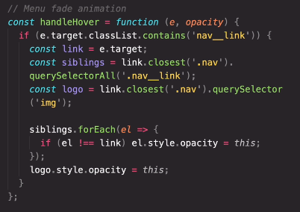Here is how .bind(1) for sets the THIS keyword to whatever is passed as an argument to the .bind(argument); method.

In the example to the left, we can see how instead of assigning the value of **opacity** argument, we are using **this** for the same purpose, as in the code, if we will be binding the function with another using .bind(), any argument entered inside .bind() will become the value passed on to the **this** keyword. In essence **this===opacity**

Of course this means that we don’t even have to declare “**opacity”** as an argument, as additional arguments are allowed in javascript, so the code will work exactly the same were we not to even write the “opacity” argument, as can be seen below:

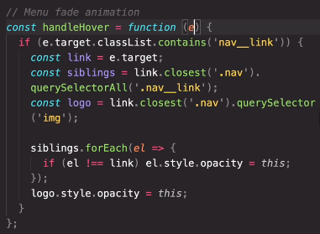

## **Implementing the sticky nav bar**

What we want is to make the navBar sticky (fixed on screen) as soon as we reach a certain position when scrolling down the page. 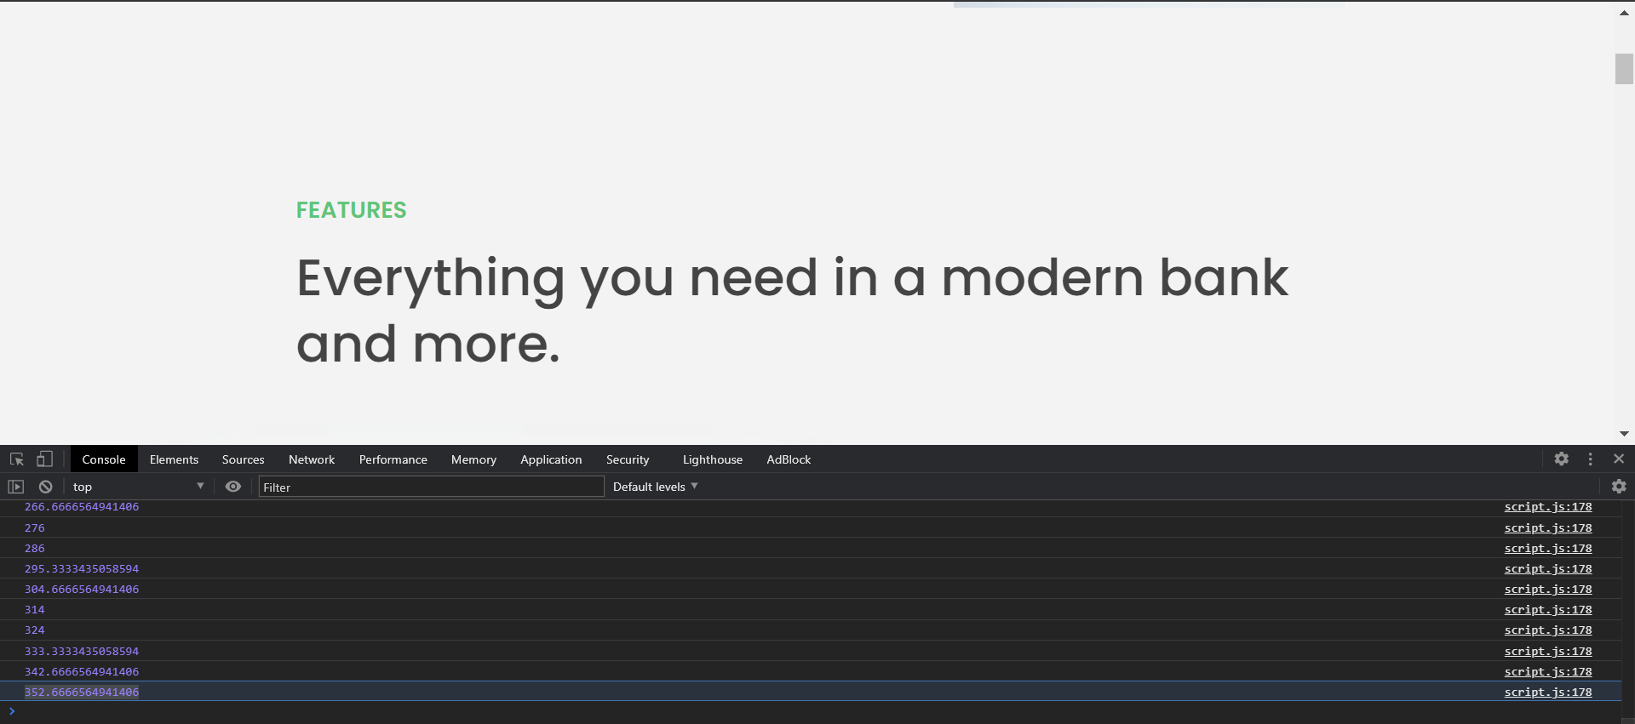

One way to do this is to implement a scroll event on the global.window object, and within it, console log **window.scrollY** property, that will tell us exactly the Y coordinates of our viewport. So that when we scroll manually to the desired position on the webpage, where we want our navBar to become sticky, we can simply look up the exact coordinates logged on our Console, and use those coordinates to set:

**if(window.scrollY === 352) nav.style.position = ‘fixed’;** Or add a class if we have it pre-prepared in our css stylesheet: ***nav.classList.add(‘.myStickyClassName’);***

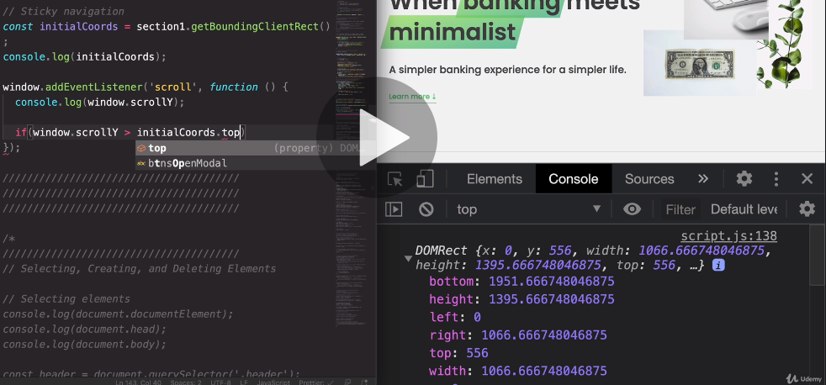**Alternatively, we may just use the position of the top of the element where we want our navBar to become sticky**

We can do this by selecting the **elementHandle.getBoundingClientRect()** method, which returns the (DOMRect)**DOM-Rectangle object**, that contains properties that contain the size and position of the HTML-rectangle-space of the element in question. The DOM-Rectangle object has the property **top** that is useful in this instance, as it tells us the distance of the object from the top of the webpage. We can use this **top property** to tell our code to make the navBar sticky whenever scrollY position from the window-global-object is larget than the top-property of our element’s DOM-rectangle,

//////////////////////////////////////

//////Sticky Navigation///////////////

//////////////////////////////////////

///////FIRST IMPLEMENTATION-METHOD (using the Scroll Event)////////

//Note that scroll is not very optimal and should ideally

//be avoided as much a possible, as it triggers a scroll event

//on each scroll-offset, which is a flippin ton of times for each little scroll

//With that said, let's go to implementing sticky navigation

//using 'scroll'event.

//It is really bad for Preformance! Especially for mobile devices

//where the ram is really weak.

//THE SCROLL EVENT important notes: ///

//Scroll event only exists on the window object

//All the information needed to implement scroll is actually

//stored in the window object itself, and not the event object as is usually the case

//that is why the (e) object is pretty useless for the "scroll" event

//// THE window.scrollY; PROPERTY

//returns the (Yaxis) distance between the top of the viewport and the top of the entire page.

//So initial on load value for :window.scrollY  is actually (0) the elements are on top of each other

//so there is no distance between them.

//(1)Get the initial coordinates of the element position at which we want our nav to become sticky

const initialCoordinates = section1.getBoundingClientRect();

//The initialCoordinates is now section1's- htmel-Rectangle-object

//(2)Add a listener for the scroll event (globally)

console.log(initialCoordinates);

window.addEventListener("scroll", function () {

  //if the user scrolls lower than our section1 element

  if (window.scrollY > initialCoordinates.top) {

    nav_handle.classList.add("sticky"); //the nav becomes sticky

  } else {

    //if the user-scroll position is not lower than our section1 element

    nav_handle.classList.remove("sticky"); //the nav bar stops being sticky

  }

});

## **IntersectionObserver API**

////////      THE INTERSECTION OBSERVER OBJECT    ////////

const observerCallback = function (*entries*, *observer*) {

  entries.forEach(function (*entry*) {

    console.log(entry); //Each time the observer activates (passing the threshold)

    //A new IntersectionObserverEntry object/event is created,

    //within an 'entries' array.

    // That entry is what we log here to read the data inside the Entry-object

  });

};

const observerOptions = {

  root: null, //The 'root' property is the element our target element will intersect

  threshold: 0.1, //Threshold is set to 10% --> 0.1

};

//The intersection observer accepts I(callbackFunctionArgument), II(ObserverObject)

const observer = new IntersectionObserver(observerCallback, observerOptions);

//Creates a new instance of IntersectionObserver class

observer.observe(section1); //we give it a target element handle to observe

## **IntersectionObserverEntry event/object**

Whenever our target element passes the threshold and triggers the observer’s callback function, a new IntersectionObserverEntry object will be created, and within it’s parameters we have the details of the threshold-event(when and how has our target element passed through the threshold set for the Observer) **It triggers each time our target passes through the threshold( line).**

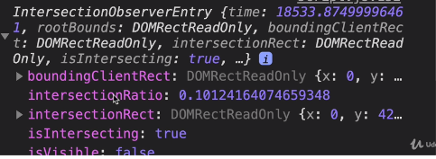

**This is much more efficient** since this type of ‘event’/event-object is triggered only when the threshold gets crossed, unlike the scroll event, which happens all the time at every scroll action.

**The most notable of these properties is the ‘intersectionRatio’(** it tells us at what percent did the targetElement trigger the intersectionObserver’s callback function.) **and ‘isIntersecting’** which details whether the target element is still passed the threshold (stil intersecting) inside our root(observed) element.Or if it is no longer visible on our intersection element.

//////The Observer Callback Function////////

//The passed callback function argument inside the IntersectionObserver

//will be called each time that the observed element(our 'target element' :section1)

//is intersecting(crossing/entering inside) the 'root Element'(null means the entire viewport,

////The ObserverCallback arguments////

//The observerCallback function accepts two arguments:

//'entries' and the IntersectionObserverObject that the Function will get passed to

// as a callback-function argument.

// The entries, argument represents an array of "threshold entries"

//How it works:

//THE ROOT Property/////

//The root property for the Intersection observer object argument

//defines what object the IntersectionObserver is observing

// root: null; --> Means it is observing the entire viewport

//The Threshold property///

////The threshold property defines the threshold of how much

////our observed Root element can be intersected (crossed/inserted) by the target element.

////(in other words) by the amount of space can our target element take up inside the Root element, before

////the callback function is triggered. if Threshold: 0.1; it would mean that when we scroll

///to the viewable range (to be able to see the target element),if the target takes up

// 10% of our viewport(passing the 10% threshold)

//the callback function of the observer will trigger.

////IN other words, when enough of the target element crosses into our observed element (enough === threshold ammount)

////the intersection triggers the observer.

///////////    HOW IT WORKS IN PRACTICE:    ///////

//(1)We define the the observer-object properties.

//-The object observed (root: _and the threhsold line (threshold: percentageOfRoot)

//(2)We define the callback function that defines what happens

//when the threshold ammount of the target space is within the root observed element.

//(3) We create a new instance of IntersectionObserver class

//passing, to its constructor, our observerCallback and our observerObject

//as arguments for creating the 'new IntersectionObserver()' -->[ tis a constructor, mum]

//(4)We activate the newly created IntersectionObserver instance

//by envoking its "Observe()" method, to which we pass the target element that

//we want the observer to observe and trigger its callback if the target

//element exceeds our set threshold.

//Real Example

**// const observerObject = {**

**// root: null, //entire viewport**

**// threshold: 0.1, //Ten percent of the viewport**

**// }**

**// const observerCallback = function(){//does some action//}**

**// observer = new IntersectionObserver(observerCallback, observerObject);**

**// observer.Observe(targetElement);**

//What happens with the code above is the following:

//Whenever the targetElement crosses the (threshold-line) set at 10% of the entire viewport

//(the line is placed at 10% from the top of the viewport )

//the callback function gets called, and the code from the callback gets executed.

//Note that it does not matter if the threshold line is crossed

// by scrolling up or down.

//The only thing that is observed is whether or

//not the targetElement crosses the threshold-line

//or in other words, if the target element intersects it.

//////////////////////////////////////////////////////////////

### Alternative way of selecting the first element from an array

const [entry] = entries; //same as writing entries[0];

const observerOptions = {

  root: null,

  threshold: 0,

  rootMargin:"90px",//a box of 90px that will be applied outside of our target element

};

This basically adds a margin on the target element, where the target element and the root intersect. Note that you can use -90 to remove margin, ie make the target element smaller.

In this example we would use rootMargin:"-90px" to make the nav element appear exactly on the start of our target element, and not inside it(initially)

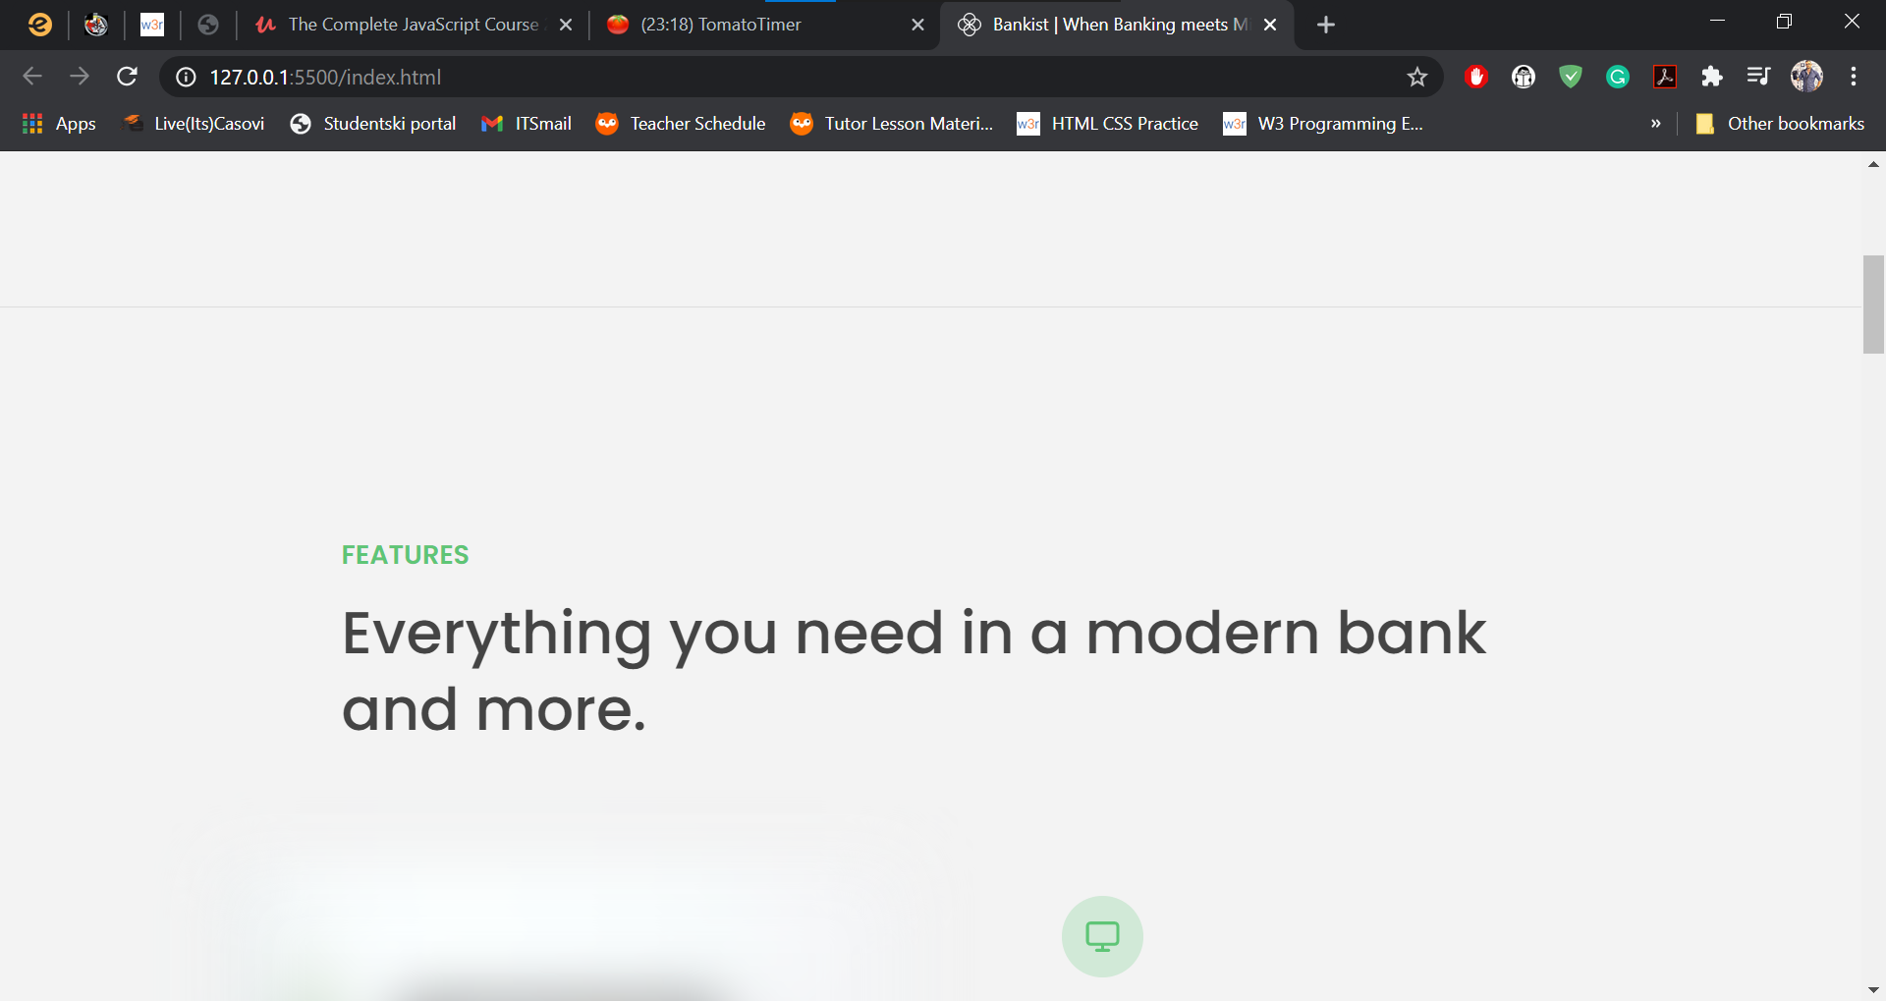We want our nav-bar to appear exactly on the line of our target element. By default, the top of our nav would appear at the start of the target element. If we add a margin to the start element (rootMargin:"-90px",)//which represents the px size of our nav.We would make the target margin push the navBar back the space of the navBar height.



Here with the (rootMargin:"90px",) our navBar crosses the section1 target element when the observer-callback triggers.

So clearly rootMargin: “90px” pushed our target element in the opposite direction.

So what we want to do must be 🡪rootMargin: “-90px” 🡪 It can only be px (not %,rem or other)…

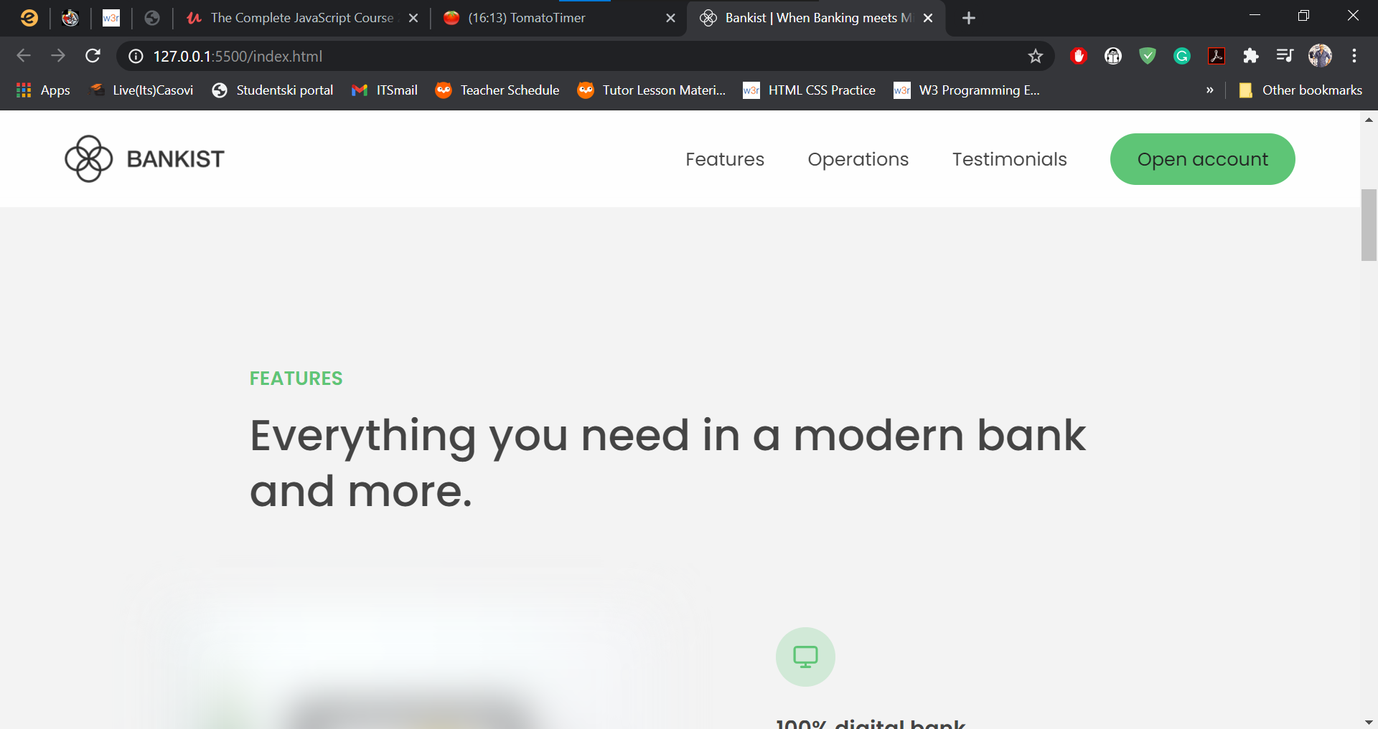

Now it first appears exactly on top of the section1 target-element, not covering it att all unless the user continues scrolling down.

The example above is hardcoded to 90px. But when building a responsive website, the px height of HTML rectangles changes all the time. So in order to account for that and make everything present the same way regardless of viewport size, here is the dinamic way of applying rootMargin

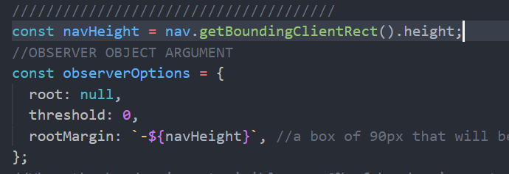

**To make A desired element stand on top of a targetElement you simply need to read and store the height of the element you wish to place on top of the target element.**

**After storing the height use it as the value to the rootMargin property, but don’t forget to use negative numbers! You want to tell it how far above (-npx)the targetelement you want to initially display your desired sticky element, not how many px inside the target element you want it to become sticky (+Npx)**

**The code:**

////////////////////////////////////////////////////////////////////////////

//////**Sticky Navigation VIA Intersection Observer Object** ///////////////

/////////////////////////////////////////////////////////////////////////////

////////      THE INTERSECTION OBSERVER OBJECT    ////////

//We want our navBar to be visible when our header completely

//leaves the viewport

const header_handle = document.querySelector(".header");

const navHeight = nav.getBoundingClientRect().height; //For observer object

//OBSERVER CALLBACK FUNCTION

const stickyNav = function (*entries*) {

  const entry = entries[0]; //same as writing entries[0];

  console.log(entry); //Checking the value of our current entry-object

  //Add the "sticky" class if the current entry.isIntersecting is false

  //in other words,if the header is not intersecting it is not visible in the viewport

  //and that is exactly when we want to add our sticky nav

  if (!entry.isIntersecting) {

    nav_handle.classList.add("sticky");

  } else {

    nav_handle.classList.remove("sticky");

  }

};

//////////////////////////////////////

//OBSERVER OBJECT

const observerOptions = {

  root: null,

  threshold: 0,

  rootMargin: `-${navHeight}px`, //a box of 90px that will be applied outside of our target elment.

};

//When the header is not visible --> 0% of header in root element

///////////////////////////////////

//OBSERVER ITSELF

const headerObserver = new IntersectionObserver(stickyNav, observerOptions);

headerObserver.observe(header_handle);

## Revealing elements on scroll

**The css that we are using to achieve the transformation from invisible (opacity: 0) to fully visible in a transition from 0 to 1 opacity in 1sec.**

.

 //by default our sections have a section--hidden class added on startup in javascript

//not hard-coded inside our html because the users disabling javascript on their

//browsers would be unable to remove the ‘section—hidden’ class,and be unable to see the content

 .section--hidden {

    opacity: 0; //makes elements invisible but still take up space on the page

    transform: translateY(8rem);

  }

//As we scroll to the sections they lose their hidden class and appear on page

section {

    padding: 15rem 3rem;

    border-top: 1px solid #ddd;

    transition: transform 1s, opacity 1s;

  }

### **Determining which section actually intersected the viewport**

//observer callback

const revealSection = function (*entries*, *observer*) {

  const entry = entries[0];

  console.log(entry);

  entry.target.classList.remove('.section--hidden');

};

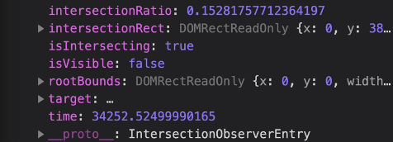

The entry object created by the observer callback function on-intersection has a **target property.**

So each time one of our sections intersects the root-threshold, a new **interesctionObserver entry** is created, here we’ve named it the **entry** element. (it will always be the first element, if only one entry is created each time the observer fires the callbackFunction.

The **target** property of the **observer-entry** object is in fact always the handle to the target-element given to the observer method observer**.observe(targetElementHandle),** when it triggers the root-threshold.

So for an observer set to observe four different elements, we would know which element triggered the observer callback function using the callbacks entries-array **IntersectionObserverEntry object,** and accessing its target property, to get the handle for the element in question

**The observer:**

const allSections = document.querySelectorAll(".section");

allSections.forEach(function (*section*) {

  sectionObserver.observe(section);//Notice how an observer observes multiple elements

  section.classList.add(".section--hidden"); //initially hiding all elements

});

**Accessing the section(html element) that triggered the callback:**

//observer callback

const revealSection = function (*entries*, *observer*) {

  const entry = entries[0];

  console.log(entry);

)//Remove hidden -> (revealSection) as it appears on screen(true), not as it leaves it

if (entry.isIntersecting) //Is intersecting is a property of entry object, not target

**entry.target.classList.remove('.section--hidden');**

};

**Alternative to the conditionStatement using an if()return; guard clause**

//observer callback

const revealSection = function (*entries*, *observer*) {

  const entry = entries[0];

  console.log(entry);

  //Guard clause

  if (!entry.isIntersecting) return;

  entry.target.classList.remove("section--hidden");

};

It tells the function to, **if** the element we want to reveal **is not inside the viewport** (root: null) (entry.IsIntersecting ===false) stop further action and **return** from the function.

### **Unobserving an element**

//observer callback

const revealSection = function (*entries*, *observer*) {

  const entry = entries[0];

  console.log(entry);

  //Guard clause

  if (!entry.isIntersecting) return;

  entry.target.classList.remove("section--hidden");

//Deallocating observer after section-reveal

  observer.unobserve(entry.target);

};

 The sections are supposed to be hidden then reveal only as you enter the website and scroll through it the first time.

As the hidden class is removed and the section revealed

we don't need or want the observer to track the section any more, as it is supposed to now stay revealed on the webpage as the user scrolls up or down at leisure.

So to save RAM space we simply stop observing the object after the initial reveal

## **Lazy Loading Images**

The most important thing to consider when building a website is website-performance. With that in mind, images can seriously slow down the pages performance, and because of that certain strategies have been developed to mitigate this problem. One of those is, **lazy-loading-images.**

The strategy works by having some really low res image in the original <img **src** attribute, that would then get replaced by a high res image specified in the <img **data-src** attribure

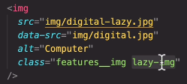

Usually we would add a class that blurrs the image, to hide the initial low-res image from the user and make it more aesthetic, before the full resolution image loads.

While the previous features we created had a more aesthetic effect, lazy loading images really drastically optimise the performance of the website.

The way we replace the value of these two attributes inside the same image element can be seen below, and again, it is a concept (programing technique) that is readily used.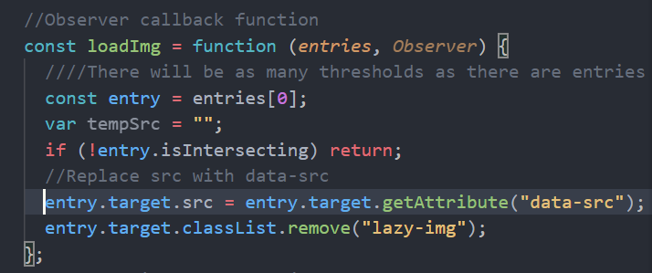

Note that this data-src attribute can also be grabbed using entry.target.**dataset.src.** And note that all the data-related-attributes are stored in the **dataset** collection inside any htmlEelemnt handle.

const imgTargets = document.querySelectorAll("img[data-src]");

//Observer callback function

const loadImg = function (*entries*, *Observer*) {

  ////There will be as many thresholds as there are entries

  const entry = entries[0];

  var tempSrc = "";

  if (!entry.isIntersecting) return;

  //(1)Replace src(low res img) with data-src(hi-res img)

  entry.target.src = entry.target.getAttribute("data-src"); // entry.target.dataset.src;

  //(2) UN-BLUR ONLY AFTER THE IMAGE HAS LOADED

  entry.target.addEventListener("load", function (*e*) {

    this.classList.remove("lazy-img");

  });

  //(3) STOP OBSERVING IMAGES

  observer.unobserve(entry.target);

};

//IntersectionObserver object

const imgObeserver = new IntersectionObserver(loadImg, {

  root: null,

  threshold: 0.15,

  //rootMargin: "200px",

  //Set the above property.value you want our images to load 200px before

  //the user reaches the image (so they don't see the blured version)

});

imgTargets.forEach(function (*img*) {

  imgObeserver.observe(img);

});

//(2) UN-BLUR AFTER THE IMAGE HAS LOADED

//When we change the src, it will take some time for our hi-res image to load

//But we don't want to remove our lazy-img (blur class) before the new image loads

//that is why we use the load event which happens after the element has loaded

//and by removing the class inside that load event handler

//we guarantee that the blur gets removed only after the image loads

## **Building a Slider Component (Part1)**

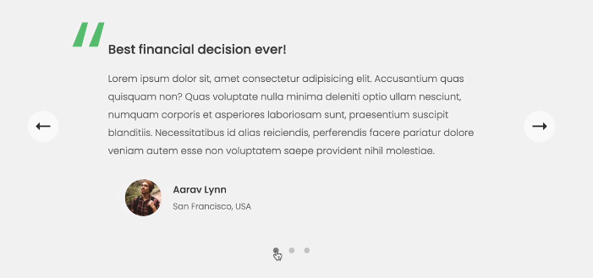

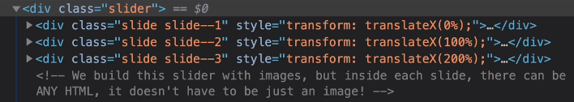

Notice that in the image above for the first slider we have the following transform: values:

**Slider1** translateX(0%) the first slider begins at the beginning of the (x)axis of the parent div

**Slider2** translateX(100%) the second slider begins at the end of the (x)axis of the parent div

**Slider3** translate(200%) the third slider begins two widths of the parent element width (x-axis)

The reason we don’t see the second and third slider to the right is because we have set the css-overflow property for these elements to hidden; **overflow: hidden;**

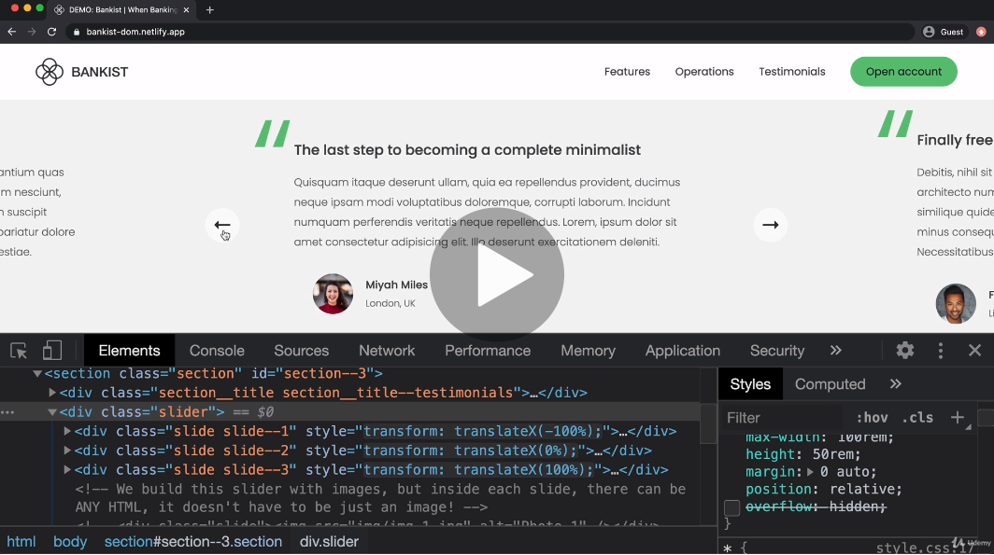Otherwise we would see these slider <div>s stack one next to each other

Notice that the transform properties as we see them above are dynamically set in javascript. The starting condition of all of these classes is such that these elements actually intersect each other(overlap) like in the image below:

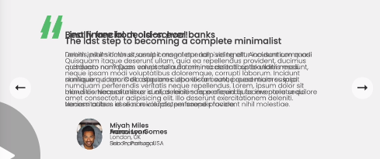

### **Step1**

The fact that the <divs> actually overlap means that our first step is to actually set up the transform properties for the elements so that they display side by side instead of on top of each other.

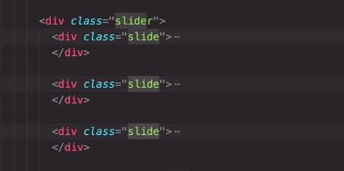

Our slider is comprised out of slides. So each div is a slide. And inside that div, we can place anything, it will not affect the functionality of our slider. As far as javascript is concerned, we only need to worry ourselves with these container elements. **.slider** and its children **.slide**

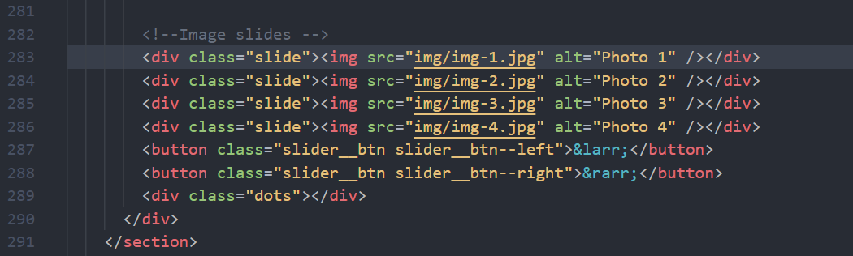With the above- mentioned in mind, for the first practice part of building the slider we shall switch to the slides with images, instead of the slide with the text, as was seen in previous pages. The images are nested in the same exact SLIDER(slide, slide, slide)layout as our text-slider was before.

////Setting the slides to stack next to one another (instead of overlapping)////

const slides = document.querySelector(".slide");

slides.forEach(function (*slide*, *index*) {

  //(1)dynamically set transform = translateX(val%) for each element

  slide.style.transform = `translateX(${100 * index}%)`;

  //0% 100% 200% 300% --> We have four images

});

//(1)dynamically set transform = translateX(val%) for each element//

//first slide 0%, second 100%, 200%, 300%. And we set this dinamically

//by multyplying each element's index by a 100.

//The width of each slide is 100%, (of the parent)

//this way, each slide starts on the end of the previous one.

### **Step2: Making the slider visible to us as we develop it**

//Making the slider visible to us as we develop it//

const slider = document.querySelector(".slider");

slider.style.transform = "scale(0.4) translateX(-800px)";

slider.style.overflow = "visible";

//Transform reshapes the size and shape of an element

//scale gives it a new proportion,(miniature, huge, medium)

//translateX and translateY shrink or expand the element

//on the X or Y axis, respectively

// overflow: visible; keeps the elements on screen even if

//their width is wider and spilling over (overflowing)their

//parent container

## **Changing slides functionality**

Note that the way changing slides work,is by thanging the value of translateX(**%**) percentage-value. By manipulating the translateX(%) value of transform property for our slider elements we may dettermine which element becomes visible.

**How this works:** The slide that we want to move to has to have the transform value of **0%** .

Seeing how the initial position of translate(%), when the first element is visible is **0%,100%,200%** we need to keep the ratio the same, but make the next element 0%. So the X-percentages for the **second element to be visible** would be **-100% 0% 100%.** And **for the third element to be visible** we would have **-200% -100% 0%.**

**Notice a pattern?**

**[0% 100% 200%** ] -100%

**[(-100)% 0% 100% ]** -100%

**[(-200)% (-100)% 0%]**

🡪 So clearly to move to the next image we just need to set **transform= translateX(${(100*1) -100}**

**🡪**And to move to the previous image: **transform= translateX(${(100*1) +100}**

**And this makes sense visually, if you consider that the slider is actually comprised of all the elements on the x-axis, where the webpage is the Y-plane intersecting the x-axis in the translateX(0%) position. Whenever we change the translateX(%) to -100, we are telling our elements to move to the left by the width of the full parent element (1 section) so now, the next section Is inside the Yplane of the viewport, while all other sections are invisible due to “overflow: hidden;” property rule.**

**It effectivelly works like the bastard-gun magazine (METRO) where the barrel is translateX(0%) and when loading a new magazine(+) the clip is initially sticking out to the right (+) but as, the gun fires(-), the clip moves to the left (-)**

**While by adding +100% on the translateX(%) we are telling the elements to move to the right(+ means to the right in the xAxis and down in the yAxis within HTML, while minus means the opposite)**

To do this dinamically is more complicated, so the solution is the one detailed below:

//Adding click events for slider buttons

let currentSlide = 0;

//Next slide

btnRight.addEventListener("click", function () {

  currentSlide++; // (index-currentSlide)*100 = [0% 100% 200% 300%]

  //[-100% 0% 100% 200%] [-200% -100% 0% 100%] [-300% -200% -100% 0%]

  slides.forEach(function (*slide*, *index*) {

    slide.style.transform = `translateX(${100 * (index - currentSlide)})`;

  });

});

//Previous slide

btnLeft.addEventListener("click", function () {

  currentSlide--; //(index-currentSlide)*100 =[-300% -200% -100% 0%]

  //[-200% -100% 0% 100%] [-100% 0% 100% 200%] [0% 100% 200% 300%]

  slides.forEach(function (*slide*, *index*) {

    slide.style.transform = `translateX(${(index - currentSlide) * 100})`;

  });

});

**How it works:**

**CurrentSlide = 0;**

translateX(${100 * (index - currentSlide)}

**currentSlide = 0, index 0/3 :** [0] 0%, [1]100%, [2]200%, [3]300%;

**currentSlide++;**

**currentSlide = 1:**

* **index 0/3: index[0] {100*(0 – 1)} = -100%**
* **index 1/3: index[1] {100*(1 – 1)} = 0%**
* **index 2/3: index[2] {100*(2 – 1)} = 100%**
* **index 3/3: index[3] {100*(3 – 1)} = 200%**
* **[-100%, 0%, 100%, 200%]**

**currentSlide++;**

**currentSlide = 2:**

* **index 0/3: index[0] {100*(0 – 2)} = -200%**
* **index 1/3: index[1] {100*(1 – 2)} = -100%**
* **index 2/3: index[2] {100*(2 – 2)} = 0%**
* **index 3/3: index[3] {100*(3 – 2)} = 100%**
* **[-200%, -100%, 0%, 100%]**

**currentSlide++;**

**currentSlide = 3:**

* **index 0/3: index[0] {100*(0 – 3)} = -300%**
* **index 1/3: index[1] {100*(1 – 3)} = -200%**
* **index 2/3: index[2] {100*(2 – 3)} = -100%**
* **index 3/3: index[3] {100*(3 – 3)} = 0%**
* **[-300%, -200%, -100%, 0%]**

## **Reseting back to the first slide if the user presses next on the last slide**

The ‘click’ event handler for the next slide would execute as many times as the user clicks the next-slide button. This means that if there are no more slides, the code would still execute, and our slider would not really work like a slider should (come back to the first element, if there are no elements left.)

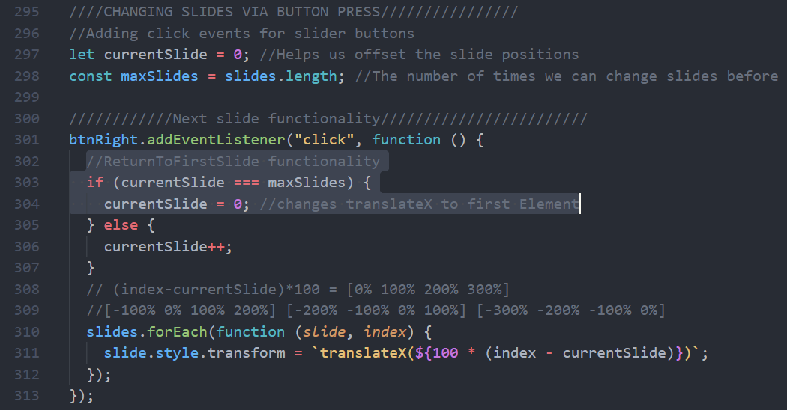

We have the currentSlide set to 0, initially, and then each time the user clicks btnRight(🡪), for switching to the next slide, the click event-handler checks if the current slide is the same number as the maximum number of slides, if it is, that means that there are no more elements left, so the handler should revert the slider back to the first element, and this functionality is achieved by reseting the initial condition that started the slider on the first element in the first time. Namely **currentSlide = 0;** 🡪 If(currentSlide ===**maxSlides - 1**) [maxSlides -1 will be the last slideindex]

Of course if this condition is not satisfied (the max is not reached 🡪 there are more slides left) then the currentSlide will increment 🡪 **currentSlide++;**

### **CSS-rules for slide animation**

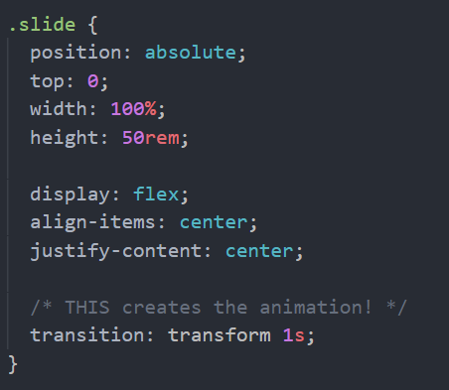

### **The initial working slider code**

//////Slider Component///////

/////////////////////////////

//Slider handles

const slides = document.querySelectorAll(".slide");

const btnLeft = document.querySelector(".slider__btn--left");

const btnRight = document.querySelector(".slider__btn--right");

//Making the slider visible to us as we develop it//

const slider = document.querySelector(".slider");

slider.style.transform = "scale(0.4) translateX(-800px)";

slider.style.overflow = "visible";

////////////////////////////////////////////////////////

////Setting the slides to stack next to one another (instead of overlapping)////

slides.forEach(function (*slide*, *index*) {

  //(1)dynamically set transform = translateX(val%) for each element

  slide.style.transform = `translateX(${100 * index}%)`;

  //0% 100% 200% 300% --> We have four images

});

////CHANGING SLIDES VIA BUTTON PRESS////////////////

//Adding click events for slider buttons

let currentSlide = 0; //Helps us offset the slide positions

const maxSlides = slides.length; //The number of times we can change slides before reaching the end

////////////Next slide functionality////////////////////////

btnRight.addEventListener("click", function () {

  //ReturnToFirstSlide functionality

  if (currentSlide === maxSlides - 1) {

    console.log("reset slides");

    currentSlide = 0; //changes translateX to first Element

  } else {

    currentSlide++;

  }

  slides.forEach(function (*slide*, *index*) {

    slide.style.transform = `translateX(${100 * (index - currentSlide)}%)`;

  });

});

**Highlighted are DRY(Don’t Repeat Yourself) sections for refactoring**

**After the first refactoring**

//Slider handles

const slides = document.querySelectorAll(".slide");

const btnLeft = document.querySelector(".slider__btn--left");

const btnRight = document.querySelector(".slider__btn--right");

//Slider state-variables

let currentSlide = 0; //Helps us offset the slide positions.

const maxSlides = slides.length; //The number of times we can change slides before reaching the end

//Making the slider visible to us as we develop it//

const slider = document.querySelector(".slider");

slider.style.transform = "scale(0.4) translateX(-800px)";

slider.style.overflow = "visible";

////////////////////////////////////////////////////////

////////////Next slide functionality////////////////////////

//Function that changes the slide to the current slide in the event listener

const goToSlide = function (*currentSlide*) {

  slides.forEach(function (*slide*, *index*) {

    slide.style.transform = `translateX(${100 * (index - currentSlide)}%`;

    // translateX(%) Sets the slides one next to each other instead of on top of each other

  });

};

goToSlide(currentSlide); //initiatalizes the slides from the ‘slides’(node-//list) with positions [0% 100% 200% 300%] for the respective elements in the list

//Event listener for the (next-slide) (-->) button click

btnRight.addEventListener("click", function () {

  //ReturnToFirstSlide functionality

  if (currentSlide === maxSlides - 1) {

    currentSlide = 0; //changes translateX to first Element

  } else {

    currentSlide++;

  }

  goToSlide(currentSlide); //Calls the function that changes slides

});

**Highlighted is the element that will get refactored into a separate function for the next iteration**

//Slider handles

const slides = document.querySelectorAll(".slide");

const btnLeft = document.querySelector(".slider__btn--left");

const btnRight = document.querySelector(".slider__btn--right");

//Slider state-variables

let currentSlide = 0; //Helps us offset the slide positions.

const maxSlides = slides.length; //The number of times we can change slides before reaching the end

//Making the slider visible to us as we develop it//

const slider = document.querySelector(".slider");

slider.style.transform = "scale(0.4) translateX(-800px)";

slider.style.overflow = "visible";

////////////////////////////////////////////////////////

////////////Next slide functionality////////////////////////

//Function that changes the slide to the current slide in the event listener

const goToSlide = function (*currentSlide*) {

  slides.forEach(function (*slide*, *index*) {

    slide.style.transform = `translateX(${100 * (index - currentSlide)}%`;

    // translateX(%) Sets the slides one next to each other instead of on top of each other

  });

};

goToSlide(currentSlide);

const nextSlide = function () {

  if (currentSlide === maxSlides - 1) {

    currentSlide = 0; //changes translateX to first Element

  } else {

    currentSlide++;

  }

};

btnRight.addEventListener("click", function () {

  //ReturnToFirstSlide functionality

  nextSlide();

  goToSlide(currentSlide); //Calls the function that changes slides

});

**UPDATE CODE WITH THE FINAL VERSION**

//Slider handles

const slides = document.querySelectorAll(".slide");

const btnLeft = document.querySelector(".slider__btn--left");

const btnRight = document.querySelector(".slider__btn--right");

//Slider state-variables

let currentSlide = 0; //Helps us offset the slide positions.

const maxSlides = slides.length; //The number of times we can change slides before reaching the end

//Making the slider visible to us as we develop it//

/*

const slider = document.querySelector(".slider");

slider.style.transform = "scale(0.4) translateX(-800px)";

slider.style.overflow = "visible";

*/

////////////////////////////////////////////////////////

////////////Next slide functionality////////////////////////

//Function that changes the slide to the current slide in the event listener

const goToSlide = function (*currentSlide*) {

  slides.forEach(function (*slide*, *index*) {

    slide.style.transform = `translateX(${100 * (index - currentSlide)}%`;

    // translateX(%) Sets the slides one next to each other instead of on top of each other

  });

};

goToSlide(currentSlide);

const nextSlide = function () {

  if (currentSlide === maxSlides - 1) {

    currentSlide = 0; //changes translateX to first Element

  } else {

    currentSlide++;

  }

};

btnRight.addEventListener("click", function () {

  //ReturnToFirstSlide functionality

  nextSlide(); //Updates value for the "currentSlide" variable

  goToSlide(currentSlide); //Calls the function that changes slides

});

///////////Previous Slide Functionality/////////////////////////////

const previousSlide = function () {

  if (currentSlide === 0) {

    currentSlide = maxSlides - 1;

    //changes translateX to the last slide

    //if the user clicks back when on the first slide

  } else {

    currentSlide--;

  }

};

btnLeft.addEventListener("click", function () {

  previousSlide(); //Updates value for the "currentSlide" variable

  goToSlide(currentSlide); //CallsFunction that changes slides

});

### **Slide Exercise(1)**

To practice and revise the principles of organizing containers into stacking next to each other as well as manipulating them left and right using **transform: translateX(value%);** ,write completely new javascript code that will enable the slider functionality to be controled/manipulated by arrow-keys on the keyboard (🡨 🡪) Left and right arrow shifting slides to the previous and next slide, respectively.

**SOLUTION part1:**

const slides_nodeList = document.querySelectorAll(".slide");

const numberOfSlides = slides_nodeList.length;

const slides_maxIndex = numberOfSlides - 1;

var current_slide = 0;

////////////////////////////////////////////

document.addEventListener("keydown", function (*e*) {

  console.log(e.key);

  if (e.key === "ArrowRight") {

    ////ArrowRight -> Next slide/////////////

    if (current_slide === slides_maxIndex) current_slide = 0;

    //move to beginning-----

    else current_slide++;

    //move to the right by one slide

    //Transform translateX(%) slide shift functionality

    for (let i = 0; i < numberOfSlides; i++) {

      slides_nodeList[i].style.transform = `translateX(${

        100 * (i - current_slide)

      }%)`;

    }

**SOLUTION part2:**

  } else if (e.key === "ArrowLeft") {

    ////ArrowLeft <- Previous slide//////////

    if (current_slide === 0) current_slide = slides_maxIndex;

    //move to the end-----

    else current_slide--;

    //move to the left by one slide

    //Transform translateX(%) slide-shift functionality

    slides_nodeList.forEach(function (*slide*, *i*) {

      slide.style.transform = `translateX(${100 * (i - current_slide)}%)`;

    });

  } else {

    return;

  }

});

## **Building a Slider Component (Part2)**

### **Creating navigationDots for our slider**

To the right, we can see the empty div container **.dots**, in the html, in which we will want to dinamically insert our dot elements, through javaScript.

After our javascript code compiles, the **.dots** container should have **.dots__dot <button>** elements inserted, as can be seen in the picture below:

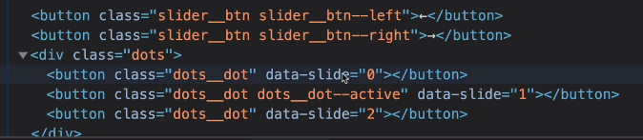

Note how we are using the **data-slide** attribute to enable te buttons to shift slides through javascript.

**Adding new html element in a loop using the insertAdjacentHTML(''**);

 dotContainer_handle.insertAdjacentHTML("beforeend");

adds successive elements [1,2,3,4] like so. Each loop iteration, it adds the next element after the last child (it becomes the new last-child)

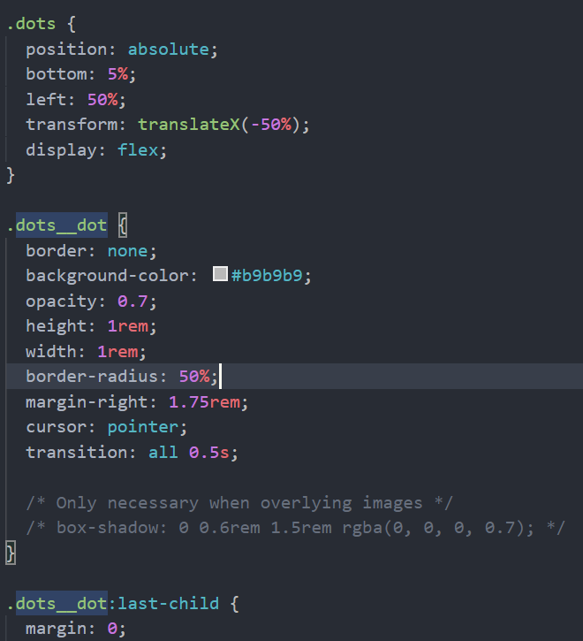dotContainer_handle.insertAdjacentHTML("beforebegin")

Figure CSS Rulz!!

.adds successive elements[5,4,3,2,1 in reverse. Each loop iteration, it adds the next element before the first (as a new first-child)

### **CSS styles that create the dots 🡪**

# CUSTOM DATA-ATTRIBUTES

Often we use custom **data-yourAttributeName** attributes in order to track/anchor/ chnge or store data for later javascript transformation, within our html elements.

**Example:**

<img src="img/card-lazy.jpg"

          data-src="img/card.jpg"

          alt="Credit card"

          class="features__img lazy-img"

        />

Here we want to change our src attribute with the value that is stored inside our custom (data-) attribute(it is called that because it is used to store data that we can later use and manipulate the element with) Here the user named his custom data attribute ‘**src**’ by writing data-**src**.

Grabbing the data attribute:

**ImgHandle.getAttribute(‘data-src’);**

**ImgHandle.dataset.src;**

**They both return the data-src content, namely:** ="img/card.jpg"

as was set for the attribute.

Note that these custom attributes always begin with **data-**yourCustomName

And that they are stored, and reference just by the name (**yourCustomName)** in the **dataset** property of the html_element_handle 🡪 **handle.dataset.yourCustomName**

## Query Selector(Attribute-SubQuery)/Querying for an element Attribute/value

Sometimes we may want to select an element based on the attribute value of said element. For example, we may have many elements of the same class, but their attributes are different. Each different image may have the same class and tag name, but their src will be different, right?

Can we use a query selector to specifically grab a handle of an image if we know its source-address? Yes!

**imgSource = ‘img/myImage.png’**

**Document.querySelector(`img[src=${imgSource}`]);**

**Note:** You can use the [ ] square braces to tell the querySelector that you want it to look for an element with a class/id/tag name that contains a certain attribute (regardless of the value contained inside the attribute in question):

**Document.querySelector(``input[placehodler]`);** 🡪Selects the first input element that also has a defined `placehodler` attribute. This is especially useful for custom data- attributes.

<img src="img/img-1.jpg" alt="Photo 1" /><

<img src="img/img-2.jpg" alt="Photo 2" />

Let’s imagine we want to toggle between The second and first imageBut we are only allowed to do this based on their src value. Let’s see how to query an element attribute in that case:

Const **switchImage** = function(currentImage)

Let images = [1,2];

If(currentImage > 0)

{document.querySelector(‘img[src = img/img-${images[1]}.jpg");//Selects the element with

currentImage = 0;

return currentImage;

}

else {

document.querySelector(‘img[src = img/img-${images[1]}.jpg");

currentImage = 1;

return currentImage;

}

**Document.querySelector(‘img[src = img/img-${images[1]}.jpg**");//Selects the element that contains a src attribute AND the the value of said src attribute is: img/img-${images[1]}.jpg

//How our practice function from above works in practice

//If we set up the initial conditions for the program

**currentImage = 1;**

**newCurrentImage = 0;**

**switchBtn.addEventListener(‘click’, function()**

**{**

**newCurrentImage = switchImage(currentImage);** //This would return 0 to new currentimage( >0)

**currentImage = newCurrentImage**;//Now the current image will be 0

**newCurrentImage = switchImage(currentImage);** // The function will now return 1 (else)

**});**

### **Querying element-attribute value for our Image-slider functionality**

const activateDot = function (*slide*) {

  //Remove active-class from all dots

  document.querySelectorAll(".dots__dot").forEach(function (*dot*) {

    dot.classList.remove("dots__dot--active");

  });

  //Add active-class to the current dot

  document

    .querySelector(`.dots__dot[data-slide=${slide}]`)

    .classList.add("dots__dot--active");

};

This function is supposed to remove a special ‘active’ class from all of our navigation-dot elements, and then to set the active-class to the dot-element that corresponds to the current slide

The current ‘slide’ is the argument that is passed to this function. But the way we use this information to update the dot that corresponds to the ‘slide’argument is by in fact using the query selector and querying the attribute value for the custom data-attribute that our dot elements have.

.querySelector(`.dots__dot[data-slide=${slide}]`)

Note that the ‘slide’ variable value inserted into the string is in fact the passed argument that the function receives when called.

### **Full (working) slider code (pre-refactor)**

//////////////////////////////

//////Slider Component///////

/////////////////////////////

//Slider handles

const slides = document.querySelectorAll(".slide");

const btnLeft = document.querySelector(".slider__btn--left");

const btnRight = document.querySelector(".slider__btn--right");

//Slider state-variables

let currentSlide = 0; //Helps us offset the slide positions.

const maxSlides = slides.length; //The number of times we can change slides before reaching the end

//Making the slider visible to us as we develop it//

/*

const slider = document.querySelector(".slider");

slider.style.transform = "scale(0.4) translateX(-800px)";

slider.style.overflow = "visible";

*/

////////////////////////////////////////////////////////

///////////////////////////////////

/////////FUNCTIONS(functionalities)/////////////////////////////

///////////////////////////////////

////////////Next slide functionality////////////////////////

//Function that changes the slide to the current slide in the event listener

const goToSlide = function (*currentSlide*) {

  slides.forEach(function (*slide*, *index*) {

    slide.style.transform = `translateX(${100 * (index - currentSlide)}%`;

    // translateX(%) Sets the slides one next to each other instead of on top of each other

  });

};

///////////Previous Slide Functionality/////////////////////////////

const previousSlide = function () {

  if (currentSlide === 0) {

    currentSlide = maxSlides - 1;

    //changes translateX to the last slide

    //if the user clicks back when on the first slide

  } else {

    currentSlide--;

  }

};

///////////Next slide function ////////////////

const nextSlide = function () {

  if (currentSlide === maxSlides - 1) {

    currentSlide = 0; //changes translateX to first Element

  } else {

    currentSlide++;

  }

};

/////////////////////////////////

////Slider: Navigation-Dots/////

///////////////////////////////

const dotContainer_handle = document.querySelector(".dots");

const createDots = function () {

  //using forEach to create as many buttons as there are slides

  //as well as to give the index of each slide to our 'data-slide'html attribute for reference

  slides.forEach(function (*__*, *index*) {

    // function(element, index) (__) is one way of naming an argument you won't be using

    //adding the element from the current loop iteration as the last child

    dotContainer_handle.insertAdjacentHTML(

      "beforeend",

      `<button class = "dots__dot" data-slide = "${index}"></button>`

    );

  });

};

const activateDot = function (*slide*) {

  //Remove active-class from all dots

  document.querySelectorAll(".dots__dot").forEach(function (*dot*) {

    dot.classList.remove("dots__dot--active");

  });

  //Add active-class to the current dot

  document

    .querySelector(`.dots__dot[data-slide="${slide}"]`)

    .classList.add("dots__dot--active");

};

const initialize = function () {

  //dot and slide initialization

  goToSlide(currentSlide);

  createDots();

  activateDot(0);

};

/////////////////////////////////////////////

/////////EVENT LISTENERS(listeneralities ;P)/

/////////////////////////////////////////////

////SLIDER INITIALIZATION /////////

initialize();

//Dots Event Listener

dotContainer_handle.addEventListener("click", function (*e*) {

  //--First we check if the user actually clicked a dot

  //and not the empty space around it

  if (e.target.classList.contains("dots__dot")) {

    const slide = e.target.getAttribute("data-slide"); //(CUSTOM DATA ATTRIBUTES are contained in the .dataset property)

    goToSlide(slide);

    activateDot(slide);

  }

});

//Slide button(<- ->) event listeners

btnRight.addEventListener("click", function () {

  //ReturnToFirstSlide functionality

  nextSlide(); //Updates value for the "currentSlide" variable

  goToSlide(currentSlide); //Calls the function that changes slides

  activateDot(currentSlide); //activates the corresponding dot

});

btnLeft.addEventListener("click", function () {

  previousSlide(); //Updates value for the "currentSlide" variable

  goToSlide(currentSlide); //CallsFunction that changes slides

  activateDot(currentSlide); //activates the corresponding dot

});

//(<-)LeftKey RightKey(->) Previous/next Slide using 'KEYDOWN'event  ////

window.addEventListener("keydown", function (*e*) {

  if (e.key === "ArrowLeft") {

    previousSlide();

    goToSlide(currentSlide);

    activateDot(curretSlide); //activates the corresponding dot

  } else if (e.key === "ArrowRight") {

    nextSlide();

    goToSlide(currentSlide); //displays the next/previous slide

    activateDot(currentSlide); //activates the corresponding dot

  }

  //above is the if shorthand notation

});

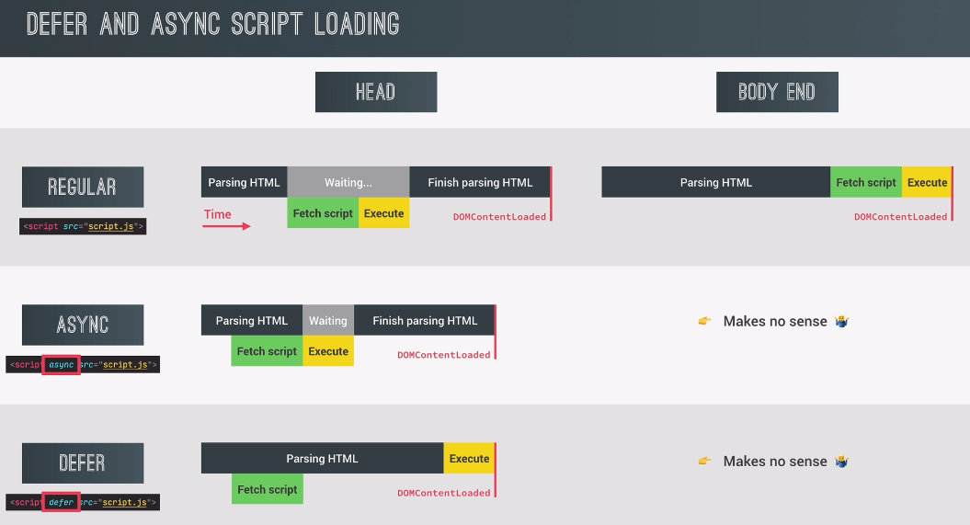

Full Javascript Code for the Bankist website

"use strict";

///////////////////////////////////////

// Modal window///////////////////////

//////////////////////////////////////

const modal = document.querySelector(".modal");

const overlay = document.querySelector(".overlay");

const btnCloseModal = document.querySelector(".btn--close-modal");

const btnsOpenModal = document.querySelectorAll(".btn--show-modal");

const openModal = function () {

  e.preventDefault();

  //Stops default <a href="#" > behavior of "#" of jumping to the top of the website

  modal.classList.remove("hidden");

  overlay.classList.remove("hidden");

};

const closeModal = function () {

  modal.classList.add("hidden");

  overlay.classList.add("hidden");

};

closeModal();

btnsOpenModal.forEach(function (*button*) {

  button.addEventListener("click", openModal);

});

btnCloseModal.addEventListener("click", closeModal);

overlay.addEventListener("click", closeModal);

document.addEventListener("keydown", function (*e*) {

  if (e.key === "Escape" && !modal.classList.contains("hidden")) {

    closeModal();

  }

});

///////////////////////////////////////////////

//////Button smooth-scroll effect//////////////

///////////////////////////////////////////////

const btnScrollTo = document.querySelector(".btn--scroll-to");

const section1 = document.querySelector("#section--1");

//Creating the click functionality that initiates smooth scroll

btnScrollTo.addEventListener("click", function (*e*) {

  const s1coords = section1.getBoundingClientRect();

  section1.scrollIntoView({ behavior: "smooth" }); //accepts an object argument

  //it tells it to scroll the element "section1" into view

});

////////////////////////////////////////

//////PAGE NAVIGATION//////////////////

//////////////////////////////////////

//1. Add event listener to common parent element

//2. Determine what element originated the event

document.querySelector(".nav__links").addEventListener("click", function (*e*) {

  e.preventDefault(); //Note it needs to be envoked on the event object, not the html element!

  const id = e.target.getAttribute("href");

  //MATCHING STRATEGY//

  //We want to prevent the click from doing anything if the user

  //clicks somwhere else on the parent element "nav__links" -> plural

  // we want only to allwo clicks on the parent's children: 'nav__link' ->singular

  if (e.target.classList.contains("nav__link"))

    //Only if the target element is of a "nav__link" class, let it pass fam!

    document.querySelector(id).scrollIntoView({ behavior: "smooth" });

});

////////////////////////////////

//////TABBED COMPONENT/////////

//////////////////////////////

const tabs = document.querySelectorAll(".operations__tab");

const tabsContainer = document.querySelector(".operations__tab-container");

const tabsContent = document.querySelectorAll("operations__content");

///event delegation for tab-button clicks///

tabsContainer.addEventListener("click", function (*e*) {

  //matching strategy, to know whitch button is clicked

  const clicked = e.target.closest(".operations__tab"); //searches for the closest operation tab

  //we want to to get the button element even if the user

  //presses the <span> text element inside the button.

  //Guard clause

  if (!clicked) return; //if clicked == null/undefined it returns false and !false == true -> return;

  //whenever there is no clicked element

  //that corresponds to our e.target.closest() handle,

  //don't do anything and leave the function

  //clearing "clicked" style from all tabs

  tabs.forEach(function (*element*) {

    element.classList.remove("operations__tab--active");

  });

  //Setting a "clicked/active" style for the current clicked tab

  clicked.classList.add("operations__tab--active"); //css active button styling for the pressed button

  ////Activate content area

  //First remove 'operations__content--active' classes from all 'operations__content' class elements

  document.querySelectorAll(".operations__content").forEach(function (*content*) {

    content.classList.remove("operations__content--active");

  }); //could have used the 'tabsContent' handle.

  //Then we add the 'operations__content--active' class to the current clicked element.

  document

    .querySelector(`.operations__content--${clicked.getAttribute("data-tab")}`)

    .classList.add("operations__content--active"); //active is a style that removes display:none; for the element

});

//////////////////////////////////////

//////Menu fade animations refactored

//////////////////////////////////////

const nav_handle = document.querySelector(".nav");

const links = nav_handle.querySelectorAll(".nav__link");

//CREATING OUR EVENT-HANDLER FUNCTION

//(opacity is different) add it as a function parameter.

const hoverHandler = function (*e*, *opacity*) {

  if (e.target.classList.contains("nav__link")) {

    const target_link = e.target;

    //(3)SELECTING THE SIBLINGS VIA PARENT ELEMENT/////////

    const sibling_links = target_link

      .closest(".nav")

      .querySelectorAll(".nav__link");

    //(4)SELECTING THE LOGO/////////////////////////////

    const logo = target_link.closest(".nav").querySelector("img");

    //(5)APPLYING THE STYLES(change the opacity)///////////

    //Changing the image opacity

    logo.style.opacity = opacity;

    sibling_links.forEach(function (*link*) {

      //Check to change only the opacity of sibling links(not the target)

      if (link !== target_link) {

        link.style.opacity = opacity;

      }

    });

  }

};

/////Using the function as an EventHandler/////

//SETTING THE OPACITY FOR ELEMENTS ON HOVER

nav_handle.addEventListener("mouseover", function (*e*) {

  hoverHandler(e, 0.5);

});

//RETURNING NORMAL OPACITY WHEN MOUSE LEAVES THE LINKS

nav_handle.addEventListener("mouseout", function (*e*) {

  hoverHandler(e, 1);

});

//REFACTORING MENU FADE ANIMATIONS//

//Here we are creating a function that will be passed on

//as an event-handler(callback-function) to an eventListener

//////////////////////////////////////

//////Sticky Navigation///////////////

//////////////////////////////////////

////////      THE INTERSECTION OBSERVER OBJECT    ////////

//We want our navBar to be visible when our header completely

//leaves the viewport

const header_handle = document.querySelector(".header");

const navHeight = nav_handle.getBoundingClientRect().height;

//OBSERVER CALLBACK FUNCTION ARGUMENT

const stickyNav = function (*entries*) {

  const entry = entries[0]; //same as writing entries[0];

  console.log(entry); //Checking the value of our current entry-object

  //Add the "sticky" class if the current entry.isIntersecting is false

  //in other words, if the header is not intersecting it is not visible in the viewport

  //and that is exactly when we want to add our sticky nav

  if (!entry.isIntersecting) {

    nav_handle.classList.add("sticky");

  } else {

    nav_handle.classList.remove("sticky");

  }

};

//////////////////////////////////////

//OBSERVER OBJECT ARGUMENT

const observerOptions = {

  root: null,

  threshold: 0,

  rootMargin: `-${navHeight}px`, //a box of 90px that will be applied outside of our target elment.

};

//When the header is not visible --> 0% of header in root element

///////////////////////////////////

//OBSERVER ITSELF

const headerObserver = new IntersectionObserver(stickyNav, observerOptions);

headerObserver.observe(header_handle);

////////////////////////////////////////////////////////////////////////////////

///////////////////////////////////

////Revealing sections on scroll//

//////////////////////////////////

//handles

const allSections = document.querySelectorAll(".section");

//observer callback

const revealSection = function (*entries*, *observer*) {

  const entry = entries[0];

  console.log(entry);

  //Guard clause

  if (!entry.isIntersecting) return;

  entry.target.classList.remove("section--hidden");

  //As the hidden class is removed and the section revealed

  //we don't need or want the observer to track the section any more

  //So to save RAM space we simply stop observing the object upon reveal

  observer.unobserve(entry.target);

};

//observer constructor with an object definition as an argument.

const sectionObserver = new IntersectionObserver(revealSection, {

  root: null, //viewport

  threshold: 0.15, //we want to reveal the section when there is 15% of it on screen

});

//Setting up one observer to multiple(4) section elements

allSections.forEach(function (*section*) {

  sectionObserver.observe(section); //Notice how an observer can observe multiple elements

  section.classList.add("section--hidden"); //initially hiding all elements

}); /////////////////////////////////////////////////////// //////////////////////////////// //////Lazy Loading Images////// /////////////////////////////// //(1)Select all lazy loaded images // We don't want to select all images on the page, just //the ones that are supposed to be lazy loaded. //Note that all of the images that are going to be lazy loaded //have a 'data-src' attribute set on them. data-src being a css property // we simply have to pass the query selector the css anchor for //all images with the [data-src] property as img[data-src]

/*//CSS style rules reference, used for achieving the effect

.section {

  padding: 15rem 3rem;

  border-top: 1px solid #ddd;

  transition: transform 1s, opacity 1s;

}

.section--hidden {

  opacity: 0;

  transform: translateY(8rem);

}

*/

/////////////////////////////////////////

//////////Lazy Loading Images //////////

////////////////////////////////////////

const imgTargets = document.querySelectorAll("img[data-src]");

//Observer callback function

const loadImg = function (*entries*, *Observer*) {

  ////There will be as many thresholds as there are entries

  const entry = entries[0];

  if (!entry.isIntersecting) return;

  //(1)Replace src(low res img) with data-src(hi-res img)

  entry.target.src = entry.target.getAttribute("data-src"); // entry.target.dataset.src;

  //(2) UN-BLUR ONLY AFTER THE IMAGE HAS LOADED

  entry.target.addEventListener("load", function (*e*) {

    this.classList.remove("lazy-img");

  });

  //(3) STOP OBSERVING IMAGES

  observer.unobserve(entry.target);

};

//IntersectionObserver object

const imgObeserver = new IntersectionObserver(loadImg, {

  root: null,

  threshold: 0.15,

  //rootMargin: "200px",

  //Set the above property.value you want our images to load 200px before

  //the user reaches the image (so they don't see the blured version)

});

imgTargets.forEach(function (*img*) {

  imgObeserver.observe(img);

});

//////////////////////////////

//////Slider Component///////

/////////////////////////////

//Slider handles

const slides = document.querySelectorAll(".slide");

const btnLeft = document.querySelector(".slider__btn--left");

const btnRight = document.querySelector(".slider__btn--right");

//Slider state-variables

let currentSlide = 0; //Helps us offset the slide positions.

const maxSlides = slides.length; //The number of times we can change slides before reaching the end

//Making the slider visible to us as we develop it//

/*

const slider = document.querySelector(".slider");

slider.style.transform = "scale(0.4) translateX(-800px)";

slider.style.overflow = "visible";

*/

////////////////////////////////////////////////////////

///////////////////////////////////

/////////FUNCTIONS(functionalities)/////////////////////////////

///////////////////////////////////

////////////Next slide functionality////////////////////////

//Function that changes the slide to the current slide in the event listener

const goToSlide = function (*currentSlide*) {

  slides.forEach(function (*slide*, *index*) {

    slide.style.transform = `translateX(${100 * (index - currentSlide)}%)`;

    // translateX(%) Sets the slides one next to each other instead of on top of each other

  });

};

///////////Previous Slide Functionality/////////////////////////////

const previousSlide = function () {

  if (currentSlide === 0) {

    currentSlide = maxSlides - 1;

    //changes translateX to the last slide

    //if the user clicks back when on the first slide

  } else {

    currentSlide--;

  }

};

///////////Next slide function ////////////////

const nextSlide = function () {

  if (currentSlide === maxSlides - 1) {

    currentSlide = 0; //changes translateX to first Element

  } else {

    currentSlide++;

  }

};

/////////////////////////////////

////Slider: Navigation-Dots/////

///////////////////////////////

const dotContainer_handle = document.querySelector(".dots");

const createDots = function () {

  //using forEach to create as many buttons as there are slides

  //as well as to give the index of each slide to our 'data-slide'html attribute for reference

  slides.forEach(function (*__*, *index*) {

    // function(element, index) (__) is one way of naming an argument you won't be using

    //adding the element from the current loop iteration as the last child

    dotContainer_handle.insertAdjacentHTML(

      "beforeend",

      `<button class = "dots__dot" data-slide = "${index}"></button>`

    );

  });

};

const activateDot = function (*slide*) {

  //Remove active-class from all dots

  document.querySelectorAll(".dots__dot").forEach(function (*dot*) {

    dot.classList.remove("dots__dot--active");

  });

  //Add active-class to the current dot

  document

    .querySelector(`.dots__dot[data-slide="${slide}"]`)

    .classList.add("dots__dot--active");

};

const initialize = function () {

  //dot and slide initialization

  goToSlide(currentSlide);

  createDots();

  activateDot(0);

};

/////////////////////////////////////////////

/////////EVENT LISTENERS(listeneralities ;P)/

/////////////////////////////////////////////

////SLIDER INITIALIZATION /////////

initialize();

//Dots Event Listener

dotContainer_handle.addEventListener("click", function (*e*) {

  //--First we check if the user actually clicked a dot

  //and not the empty space around it

  if (e.target.classList.contains("dots__dot")) {

    const slide = e.target.getAttribute("data-slide"); //(CUSTOM DATA ATTRIBUTES are contained in the .dataset property)

    goToSlide(slide);

    activateDot(slide);

  }

});

//Slide button(<- ->) event listeners

btnRight.addEventListener("click", function () {

  //ReturnToFirstSlide functionality

  nextSlide(); //Updates value for the "currentSlide" variable

  goToSlide(currentSlide); //Calls the function that changes slides

  activateDot(currentSlide); //activates the corresponding dot

});

btnLeft.addEventListener("click", function () {

  previousSlide(); //Updates value for the "currentSlide" variable

  goToSlide(currentSlide); //CallsFunction that changes slides

  activateDot(currentSlide); //activates the corresponding dot

});

//(<-)LeftKey RightKey(->) Previous/next Slide using 'KEYDOWN'event  ////

window.addEventListener("keydown", function (*e*) {

  if (e.key === "ArrowLeft") {

    previousSlide();

    goToSlide(currentSlide);

    activateDot(curretSlide); //activates the corresponding dot

  } else if (e.key === "ArrowRight") {

    nextSlide();

    goToSlide(currentSlide); //displays the next/previous slide

    activateDot(currentSlide); //activates the corresponding dot

  }

  //above is the if shorthand notation

});

## **PROGRAMMING TECHNIQUES**

### **Acessing The handle for Sibling elements 🡪 technique.**

//(1)From the element go to the closest parent

//container using the .closest('parentContainer') method

//(2) from said container make a querySelectAll('originalElementClass');

// which will return a node-list of all of the elements within the parent container

//that share the same class of our original element (original element's siblings)

//NavBar -->Parent Element

//Lowers opacity when the mouse hovers over element

navBar_handle.addEventListener("mouseover", function (*e*) {

  //Guard clause checking if the hovered-over element is a nav__link

  //(menu fades only by hovering over a link )

  if (e.target.classList.contains("nav__link"))  {

    const hovered_link = e.target; //save it as the link

    const nav_elements = Array.from(navBar_handle.children);

    //Can't get sibling links by accessing  navBar_handle.children

    //because the property only returns direct children

    //Which means we can never see past the <ul> child that

    //contains our desired <li> grandChildren of the Parent navBar_handle

    const sibling_links = hovered_link

      .closest(".nav")

      .querySelectorAll(".nav__link");

//This way we get nodeList of handles, and not HTMLcoll, or array of HTMLObject

    sibling_links.forEach(function (*link*) {

      if (link !== hovered_link) link.style.opacity = 0.5;

    });

    nav_logo.style.opacity = 0.5;

  }

});

### **My-Method**: Fade all sibling elements to the desired opacity (uses class Attribute)

const fadeSiblings = function (

*mainElement*,

*parentClass*,

*siblingClass*,

*opacity*

) {

  //Get the sibling links, by accessing all elements of the same class

  //From the closest (direct) parent class

  //Note that it returns the MainElement as well!

  const siblings = mainElement

    .closest(parentClass)

    .querySelectorAll(siblingClass);

  //Lower the opacity of all the sibling elements around the mainElement

  siblings.forEach(function (*sibling*) {

    //Checks to iterate only the siblings that are not  mainElement

    if (sibling !== mainElement) sibling.style.opacity = opacity;

  });

};

**Example call:**

**fadeSiblings(e.target, ".nav", ".nav__link", 0.5);**

### **Slider Template code 🡪 technique**

**SliderPart!**

//Related HTML

/*

<!--Image slides -->

<div class="slider">

  <div class="slide"><img src="img/img-1.jpg" alt="Photo 1" /></div>

  <div class="slide"><img src="img/img-2.jpg" alt="Photo 2" /></div>

  <div class="slide"><img src="img/img-3.jpg" alt="Photo 3" /></div>

  <div class="slide"><img src="img/img-4.jpg" alt="Photo 4" /></div>

  <button class="slider__btn slider__btn--left">&larr;</button>

  <button class="slider__btn slider__btn--right">&rarr;</button>

  <div class="dots"></div>

</div>

*/

/*

//The slides are positioned absolutely relative to their "sliders"parent

//From the top left corner fitting with a 100%width

//This means that all of the slides are stacked on top of each other

.slide {

  position: absolute;

  top: 0;

  width: 100%;

  height: 50rem;

  display: flex;

  align-items: center;

  justify-content: center;

  //--THIS creates the animation!

  transition: transform 1s;

}

//Resizes the images in order for them to fit in size to the slide div

.slide > img {

  //--Only for images that have different size than slide

  width: 100%;

  height: 100%;

  object-fit: cover;

}

*/

**SliderPart2**

//(1)Understanding the problem:

//The <div> slides are stacked one on top of the other

//What we want to happen is to stack them in one horizontal plane

//since, they are absolutely positioned, they will transform: translateX(%)

//Without moving and shifting any other elements on the page

//Being lifted(excempt from the normal layout)

//(2)Divide and conquer

//--get the Node-List of all the 'slide' containers

//--Create a method that adds to all of the elements a

//transform: translateX(%) property with the value set as such

//that the first slide, is in the original position of the slide

// translateX(0%) and every followign slide is offset to the right

// by the length of the 'sliders' contiainer element

//Since the slider element is 100% widht of the parent container

//executing this translation on the horizontal axis can be done

//by shifting each following slider element by an additional 100%

// [0%, 100%, 200%, 300%] --> For four slider elements

///Slider handles///

const sliders = document.querySelectorAll(".slide");

const btnLeft = document.querySelector(".slider__btn--left");

const btnRight = document.querySelector(".slider__btn--right");

////Slider-state variables////

let currentSlideIndex = 0;

const maxSlideIndex = sliders.length - 1;

////Slider-functions////

const goToSlide = function (*slideIndex*) {

  sliders.forEach(function (*slide*, *i*) {

    slide.style.transform = `translateX(${100 * (i - slideIndex)}%)`;

    currentSlideIndex = slideIndex;

  });

};

**SliderPart3**

//Making slider elements visible when programming it//////////////

/*

const slider = document.querySelector(".slider");

slider.style.transform = "scale(0.5) ";

slider.style.overflow = "visible";

*/

////////////////////////////////////////////////////////////////

/////Setting up the slides to stack horizontally

goToSlide(currentSlideIndex);

////Next slide functionality////

btnRight.addEventListener("click", function () {

  //On rightButtonClick the current slide becomes the next slide++

  currentSlideIndex++;

  //If the new currentslide index is a umber above the last slide

  if (currentSlideIndex > maxSlideIndex) {

    goToSlide(0); //returns to the first slide element

  } else {

    //goes to the next slide

    goToSlide(currentSlideIndex);

  }

});

////Previous slide functionality////

btnLeft.addEventListener("click", function () {

  //On leftButtonClick the current slide becomes the previous slide--

  currentSlideIndex--;

  //If the new currentSlide index is a number bellow [0]

  if (currentSlideIndex < 0) {

    goToSlide(maxSlideIndex); //goes to the  the last slide element

  } else {

    //Goes to the previous slide

    goToSlide(currentSlideIndex);

  }

});